AutoCAD® Civil 3D® 2010
“Country Kit Denmark”
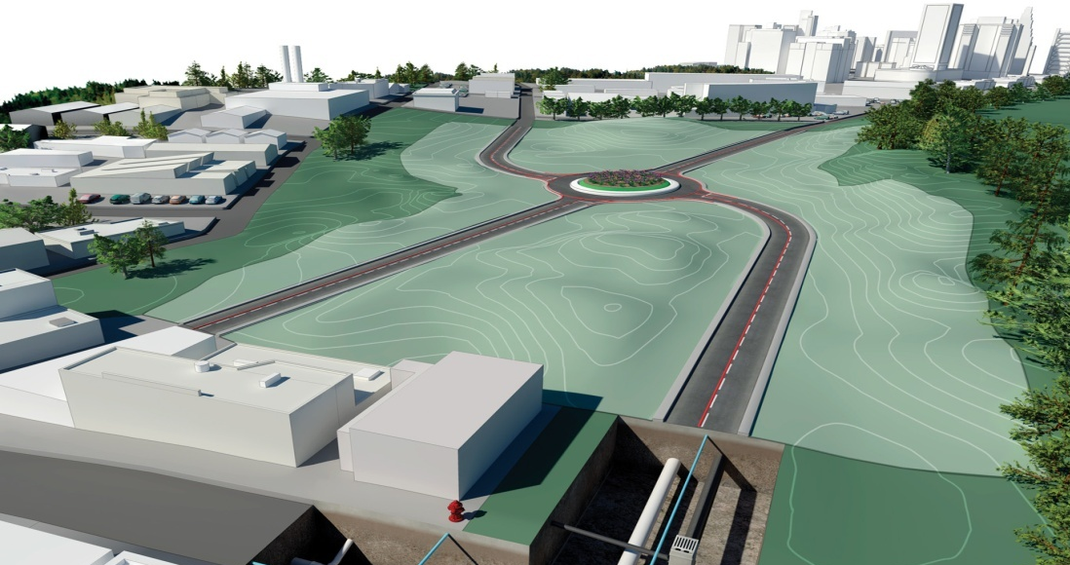

Formålet med dette dokument:
At beskrive generelle indstillinger af AutoCAD Civil 3D 2010 Country Kit for Denmark
Forfatter:
Jens Hallkvist, NTI CADcenter A/S

Revision History | Status
Jan 12 2009 | Draft 1 / JHL
Jan 23 2009 | Draft 2 / JHL
Feb 3 2009 | Final 2.1 / JHL

Contents

1 General 4
1.1 Introduction 4
1.2 Overview 4
2 Text 7
3 Hatch 8
4 Layers 9
5 Reports 11
6 Drawing Settings 12
6.1 Object Layers 12
6.2 Ambient Settings 14
7 Object styles 19
7.1 Multi-purpose Styles 19
7.2 Points 26
7.3 Surfaces 28
7.4 Parcels 39
7.5 Grading 41
7.6 Alignments 44
7.7 Profiles 50
7.8 Sections 59
7.9 Pipe Networks 61
7.10 Corridors 64
7.11 Plan and Profile Sheets 73
7.12 Survey 74
8 Tool palette(s) 75
8.1 Assemblies 75
8.2 Material styles 75
8.3 Drawing symbols and (MV) Blocks 75
9 Pipe and Structure Catalog 76
9.1 Spildevand 76
9.2 Regnvand 77
9.3 Fælles 78
9.4 Dræn 79
9.5 Labels 79
9.6 Tables 79
10 Highway design check files 81
11 Quantity Take Off 83
11.1 Introduction of QTO 83
11.2 QTO Settings 83
12 Superelevation 85
13 Intersections 86

General

Introduction

The document is an overview of all settings that AutoCAD Civil 3D 2010 Country Kit Denmark contains.

The document contains abbreviations mention below:

- AutoCAD Civil 3D 2010 - Civil 3D
- AutoCAD Civil 3D 2010 Country Kit Denmark - CKD

Overview

CKD contains folders mention below:

- Template. Folder with template for Danish styles for Civil 3D objects and labels.
- _DK Pipes Catalog. Folder with pipes files that correspond with Parts Lists (styles) in the template.
- Plan Production. Folder with templates that contains settings for Plan Production
- Corridor Design Standards. Folder with a setup file for Design Criteria and Superelevation for Corridor models.
- Quantities Reports. Folder with files containing settings for generating reports of volume for Corridor models or dynamic tables in the current drawing.
- Toolbox. Folder with files containing reports, which can be run from the Toolbox tab in the Toolspace.
- Assemblies. Folder containing drawings with predefined assemblies that can be aceesed by the Tools Palettes or create intersections.
- Pay Item Data. Folder with files containing settings for reporting areas and length from objects in the current drawing.

Toolspace is the Primary Civil 3D property window. This window is used for handling Civil 3D objects and settings of all Civil 3D styles for Civil 3D objects and labels. The Toolspace has two important tabs:

- Prospector. Use this tab for handling properties and styles for Civil 3D objects and labels.
- Settings. Use this tab for general settings of Civil 3D styles.

Prospector
Any Civil 3D object contains its own style. This style controls the Civil 3D object appearance (object and label) in the drawing. The Prospector tab in the Toolspace is the Primary window for handling property, styles and commands for all Civil 3D objects.
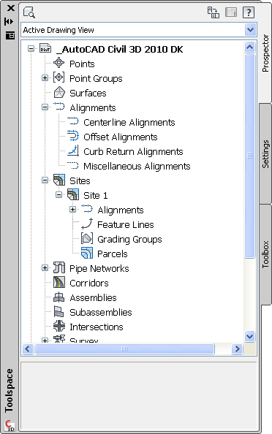

Below is a list of Civil 3D object types:

- Points og Point Group
- Feature Lines
- Surfaces
- Alignments
- Profiles
- Corridors og Sections
- Pipes
- Parcels
- Grading
- Survey
- View Frame Groups – Plan Production
- Intersections

From the Prospector tab in the Toolspace it is possible to create, copy or edit styles for Civil 3D objects. In addition to this labels are generated as dynamic data mostly annotative.

Note that new styles not automatically will be saved in the template for the CKD. This has to be done manually with Drag and Drop.

Settings
Civil 3D objects are generated with their own styles when created in the drawing with a Civil 3D command. Styles are standard in the template for the current CKD which is recommended to use for every new drawing in Civil 3D so new objects are created with the same look (Danish). Use the QNEW settings in AutoCAD Options to startup Civil 3D with the correct template.

Style setting happens from the Settings tab in the Toolspace. Here it is possible create, copy or edit Civil 3D styles. Note that new or edited styles not automatically will be saved in the template for the CKD. This has to be done manually with Drag and Drop.

US or UK styles are not removed from the CKD. In Denmark there are no standards for layer and color. Regarding the layers Civil 3D objects are assigned with standard Civil 3D layers while other objects are placed in layer 0.

Colors
In general there is an idea regarding colors for some Civil 3D objects. This is:

- Red color. Is primary used for Profiles, Sections and Mass Haul Diagram together with grey and black/white nuance
- Black/white color. Is primary used for labels and tables created in the drawing

By this it is quick

By this color choice you will get a fast visual overview of the Civil 3D drawing regarding to find the plan, profiles, sections and dynamic tables that are created in the drawing.

Text
The table below lists used text styles.

Text Style | Description | Font | Plotted Size
Standard |  | ISOCP | 1.5mm > 5.0mm

Hatch
The table below lists used hatch types.

Hatch Pattern Name | Description | Hatch Pattern File
SOLID | Used for hatching Corridor elements in Plan, some specific views in Profiles and Sections | Template
ANSI31 | Used for hatching some views in Profiles and in Sections | Template

Layers
The table below lists used layers and selected settings.

Layer | On | Freeze | Lock | Color | Linetype
0 | True | False | False | white | Continuous
A-BLDG | True | False | False | white | Continuous
AHP | True | False | False | white | Continuous
Block amenity light columns | True | False | False | 50,50,50 | Continuous
Block amenity light glass | True | False | False | 200,200,200 | Continuous
Block tree concept canopy | True | False | False | white | Continuous
Block tree concept trunk | True | False | False | white | Continuous
C-ALIGN | True | False | False | white | DASHED
C-FLINE | True | False | False | 152 | Continuous
C-FLINE-PROF | True | False | False | 152 | Continuous
C-FLINE-SCTN | True | False | False | 152 | Continuous
C-HLP-KURVETEKST | True | False | False | blue | Continuous
C-PIPE-DRN | True | False | False | green | ACAD_ISO02W100
C-PIPE-FLS | True | False | False | red | DASHED
C-PIPE-RGV | True | False | False | blue | Continuous
C-PIPE-SPV | True | False | False | red | Continuous
C-PIPE-STD | True | False | False | white | Continuous
C-PIPE-STD-LABL | True | False | False | white | Continuous
C-PIPE-STD-PROF | True | False | False | white | Continuous
C-PIPE-STD-SCTN | True | False | False | white | Continuous
C-PIPE-TABL | True | False | False | white | Continuous
C-PROP | True | False | False | white | Continuous
C-PROP-LABL | True | False | False | white | Continuous
C-PROP-LINE | True | False | False | magenta | Continuous
C-PROP-LINE-LABL | True | False | False | magenta | Continuous
C-PROP-TABL | True | False | False | white | Continuous
C-ROAD | True | False | False | white | Continuous
C-ROAD-ALG-LABL | True | False | False | white | Continuous
C-ROAD-ASSM | True | False | False | 40 | Continuous
C-ROAD-CORR | True | False | False | blue | Continuous
C-ROAD-INTS | True | False | False | white | Continuous
C-ROAD-INTS-LABL | True | False | False | white | Continuous
C-ROAD-LABL | True | False | False | white | Continuous
C-ROAD-PROF | True | False | False | white | Continuous
C-ROAD-PROF-LABL | True | False | False | white | Continuous
C-ROAD-SAMP | True | False | False | white | HIDDEN
C-ROAD-SAMP-LABL | True | False | False | white | HIDDEN
C-ROAD-SCTN | True | False | False | white | Continuous
C-ROAD-SCTN-CORR | True | False | False | blue | Continuous
C-ROAD-SCTN-LABL | True | False | False | white | Continuous
C-ROAD-SCTN-QTO | True | False | False | white | Continuous
C-ROAD-SCTN-SHET | True | False | False | white | Continuous
C-ROAD-SHAP | True | False | False | blue | Continuous
C-ROAD-SHAP-PATT | True | False | False | blue | Continuous
C-ROAD-TABL | True | False | False | white | Continuous
C-STRM-PIPE | True | False | False | white | Continuous
C-STRM-SCTN | True | False | False | white | Continuous
C-STRUCT-STD | True | False | False | white | Continuous
C-STRUCT-STD-LABL | True | False | False | white | Continuous
C-TOPO | True | False | False | white | Continuous
C-TOPO-GRAD | True | False | False | 94 | Continuous
C-TOPO-GRAD-FLIN | True | False | False | 152 | Continuous
C-TOPO-LABL | True | False | False | white | Continuous
C-TOPO-TABL | True | False | False | white | Continuous
DEFPOINTS | True | False | False | white | Continuous
Hjälplinje Nivåkurvtext | True | False | False | blue | Continuous
NOT-TABELL | True | False | False | green | Continuous
NOT-TABELL-RAM | True | False | False | green | Continuous
NOT-TABELL-RASTER | True | False | False | green | Continuous
NOT-TABELL-TEXT | True | False | False | green | Continuous
NOT-TABELL-TITEL | True | False | False | green | Continuous
PROFIL-DIAG | True | False | False | red | Continuous
PROFIL-RAM | True | False | False | red | Continuous
PROFIL-TEXT | True | False | False | red | Continuous
PROFIL-TICK | True | False | False | red | Continuous
PROFIL-TITL | True | False | False | red | Continuous
TERRAENKOTEPKT | True | False | False | white | Continuous
V-NODE | True | False | False | red | Continuous
V-NODE-TABL | True | False | False | white | Continuous
VAG-SHAPE-2D | True | False | False | red | Continuous
VAG-SHAPE-3D | True | False | False | 8 | Continuous
VAG-SHAPE-RASTER | True | False | False | 31 | Continuous

Reports
The table below lists all CKD reports (Toolspace > Toolbox > DK rapporter).

Report Name | Description | Sample File Name | Priority
Alignment > Kurver | Danish report with a list of curves for a selected Alignment.
Alignment > Station og kurver | Danish report with a list og station and curve for a selected Alignment.
Parcel > Arealer | Danish report with a list of Parcel areas.
Parcel > Arealer til Excel… | Microsoft Excel of Parcel areas.
Points > Punkter | Danish report with a list of Points.
Points > Punkter til Excel… | Microsoft Excel of Points.
Profile > PVI stationer | Danish report with a list of PVI points.
Profile > Ver. Profiler til Excel… | Microsoft Excel with PVI points.
Ledningsnetværk > Ledninger | Danish report with a list of pipes.
Ledningsnetværk > Komponenter | Danish report with a list of structures.
Ledningsnetværk > Ledninger og komponenter | Danish report with a list of pipes and structures.
Ledningsnetværk > Komponenter til Excel… | Microsoft Excel with structures.
Surface > Information | Danish report with summary data for Surfaces.
Surface > Punkter til Excel… | Microsoft Excel with surface points.

Drawing Settings

Object Layers

The table below lists all assigned Civil 3D object layers.

Object | Default Layer
Object | Layer
Alignment | C-ROAD
Alignment-Labeling | C-ROAD-LABL
Alignment Table | C-ROAD-TABL
Assembly | C-ROAD-ASSM
Building Site | A-BLDG
Corridor | C-ROAD-CORR
Corridor Section | C-ROAD-SCTN-CORR
Feature Line | C-FLINE
General Note Label | 0
General Segment Label | 0
Grading | C-TOPO-GRAD
Grading-Labeling | C-TOPO-LABL
Grid Surface | C-TOPO
Grid Surface-Labeling | C-TOPO-LABL
Interference | 0
Intersection | C-ROAD-INTS
Intersection-Labeling | C-ROAD-INTS-LABL
Mass Haul Line | 0
Mass Haul View | 0
Match Line | 0
Match Line-Labeling | 0
Material Section | 0
Material Table | 0
Parcel | C-PROP
Parcel-Labeling | C-PROP-LABL
Parcel Segment | C-PROP-LINE
Parcel Segment-Labeling | C-PROP-LINE-LABL
Parcel Table | C-PROP-TABL
Pipe | C-PIPE-STD
Pipe-Labeling | C-PIPE-STD-LABL
Pipe and Structure Table | C-PIPE-TABL
Pipe Network Section | C-PIPE-STD-SCTN
Pipe or Structure Profile | C-PIPE-STD-PROF
Point Table | V-NODE-TABL
Profile | C-ROAD-PROF
Profile-Labeling | C-ROAD-PROF-LABL
Profile View | C-ROAD-PROF
Profile View-Labeling | C-ROAD-PROF-LABL
Sample Line | C-ROAD-SAMP
Sample Line-Labeling | C-ROAD-SAMP-LABL
Section | C-ROAD-SCTN
Section-Labeling | C-ROAD-SCTN-LABL
Section View | C-ROAD-SCTN
Section View-Labeling | C-ROAD-SCTN-LABL
Section View Quantity Takeoff Table | C-ROAD-SCTN-QTO
Sheet | C-ROAD-SCTN-SHET
Structure | C-STRUCT-STD
Structure-Labeling | C-STRUCT-STD-LABL
Subassembly | C-ROAD-ASSM
Surface Legend Table | C-TOPO-TABL
Survey Figure | 0
Survey Network | 0
Tin Surface | C-TOPO
Tin Surface-Labeling | C-TOPO-LABL
View Frame | 0

Edit Drawing Settings…
Civil 3D object layers are available from Edit Drawing Settings. The figure below shows from where the command is accessible.
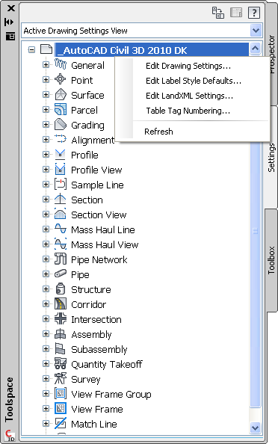

Object Layers…
Figure below show the window and tab with Object Layers.
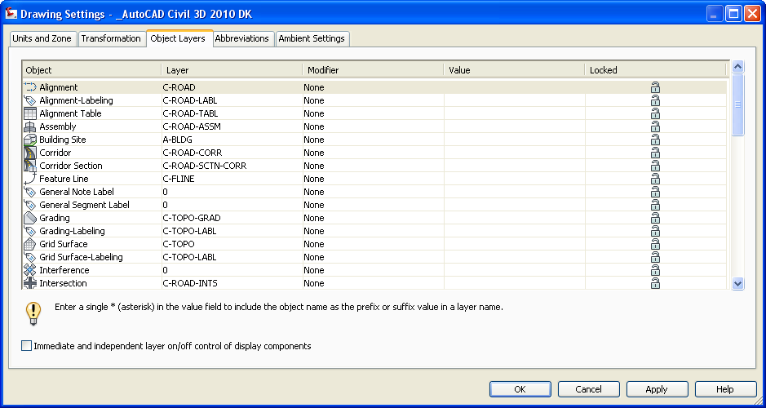

Ambient Settings

Table below lists all values for Civil 3D units.

Property |  | Value
General
 | Plotted Unit Display Type | decimal
 | Set AutoCAD Units | no
 | Save Command Changes to Settings | no
 | Show Event Viewer | yes
 | Show Tooltips | yes
 | Imperial to Metric conversion | Use International Foot
 | New Entity Tooltip State | on
 | Driving Direction | Right Side of the Road
 | Drawing Unit | meter
 | Drawing Scale | 0.500
 | Scale Inserted Objects | yes
 | Independent Layer On | no
Labeling
 | Labeling Prompt Method | Command Line
Unitless
 | Precision | 3
 | Rounding | round normal
 | Sign | sign negative '-'
Distance
 | Unit | meter
 | Precision | 3
 | Rounding | round normal
 | Sign | sign negative '-'
Dimension
 | Unit | millimeter
 | Precision | 3
 | Rounding | round normal
 | Sign | sign negative '-'
Coordinate
 | Unit | meter
 | Precision | 3
 | Rounding | round normal
 | Sign | sign negative '-'
Grid Coordinate
 | Unit | meter
 | Precision | 4
 | Rounding | round normal
 | Sign | sign negative '-'
Elevation
 | Unit | meter
 | Precision | 3
 | Rounding | round normal
 | Sign | sign negative '-'
Area
 | Unit | square meter
 | Precision | 2
 | Rounding | round normal
 | Sign | sign negative '-'
Volume
 | Unit | cubic meter
 | Precision | 2
 | Rounding | round normal
 | Sign | sign negative '-'
Speed
 | Unit | kilometer/hr.
 | Precision | 0
 | Rounding | round normal
 | Sign | sign negative '-'
Angle
 | Unit | grad
 | Precision | 3
 | Rounding | round normal
 | Format | decimal
 | Sign | sign negative '-'
 | Drop Decimal for Whole Numbers | no
 | Drop Leading Zeros for Degrees | yes
Direction
 | Unit | grad
 | Precision | 3
 | Rounding | round normal
 | Format | decimal
 | Direction | short name
 | Capitalization | upper case
 | Sign | sign negative '-'
 | Measurement Type | North Azimuth
 | Bearing Quadrant | 1 - NE
 | Drop Decimal for Whole Numbers | no
 | Drop Leading Zeros for Degrees | yes
Lat Long
 | Unit | degree
 | Precision | 3
 | Rounding | round normal
 | Format | DD° MM' SS.SS" (spaced)
 | Direction | prefix short name
 | Capitalization | upper case
 | Drop Decimal for Whole Numbers | no
 | Drop Leading Zeros for Degrees | yes
Grade
 | Precision | 3
 | Rounding | round normal
 | Format | percent
 | Sign | sign negative '-'
Slope
 | Precision | 3
 | Rounding | round normal
 | Format | rise:run
 | Sign | sign negative '-'
Grade/Slope
 | Precision | 2
 | Rounding | round normal
 | Format | rise:run
 | Sign | sign negative '-'
Station
 | Unit | meter
 | Format | station format
 | Precision | 3
 | Rounding | round normal
 | Sign | sign negative '-'
 | Station Delimiter Character | plus sign '+'
 | Station Delimiter Position | 1+000
 | Drop Decimal for Whole Numbers | yes
 | Drop Leading Zeros Right of Station Character | yes
 | Minimum Display Width | 0
Transparent Commands
 | Prompt for 3D Points | false
 | Prompt for Y before X | false
 | Prompt for Easting then Northing | false
 | Prompt for Longitude then Latitude | false

Edit Drawing Settings…
Civil 3D units are available from Edit Drawing Settings. The figure below shows from where the command is accessible.

Ambient Settings…
Figure below show the window and tab with Ambient Settings.
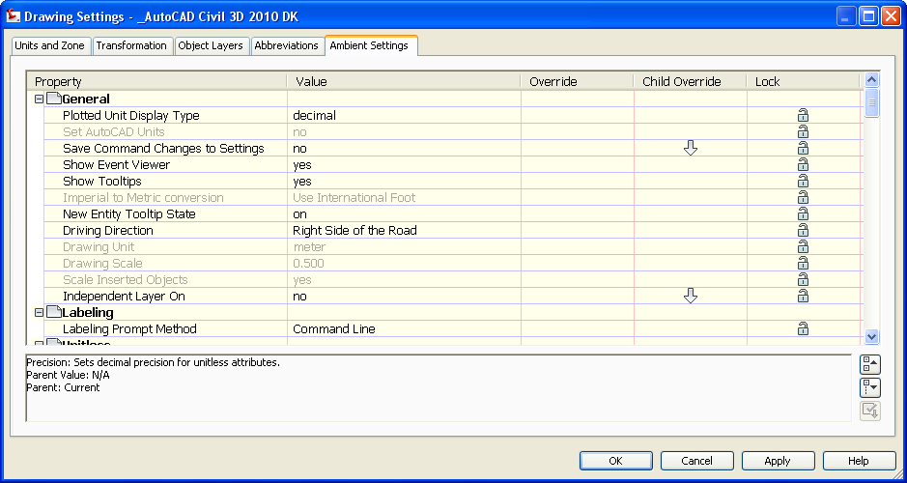

Object styles
All Civil 3D object styles is in the CKD template. The name and the template is <_AutoCAD Civil 3D 2010 DK.dwt>. All Civil 3D object styles with no CKD modification are indicated with <None>.

Multi-purpose Styles

Feature Line Styles | Description | Screen grab / DWF / DWG | Default
Basis Feature Line | Feature Line with color 152 and linetype CENTER | 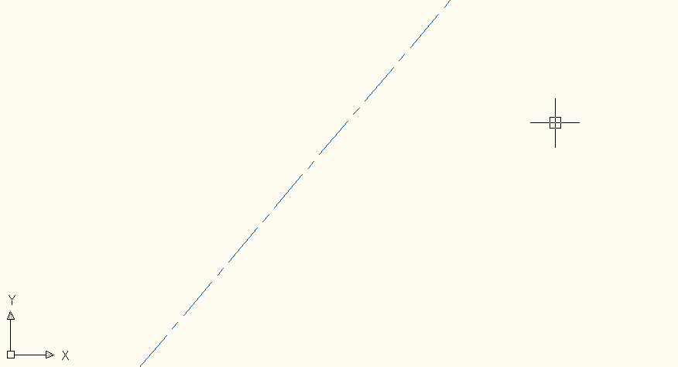 | Yes

Code Set Styles | Description | Screen grab / DWF / DWG | Default
Alle koder | Show all Corridor Subassemblies with markers. |  | Yes
Alle koder uden markør | Show all Corridor Subassemblies without markers.
Alle koder uden markør [Hatch] | Show all Corridor Subassemblies as hatch without markers.  Only for use in Top View.
Alle koder uden markør [Viz] | Show all Corridor Subassemblies with Materials and without markers.  Only for use in a Isometric View and Visual Style different from 2D Wireframe.

Marker Styles | Description | Screen grab / DWF / DWG | Default
Basis | Marker is a small circle with magenta color | 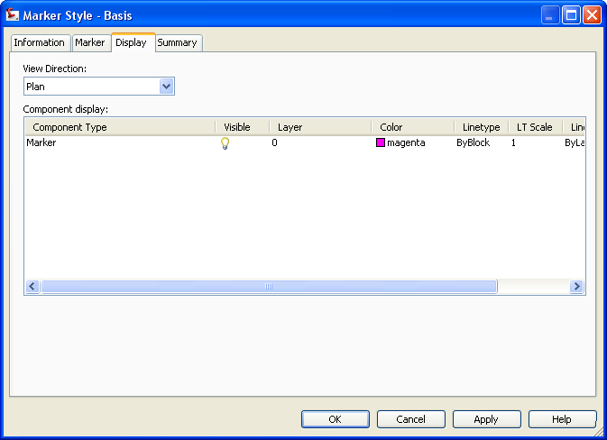 | Yes
Slukket | No marker | 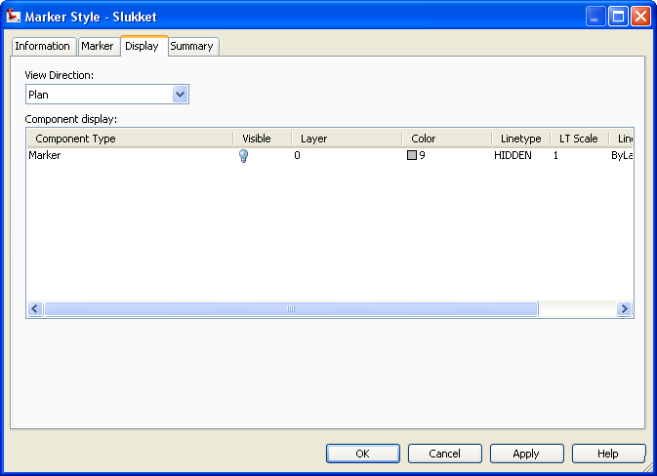

Link Styles | Description | Screen grab / DWF / DWG | Default
<None>

Shape Styles | Description | Screen grab / DWF / DWG | Default
Fortov | Hatch of Sidewalk when using Code Set Style Alle koder uden markør [Hatch]. | 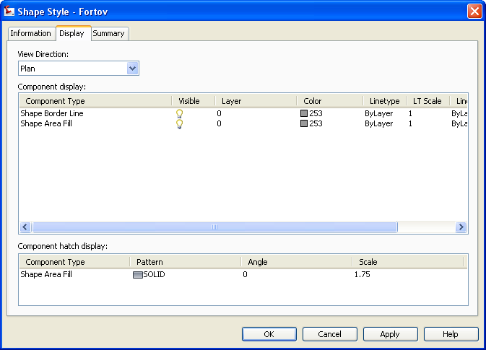 | Yes
Kantsten | Hatch of Curb when using Code Set Style Alle koder uden markør [Hatch]. | 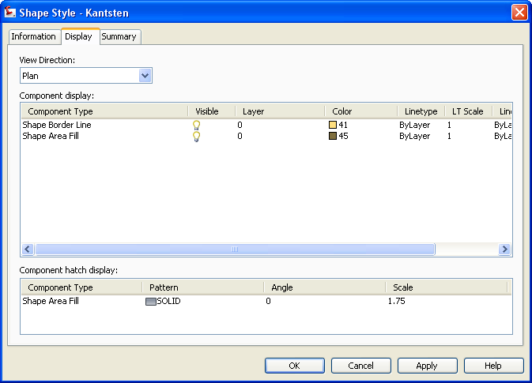 | Yes
Kørebane | Hatch of Pave when using Code Set Style Alle koder uden markør [Hatch]. | 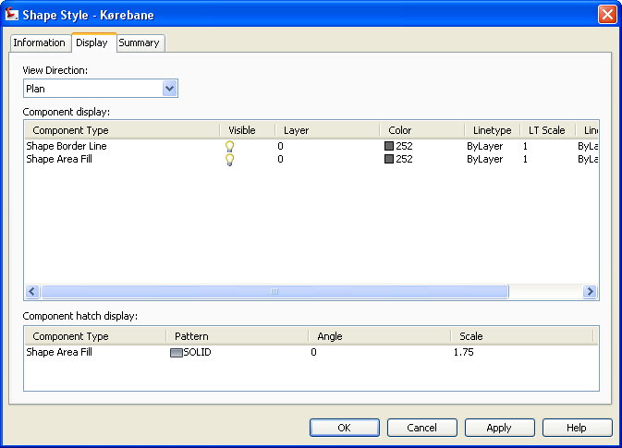 | Yes
Terræn | Hatch of Daylight (Cut and Fill) when using Code Set Style Alle koder uden markør [Hatch]. | 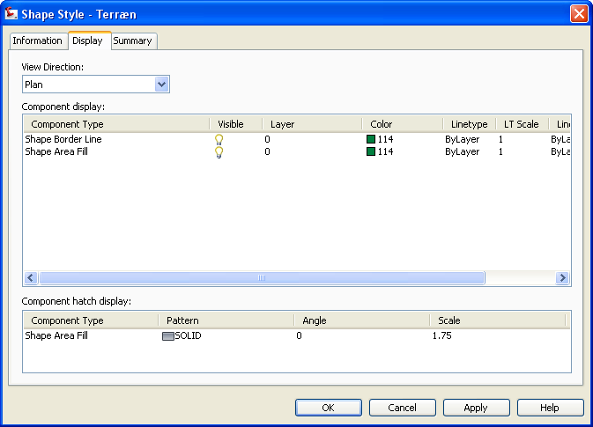 | Yes

Slope Pattern Style | Description | Screen grab / DWF / DWG | Default
Skråningssignatur | Draw Slopes with yellow color. | 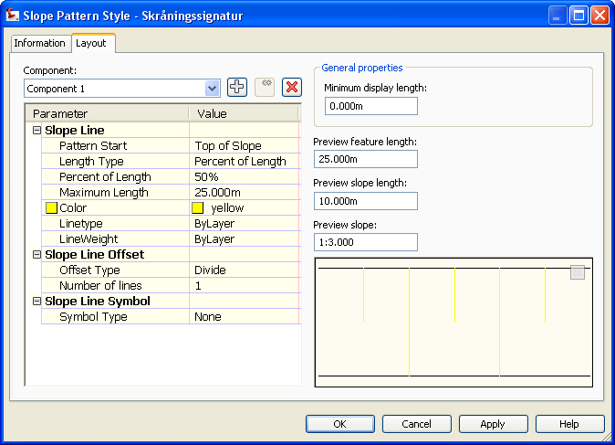 | Yes

Multi-purpose Label Styles | Description | Screen grab / DWF / DWG | Default
Note
<None>
Line
<None>
Curve
<None>
Marker
<None>
Link
<None>
Shape
<None>

Projection Styles | Description | Screen grab / DWF / DWG | Default
<None> |  |  | Yes

Points

User Defined Attribute Classifications | Description | Screen grab / DWF / DWG | Default
<None>

Point Styles | Description | Screen grab / DWF / DWG | Default
<None>

Point Label Styles | Description | Screen grab / DWF / DWG | Default
Kode | Show only the code (Raw Description). | 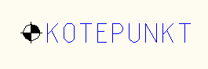
Kote | Show only the elevation (Point Elevation). | 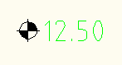
Nummer | Show only the number (Point Number) | 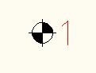
Nummer m. kode og kote | Show number, elevation and code. | 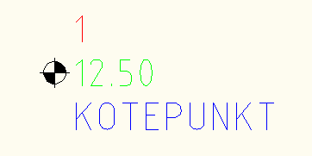

Description Key Sets | Description | Screen grab / DWF / DWG | Default
Nummer | Example of a Description key Sets. | 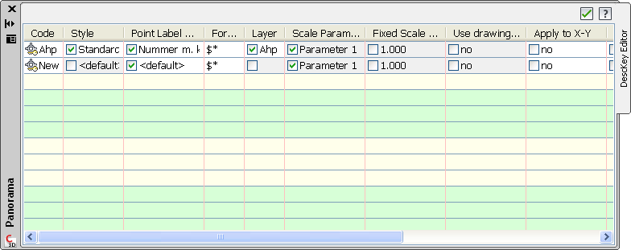

Point Table Styles | Description | Screen grab / DWF / DWG | Default
Koordinater | Table in drawing listing number, code, x, y and z coordinates. | 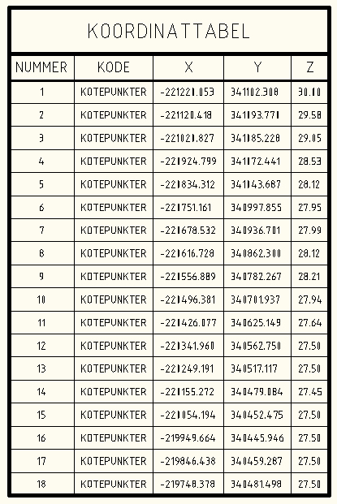

Surfaces

Surface Styles | Description | Screen grab / DWF / DWG | Default
Afvandingsområde | Show surface Watersheds with labels | 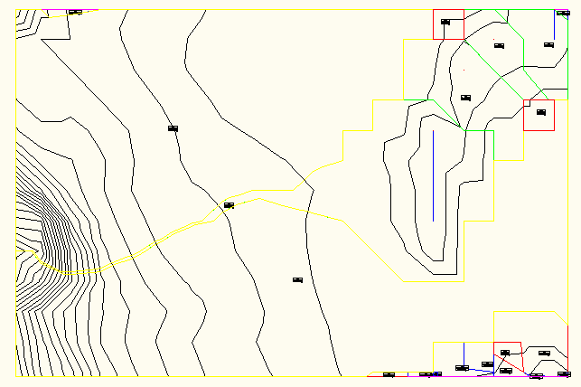
Cut og Fill (TIN Volume) | Show surface with 2 colors for Cut and Fill plans (TIN Volume surface).  Adjusts colors in Surface Properties > Definition by creating 2 elevation interval with elevation 0 as focal point.  Elevation in TIN Volume Surfaces is relative elevations. | 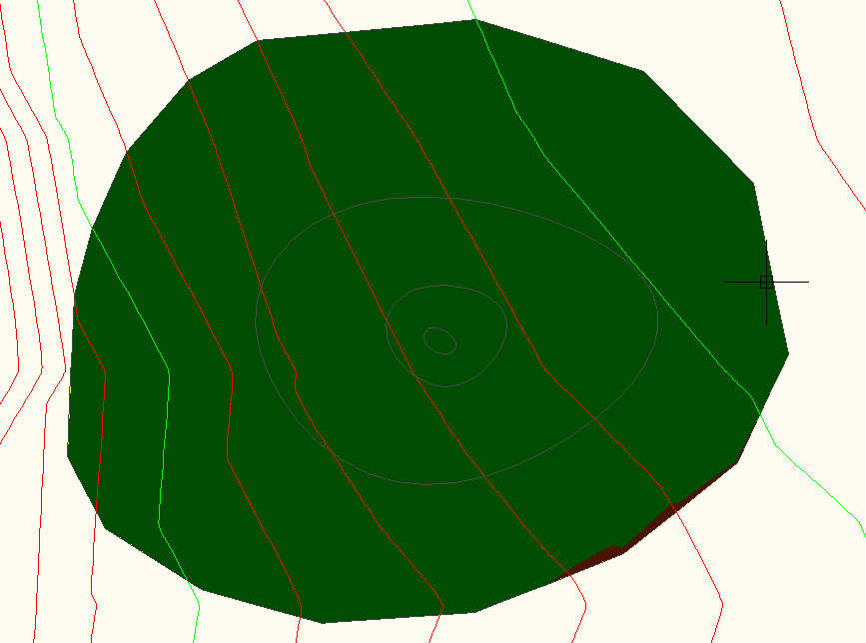
Farver (1 m) | Show surface with colors for 4 elevation intervals. | 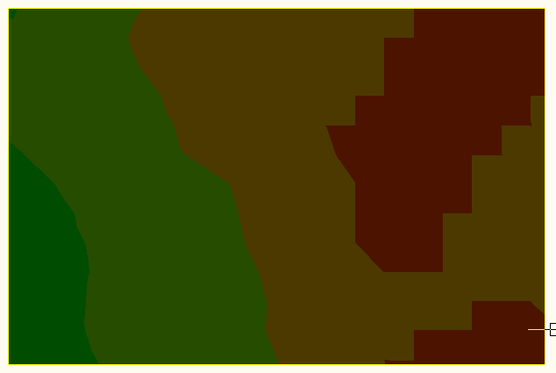
Grid (25 m) | Show surface with grid in 25m in X and Y direction. | 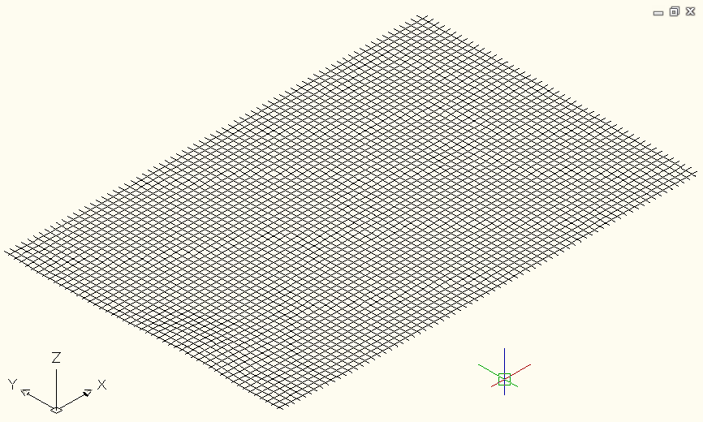
Grid (25 m) som overdrivelse | Show surface with grid in 25m in X and Y direction and 10x exaggerate I elevation. | 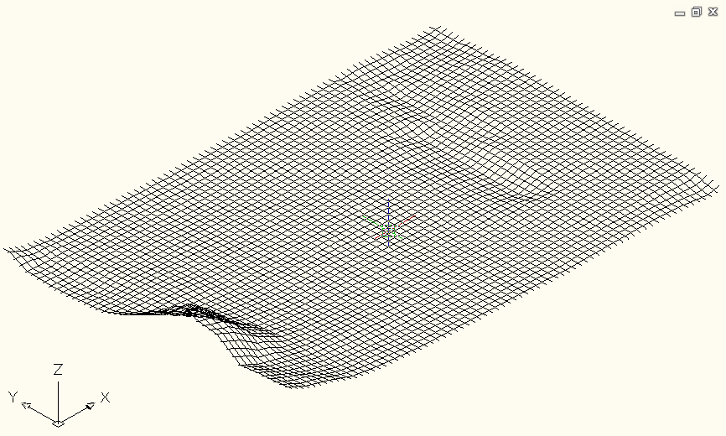
Grid (50 m) | Show surface with grid in 50m in X and Y direction. | 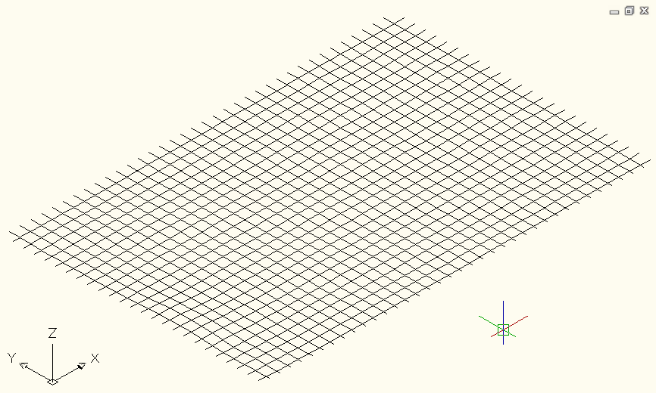
Grid (50 m) som overdrivelse | Show surface with grid in 50m in X and Y direction and 10x exaggerate I elevation. | 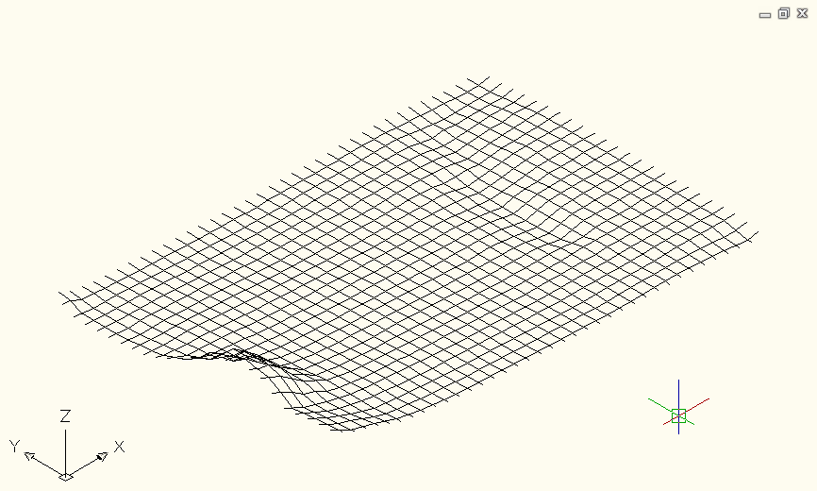
Grid (100 m) | Show surface with grid in 100m in X and Y direction. | 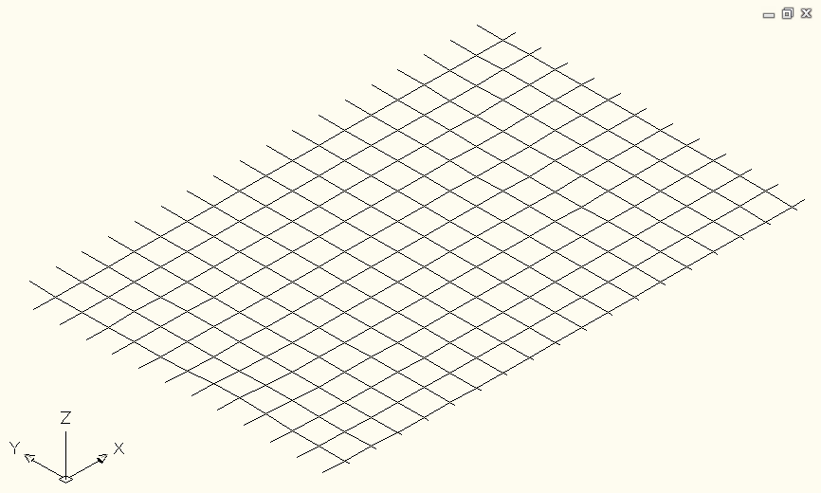
Grid (100 m) som overdrivelse | Show surface with grid in 100m in X and Y direction and 10x exaggerate I elevation. | 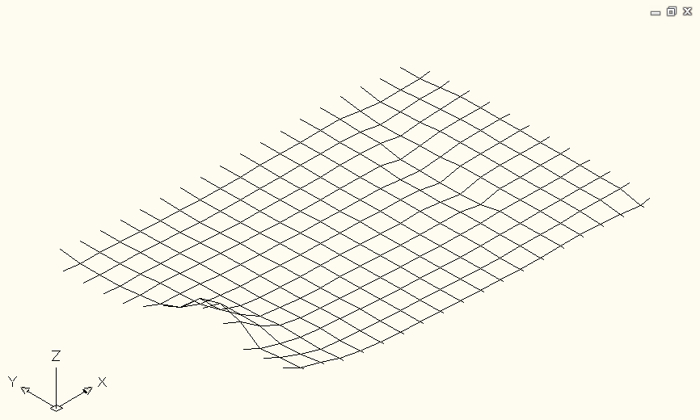
Kurver (0.25 m) | Show surface with contours with interval 25cm.  Colors are red and green. | 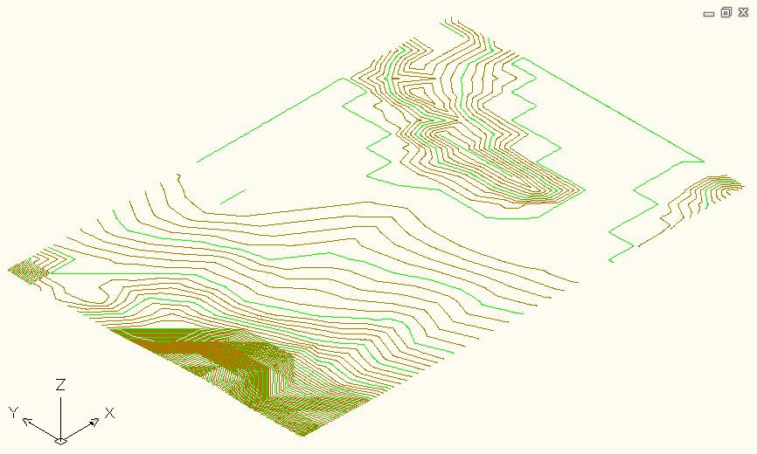
Kurver (½ m) | Show surface with contours with interval ½m.  Colors are red and green. | 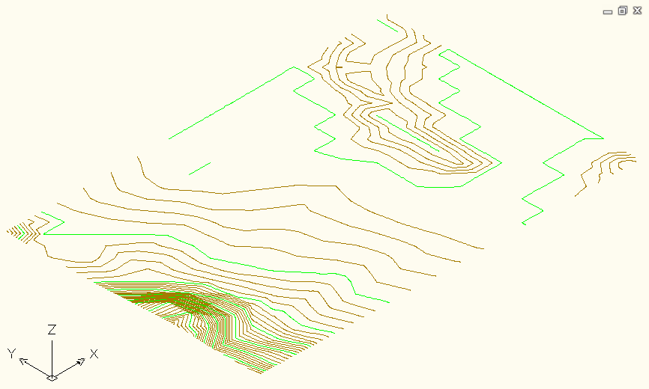
Kurver (½ m) med hældninger | Viser surface med forskellige farver efter størrelse på hældninger  Show surface with different colors depending the value of slopes | 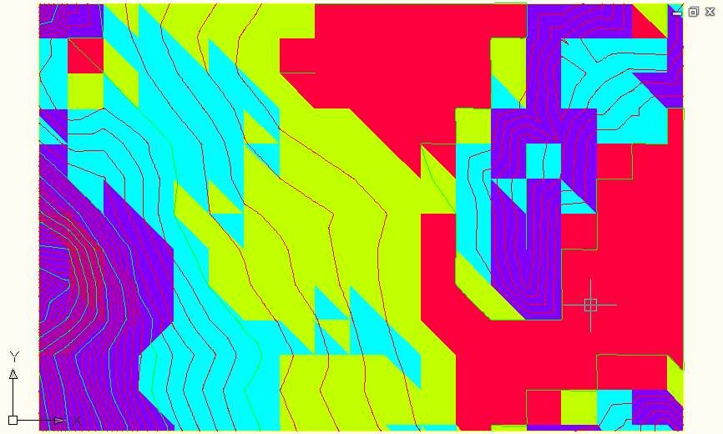
Kurver (½ m) med hældningspile | Show surface with contours with interval ½m with colored slope arrows.  Colors are red and green for contours. | 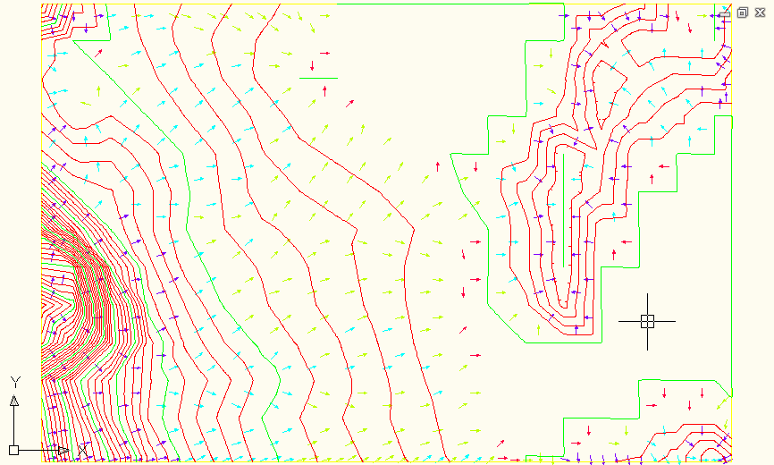
Kurver (½ m) som baggrund | Show surface with contours with interval ½m.  Color is grey. | 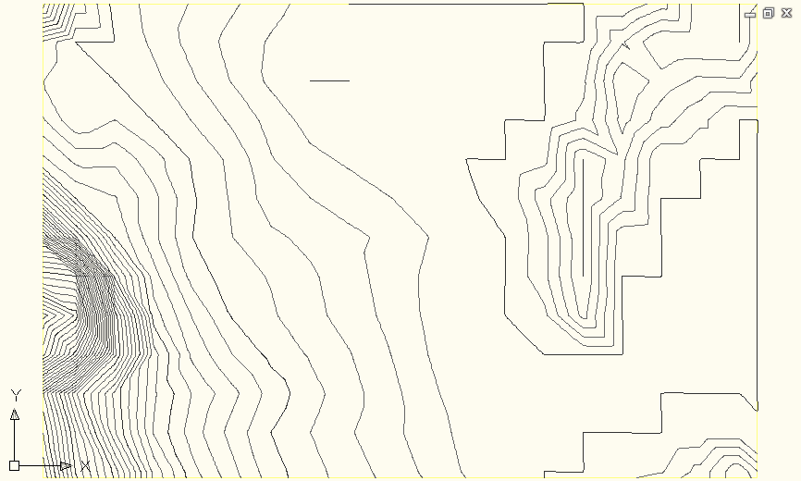
Kurver (2½ m) | Show surface with contours with interval 2½m.  Colors are red and green. | 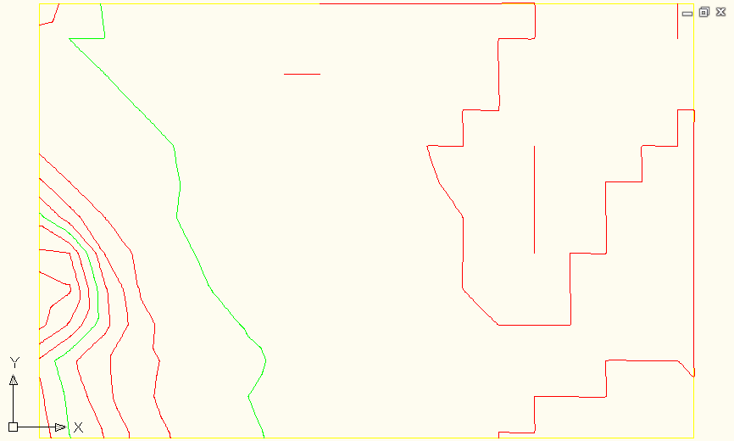
Net og punkter | Show surface triangles and points. | 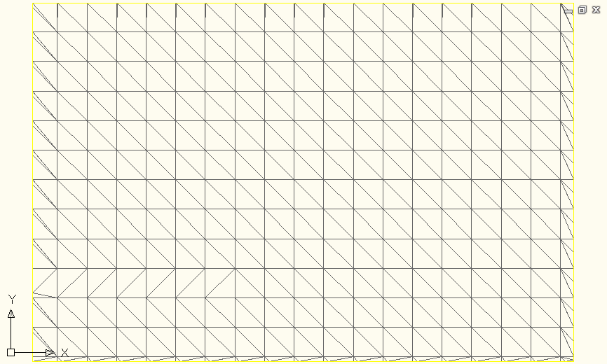
Slukket | Show surface border in Plan and Model view. | 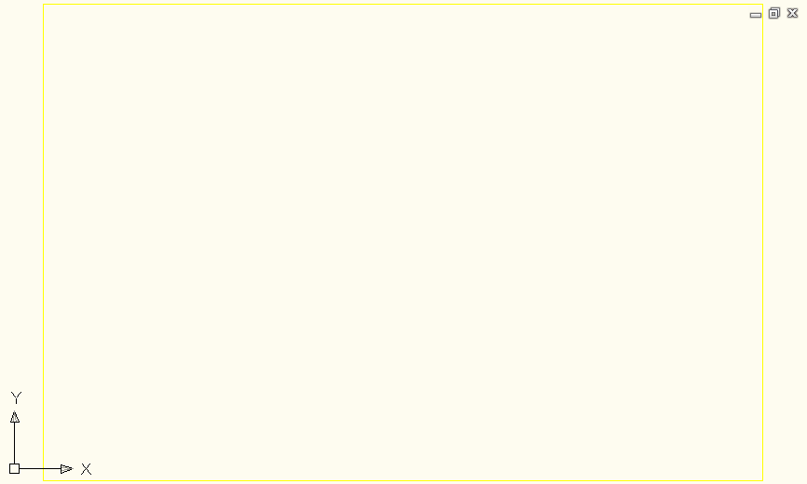
Slukket (uden grænser) | Don’t show any surface items at all in both Plan and Model view.

Surface Label Styles Name/Type | Description | Screen grab / DWF / DWG | Default
Contour
Højdekurver | Spot Elevation. | 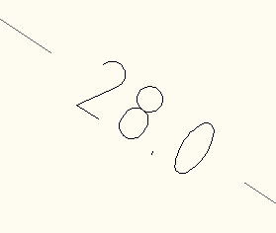
Slope
Hældning i procent | Slope in per mille. | 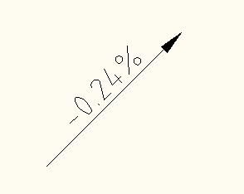
Hældning i promille | Slope in percent. | 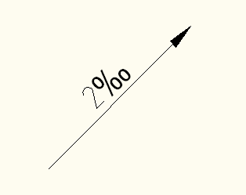
Spot Elevation
Punkthøjde | Spot Elevations. | 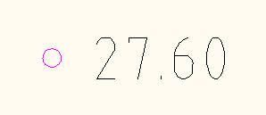
Watershed
Afvandingsområde | Label for Watersheds. | 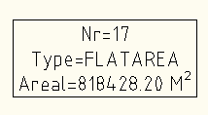

Surface Table Styles Name/Type | Description | Screen grab / DWF / DWG | Default
Direction
Min og max tegning
Elevation
Min og max højde
Slope
Min og max hældning
Slope Arrow
Hældningspil
Contour
Min og max højdekurver
Watershed
Afvandingsområde
User Defined Contour
Ekstra højdekurver

Parcels

User-Defined Attributes | Description | Screen grab / DWF / DWG | Default
<None>

Parcel Styles | Description | Screen grab / DWF / DWG | Default
Ejendom | Show Parcels with green color. | 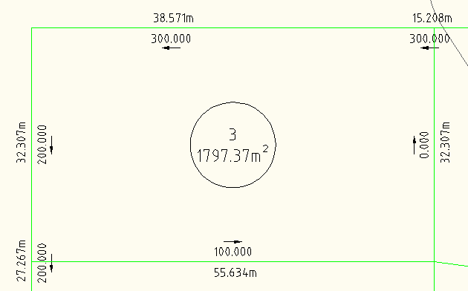
Område | S | 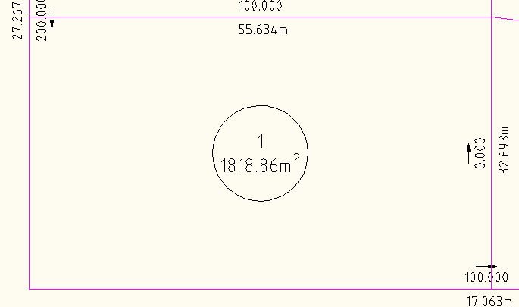

Parcel Label Styles | Description | Screen grab / DWF / DWG | Default
Area
Betegnelse | Show parcel number i a circle.
Betegnelse og areal | Show Parcel number and area in a circle. | 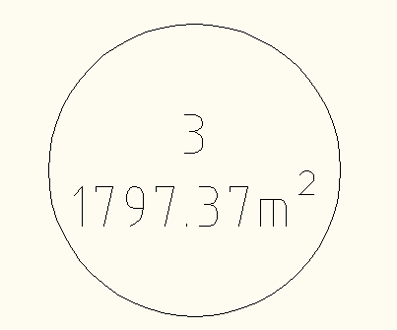
Område | Show number and area in a rectangle.
Line
Ejendom | Show length and direction for lines. | 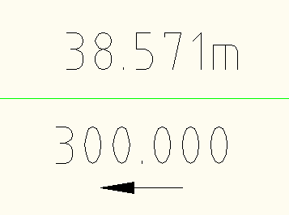
Curve
Kurver | Show length and radius for curves. | 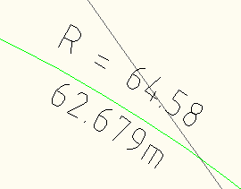

Parcel Table Styles | Description | Screen grab / DWF / DWG | Default
Line
<None>
Curve
<None>
Segment
<None>
Area
Ejendom | Table with Parcel number, area, length for lines and curves that defines a Parcel. | 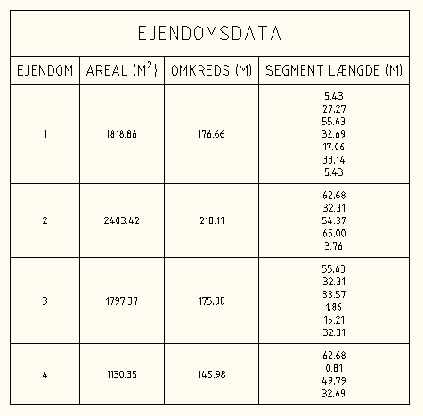

Grading

Grading Styles | Description | Screen grab / DWF / DWG | Default
Afgravning | Slope Pattern Style for cut with red color in Plan and Model view. | 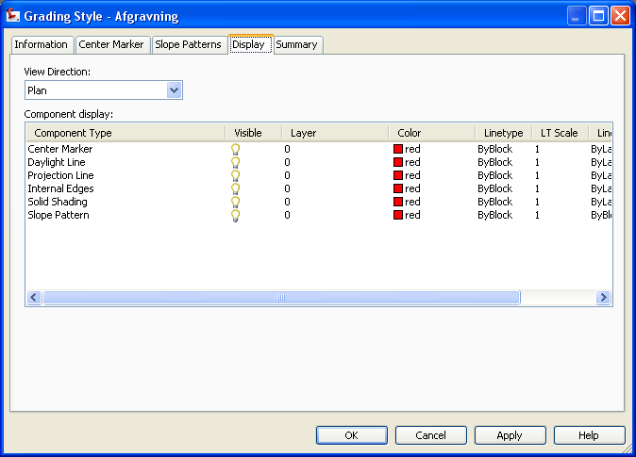 | Yes
Opfyldning | Slope Pattern Style for fill with yellow color in Plan and Model. | 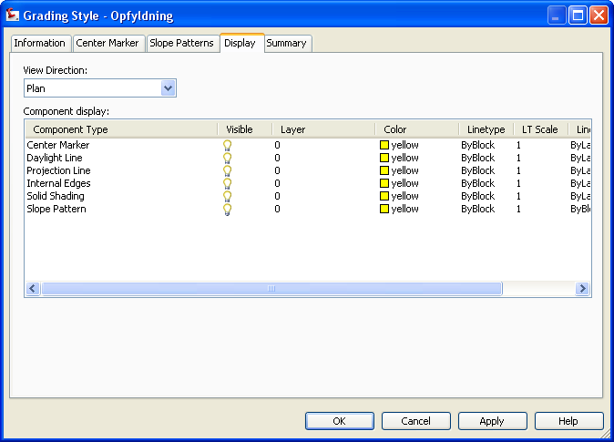 | Yes

Grading Criteria Sets | Description | Screen grab / DWF / DWG | Default
Basis | Afstand & hældning  Slope with distance from Feature Line with Grade. | 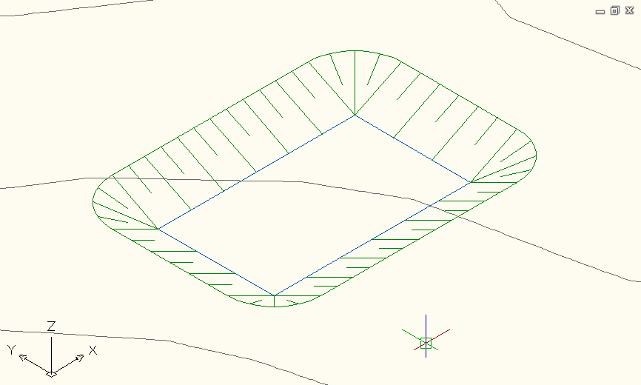
Basis | Afstand & skråning  Slope with distance from feature Line with slope fx 1:2. | 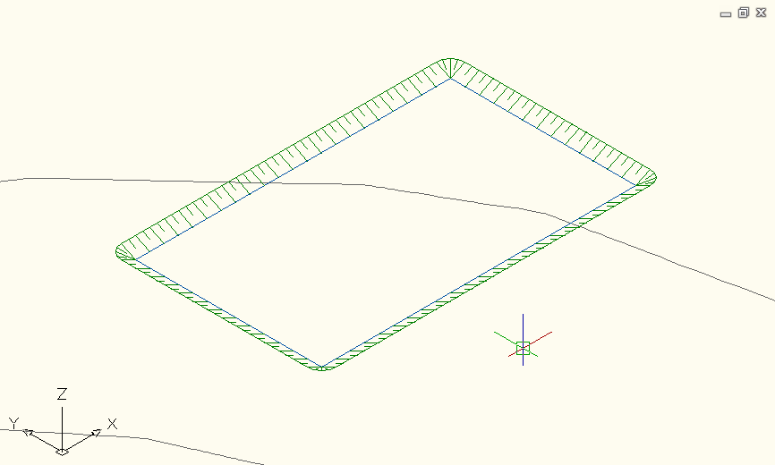
Basis | Højde & hældning  Slope with height and grade fx 1:2 from Feature Line. | 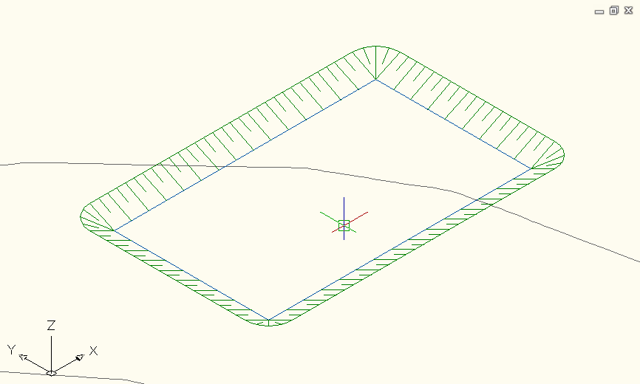
Basis | Terræn & 1-2 hældning  Slope to daylight with slope 1:2. | 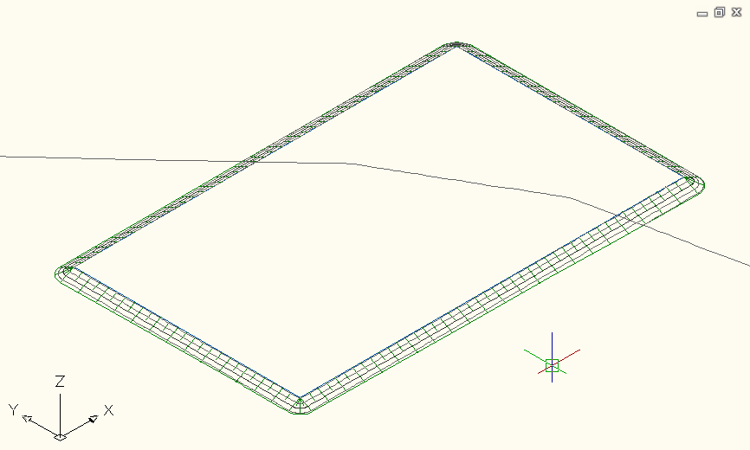 | Yes
Basis | Terræn & 1-3 hældning  Slope to daylight with slope 1:3. | 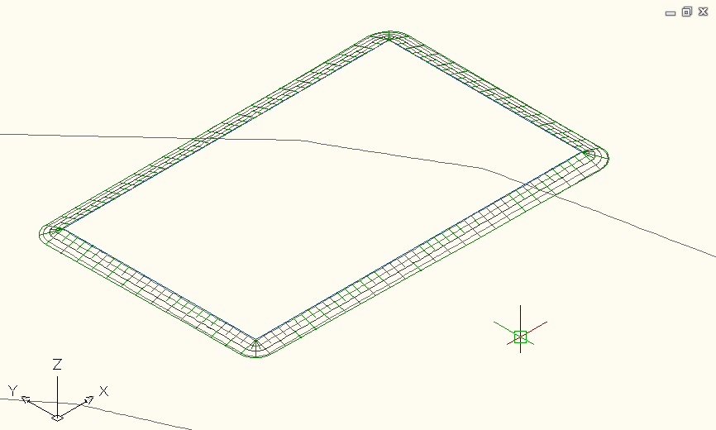
Basis | Terræn & 1-6 hældning  Slope to daylight with slope 1:6. | 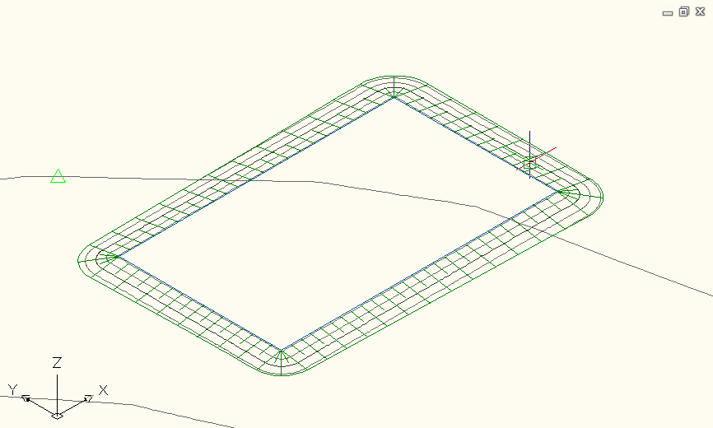
Basis | Terræn og hældning  Slope to daylight with slope input for cut and fill. | 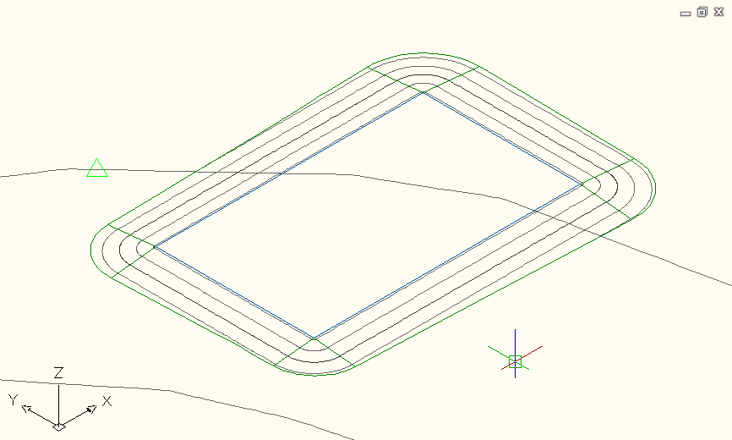

Alignments

Alignment Style | Description | Screen grab / DWF / DWG | Default
Plot | Alignment (color red) without indicating transitions.
Veje | Alignment with red color for tangents, green color for spirals and blue color for curves. | 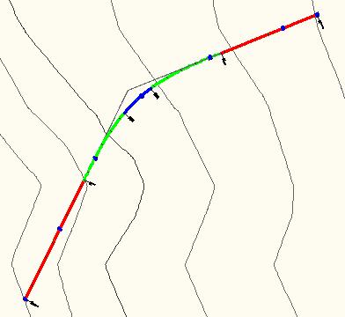 | Yes
Veje parallel | Offset Alignments with red color for tangents, green color for spirals and blue color for curves.  Linetype is HIDDEN for visual separation from primary Alignment. | 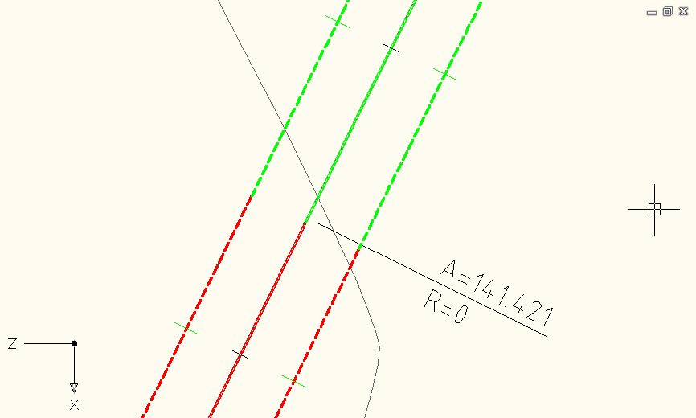

Alignment Design Checks | Description | Screen grab / DWF / DWG | Default
Design Check Sets
<None>
Line
<None>
Curve
<None>
Spiral
<None>
Tangent Intersection
<None>

Alignment Label Type/Name | Description | Screen grab / DWF / DWG | Default
Alignment Label Sets
Basis | Black/white labels with station and transitions. | 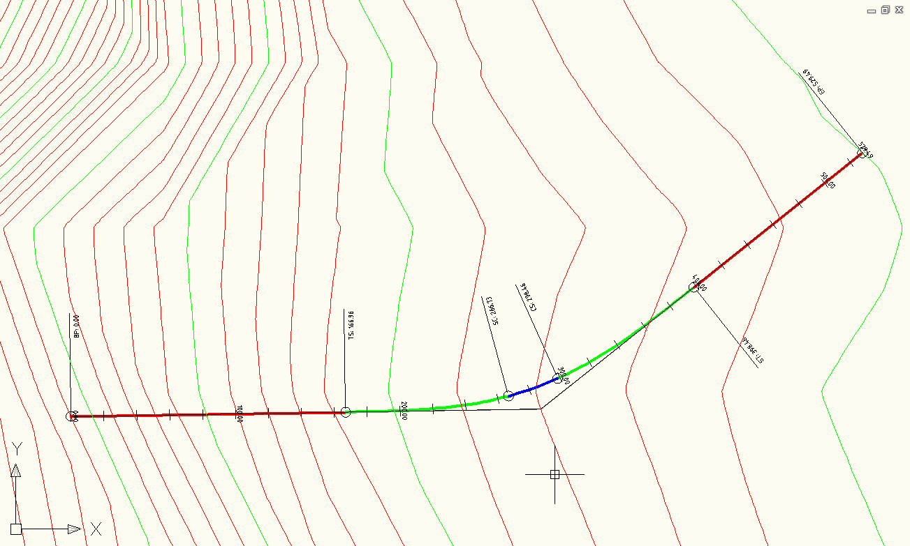
Jernbane | Yellow labels with station and no transitions. | 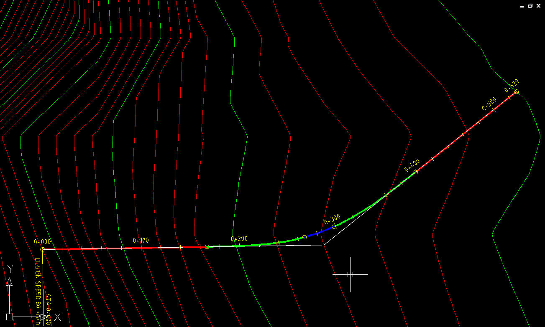
Slukket | No labels but minor ticks. | 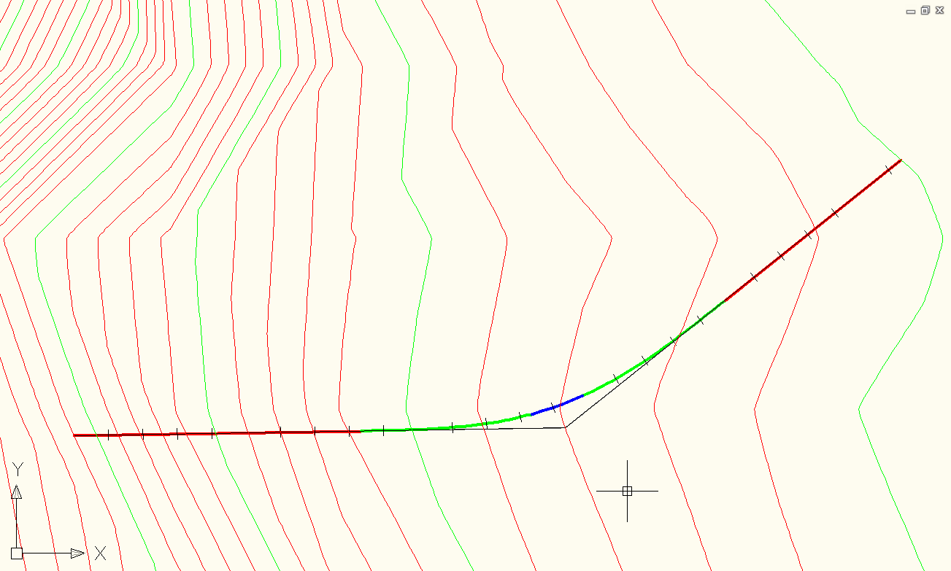
Veje | Black/white labels with station and transitions. | 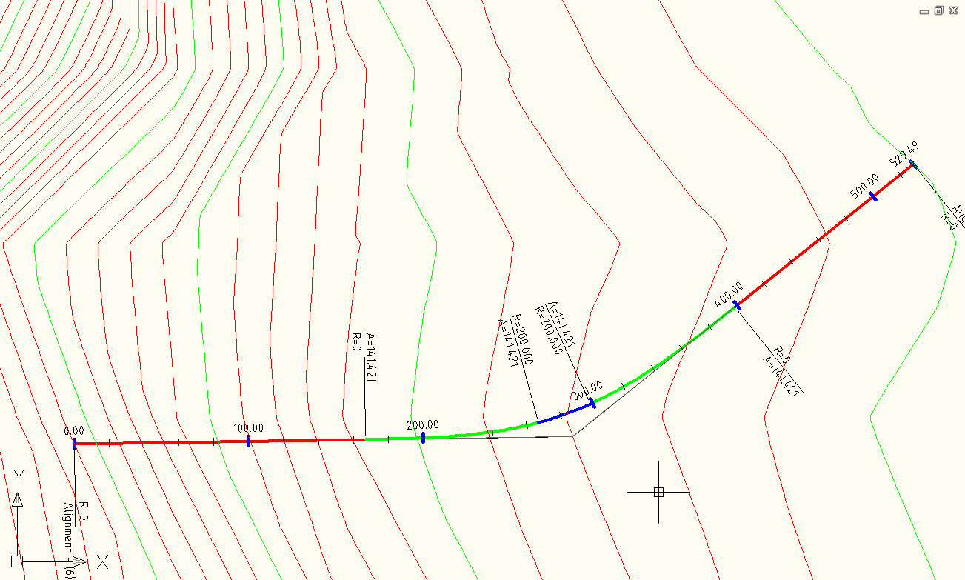
Veje (simpel) | Black/white labels with stations. | 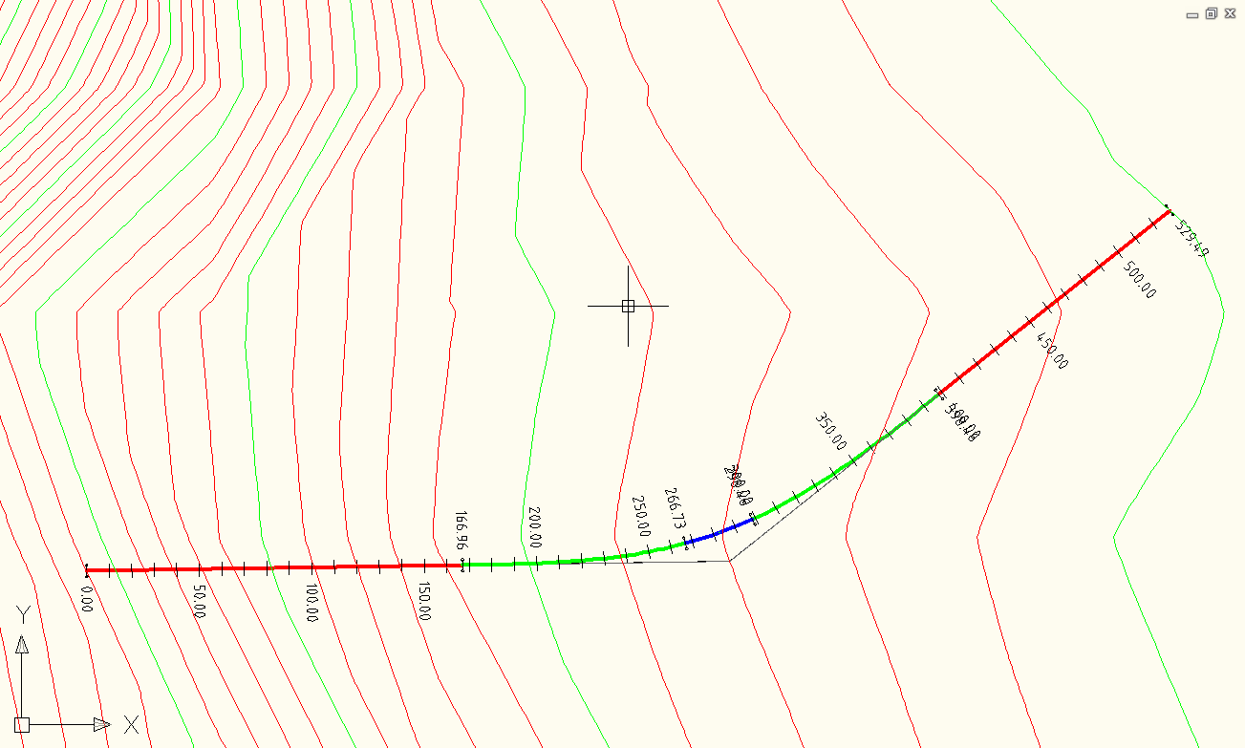
Veje (superelevation) | Black/white labels with station and transitions. | 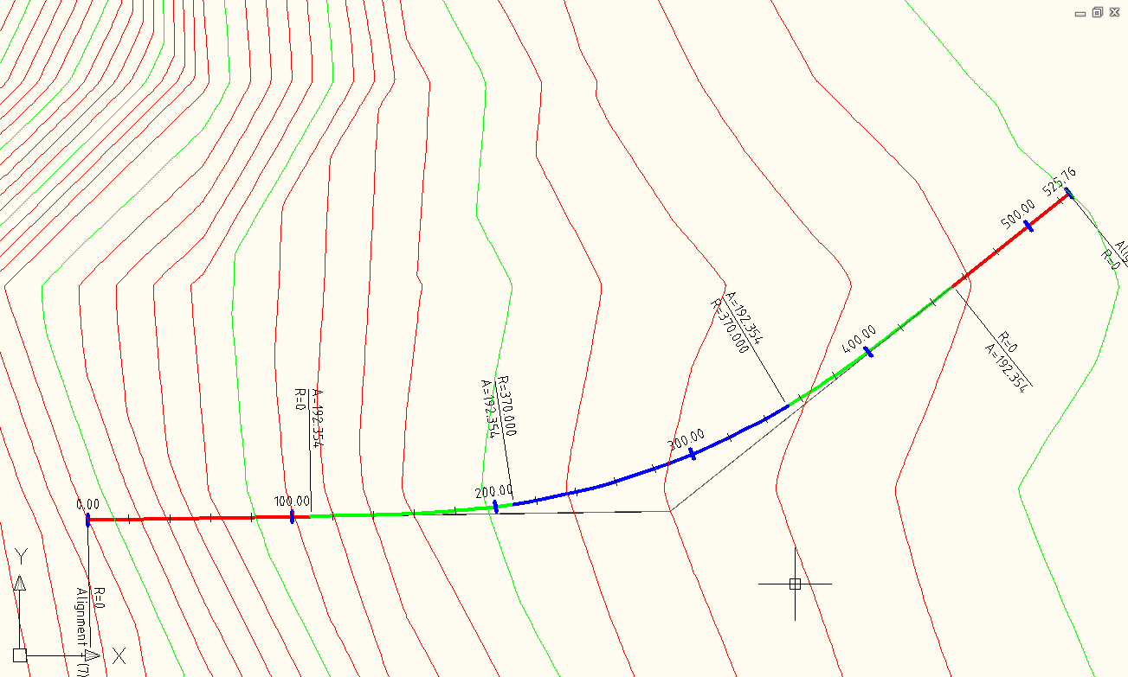
Major Station | Label at Major Stations
Basis
Jernbane
Slukket
Veje
Veje (simpel)
Minor Station | Label at Minor Stations
Basis
Jernbane
Veje
Veje (simpel)
Geometry Point | Label at Geometry Points
Basis
Jernbane
Veje
Veje (simpel)
Profile Geometry Point | Labels at the profile geometry points on the alignment
<None>
Station Equation | Station equation Labels
Konnektion Jernbane
Konnektion Veje
Design Speed | Design Speed labels
Jernbane
Veje
Superelevation Critical Points | Labels at the critical Superelevation points on the alignment
Skulder superelevation (model)
Superelevation (model)
Station Offset | Station Offset Labels
Sektion og sideafstand
Line | Tangent labels
Elementnummer
Curve | Arc Labels
Elementnummer
Spiral | Spiral Labels
Elementnummer
Tangent Intersection | PI Labels
Vinkelspot

Alignment Table Type/Name | Description | Screen grab / DWF / DWG | Default
Line
Linietabel
Curve
Kurvetabel
Spiral
Koltoidetabel
Segment | Line, curve or spiral element in a single table
Elementtabel

Profiles

Profile Style | Description | Screen grab / DWF / DWG | Default
Bund (sektion) | Purple (color 202) line for Datum Corridor Surface. | 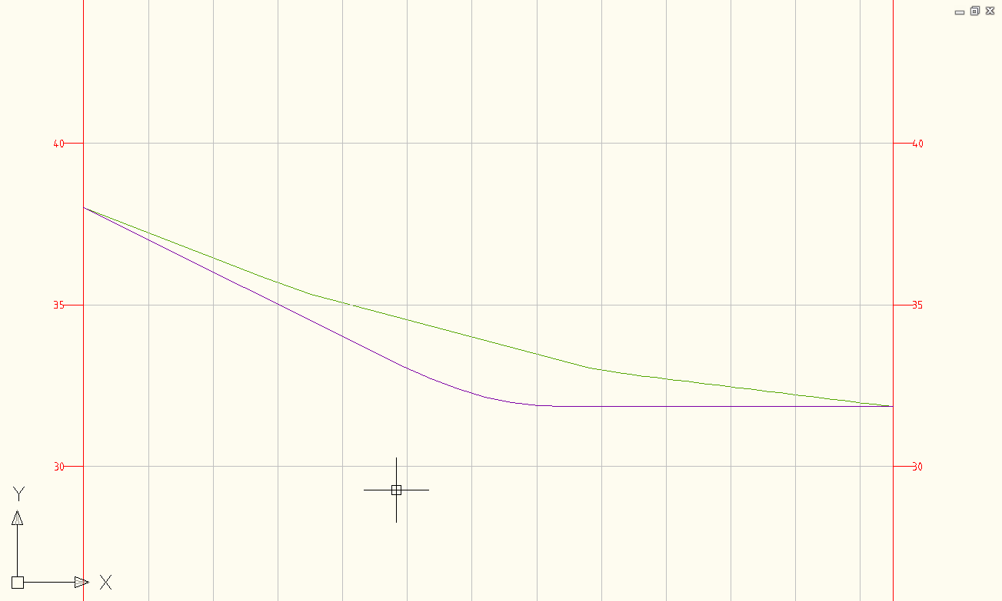
Top (sektion) | Light-blue (color 140) line for Top Corridor Surface. | 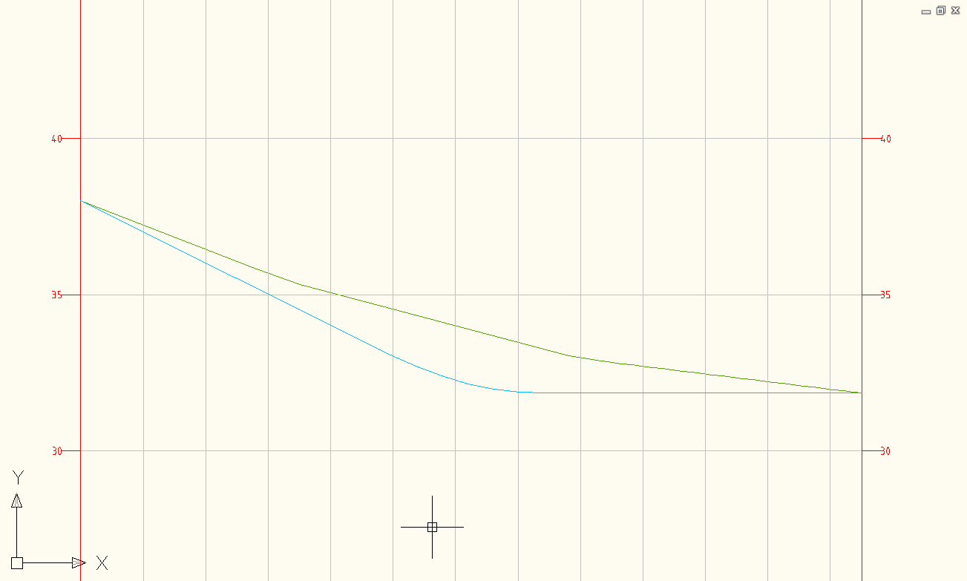
Råjord | Grey (color 9) line for soil. | 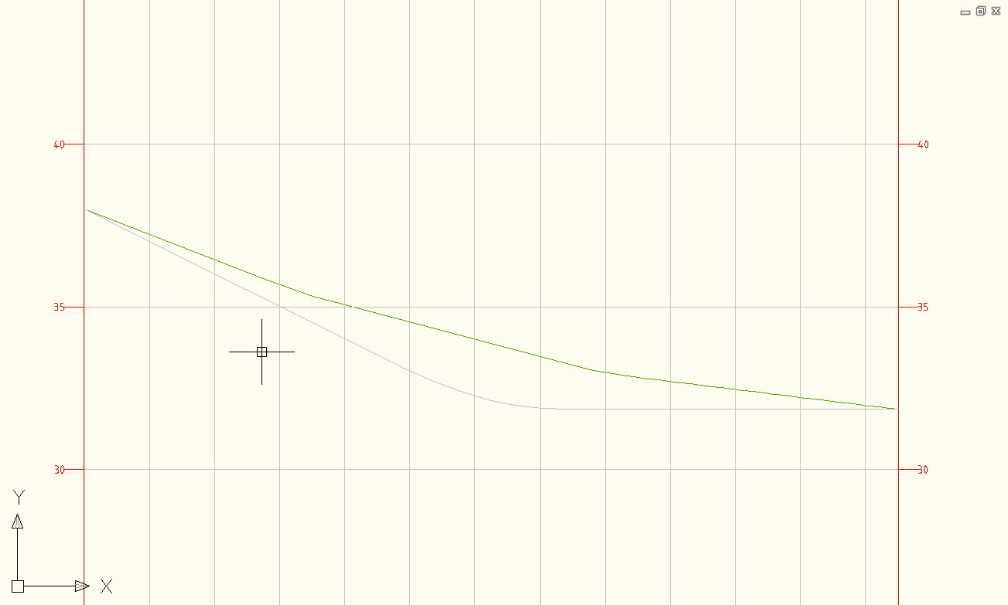
Terræn | Green (color 72) line for existing ground. | 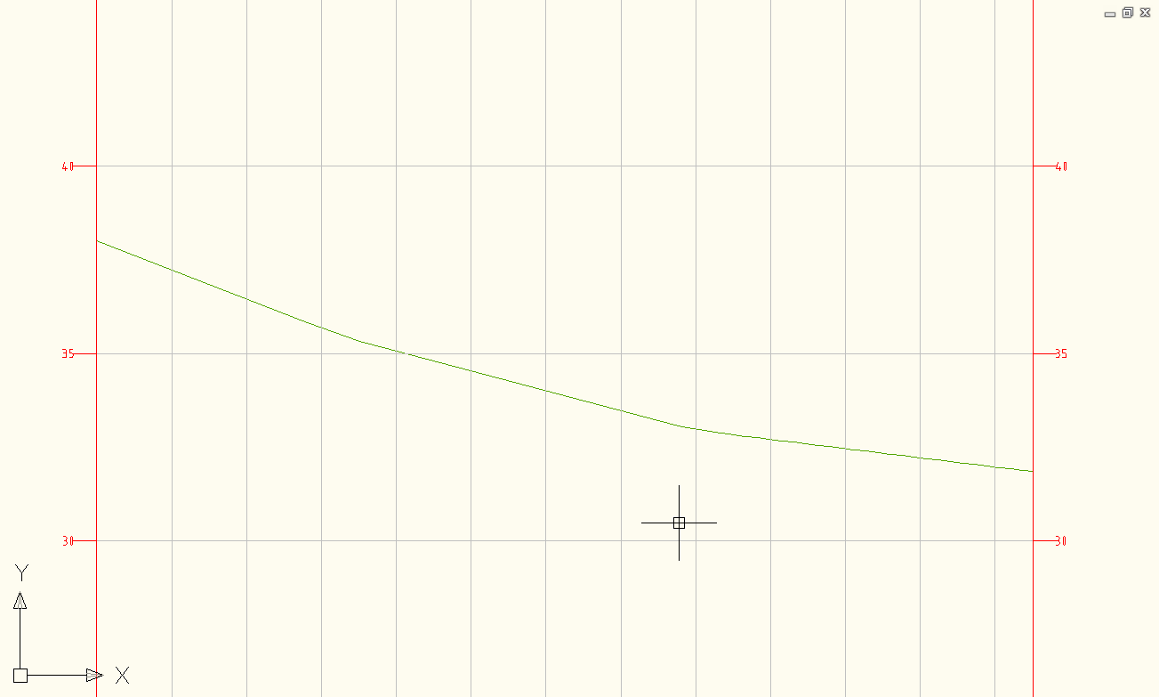
Vejprofil | Red color for tangents and blue colors for curves.  Linetype is Continous. | 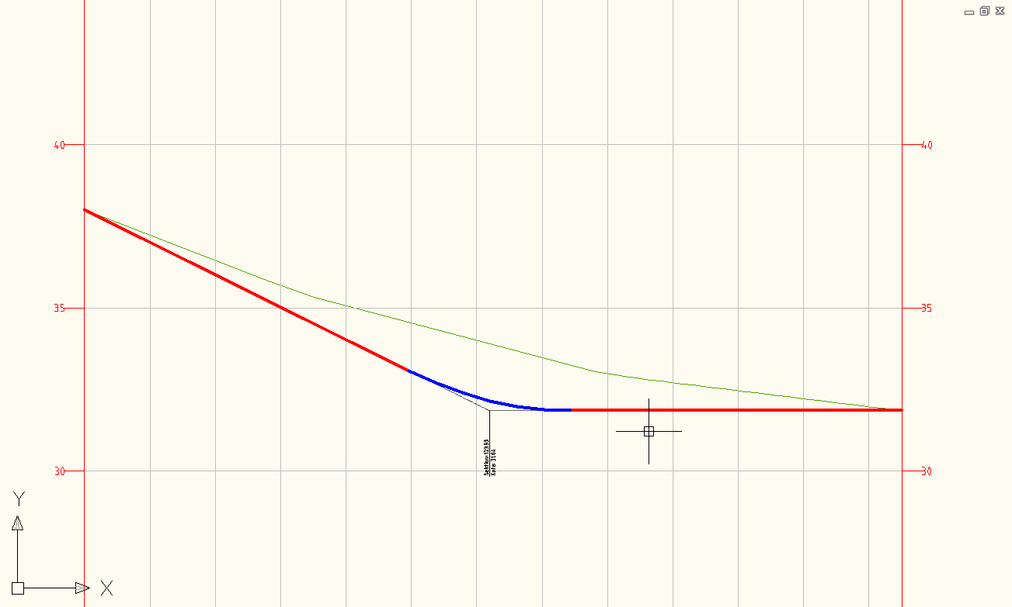
Vejprofil (simpel) | Green color for tangents and blue color for curves.  Linetype is Continous. | 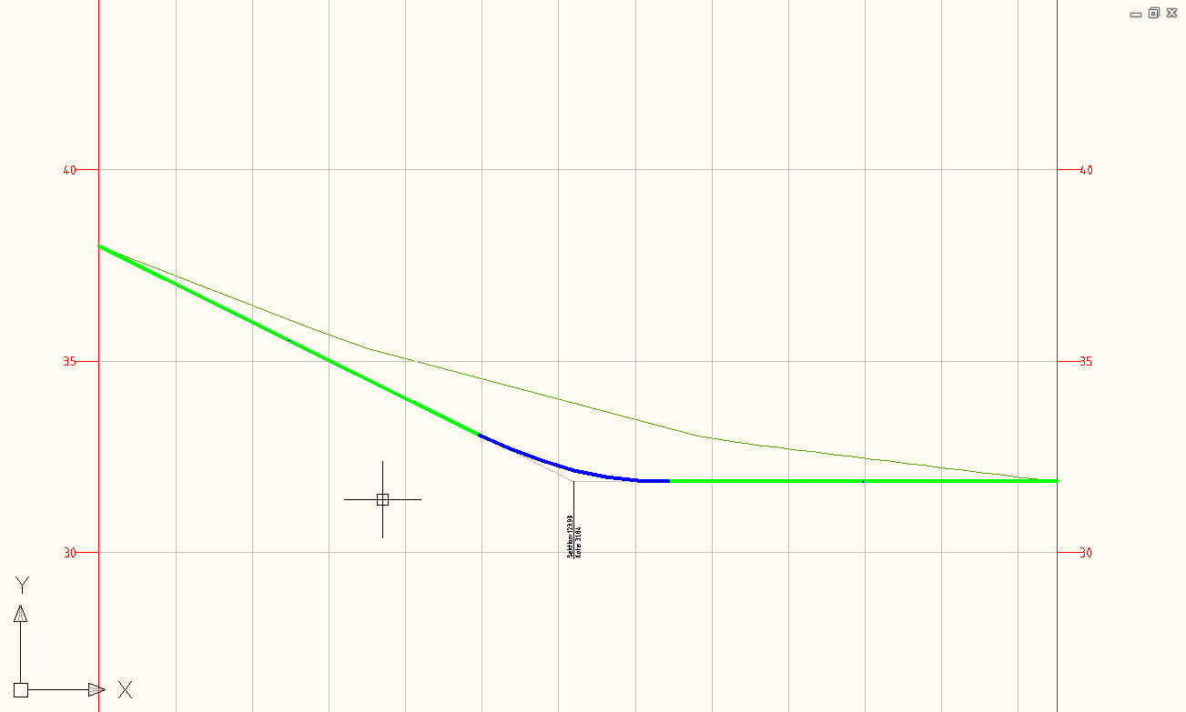

Profile Design Checks | Description | Screen grab / DWF / DWG | Default
Design Check Sets
<None>
Line
<None>
Curve
<None>

Profile Label Type/Name | Description | Screen grab / DWF / DWG | Default
Profile Label Sets
Vejprofil | Standard label for PVI. | 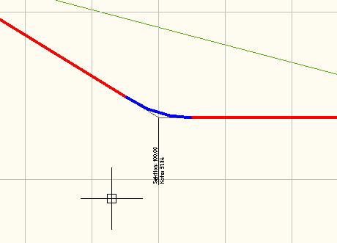
Major Station
Hovedsektion
Minor Station
Sektion
Horizontal Geometry Point
Sektion og type
Grade Breaks
Hældning og højde
Line | Tangent Labels
Tangent
Curve
Kurver  - Konkav  - Konvex | Standard label for Concave and Convex curves. | 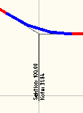
Data | Detail label for Concave and Convex curves. | 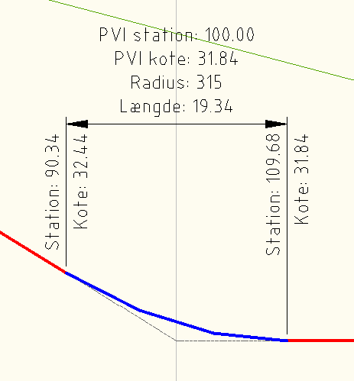

Profile View Type/Name | Description | Screen grab / DWF / DWG | Default
Vejprofil | Standard Profile with a 5m block above and below lowest and highest elevation for vertical profiles.  Grid is 5m for elevation and 20m for station.  Grid is 10x exaggerated. | 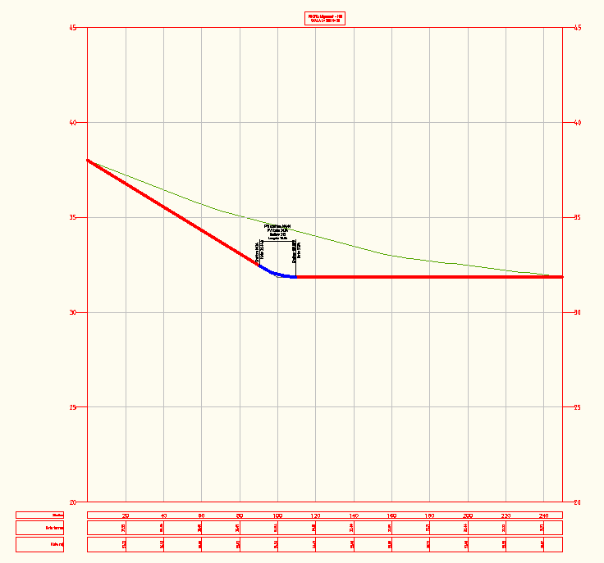 | Yes
Vejprofil (simpel) | Profile with a 1m grid for elevation and 20m for station.  Grid is 10x exaggerated. | 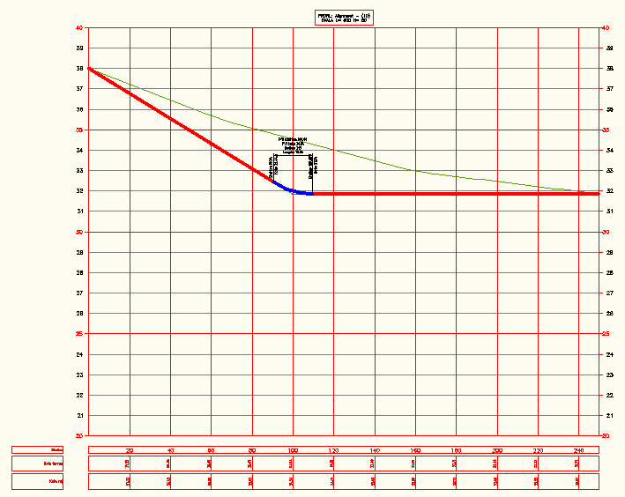
Vejprofil (uden overdrivelse) | Som vejprofil uden overdrivelse  Profile like Vejprofil but without exaggrerated. | 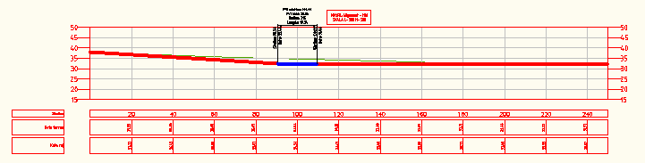

Profile View Label Type/Name | Description | Screen grab / DWF / DWG | Default
Station Elevation
Station og kote | Standard label for a selected point. | 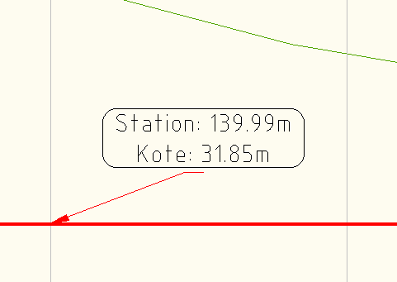
Depth
Hældning (promille) | Slope in per mille. | 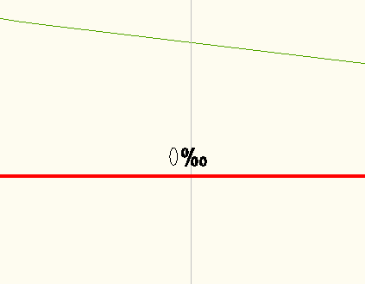

Profile Band Type/Name | Description | Screen grab / DWF / DWG | Default
Profile Band Set
Vejprofil | Bands for station, elevation (EG), elevation (Top Corridor model), vertical (Top Corridor model) and horizontal (Alignment) geometry. | 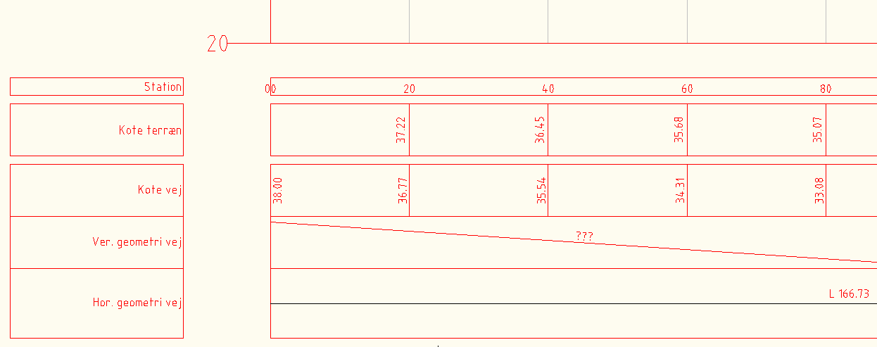
Vejprofil (simpel) | Bands for station, elevation (EG) and elevation (Top Corridor model). | 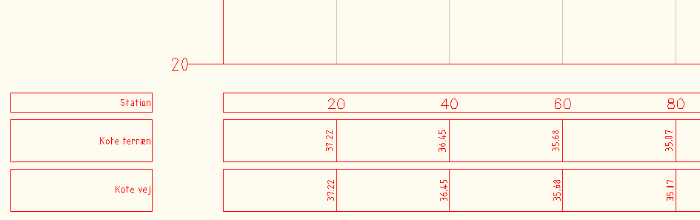 | Yes
Vej- og ledningsprofil | See Vej- og ledningsprofil (Spildevand) but with 3 sets of Structures and Pipes. | Se under Vej- og ledningsprofil (Spildevand)
Vej- og ledningsprofil (Fælles) | See under Vej- og ledningsprofil (Spildevand) | Se under Vej- og ledningsprofil (Spildevand)
Vej- og ledningsprofil (Regnvand) | Se under Vej- og ledningsprofil (Spildevand) | Se under Vej- og ledningsprofil (Spildevand)
Vej- og ledningsprofil (Spildevand) | Bands for station, elevation (EG), elevation (Top Corridor model), vertical (Top Corridor model) and horizontal (Alignment) geometry.  Additional data for Structures and Pipes. | 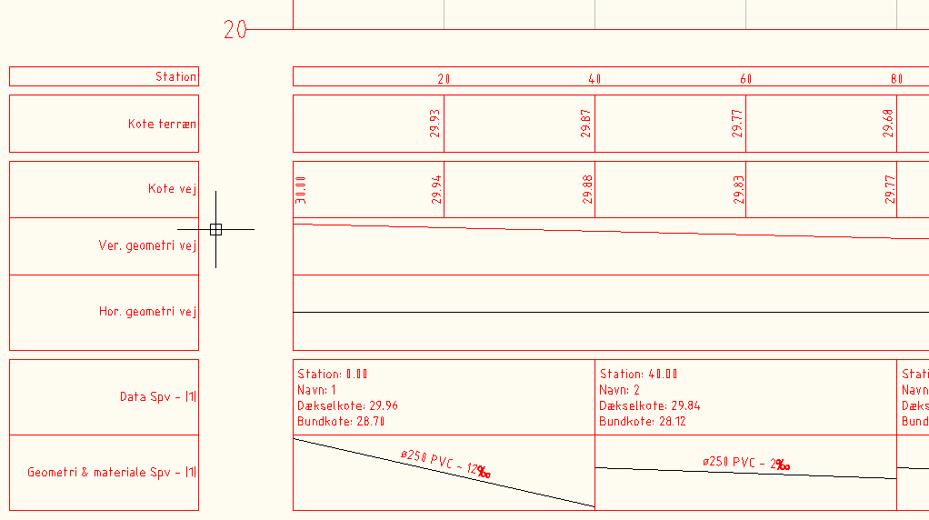
Profile Data
Jordart
Kote terræn
Kote vej
Kote vej simpel
Markslag
Station
Station simpel
Tangeringspunkt
Vertical Geometry
Geometri terræn
Hældning vej i procent
Profildata
Ver. Geometri vej
Horizontal Geometry
Hor. Geometri vej
Plandata
Superelevation Data
Tværfald
Sectional Data
<None>
Pipe Network
Fv. Geometri og materiale
Fv. Komp.data
Rgv. Geometri og materiale
Rgv. Komp.data
Spv. Geometri og materiale
Spv. Komp.data

Sections

Figur nedenfor viser standard udskrivning af tværsnit, der har baggrund i korridor model til en vej.

Sample Line Styles | Description | Screen grab / DWF / DWG | Default
Sektionsmarkering

Sample Line Label Styles | Description | Screen grab / DWF / DWG | Default
Sektionsnavn

Section Styles | Description | Screen grab / DWF / DWG | Default
Bund | Dark-purple (color 202) line.
Terræn | Dark-green (color 72) line.
Top | Light-blue (color 140) line.
Vejsektion | Red line.

Section Label Styles | Description | Screen grab / DWF / DWG | Default
Label Sets
Slukket
Major Offset
<None>
Minor Offset
<None>
Grade Break
<None>
Segment
<None>

Section View Styles | Description | Screen grab / DWF / DWG | Default
Tværprofil | Standard Section view without bands.  Structure and Pipes are colored by their Parts List. | 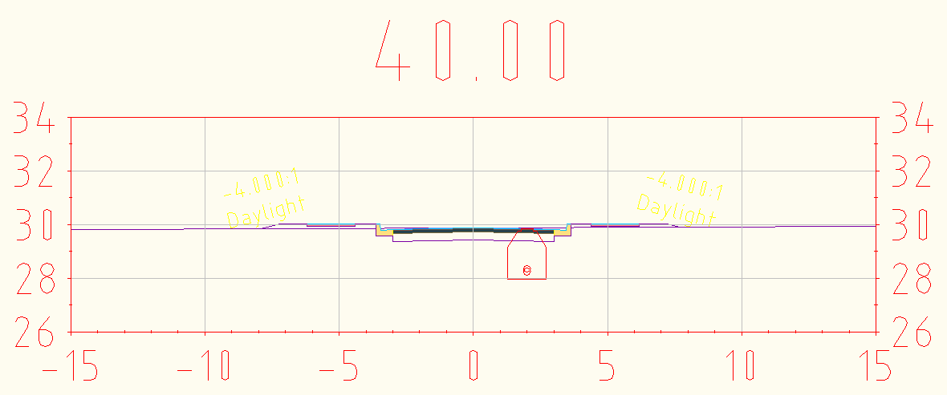 | Yes

Group Plot Styles | Description | Screen grab / DWF / DWG | Default
<None>

Sheet Styles | Description | Screen grab / DWF / DWG | Default
<None>

Label Styles | Description | Screen grab / DWF / DWG | Default
Offset Elevation
Offset over kote
Grade
Fald (mellem to punkter)

Section Band Styles | Description | Screen grab / DWF / DWG | Default
Band Sets
<None>
Section Data
<None>

Section Table Styles | Description | Screen grab / DWF / DWG | Default
Total Volume
<None>
Material
<None>

Pipe Networks

Parts Lists | Description | Screen grab / DWF / DWG | Default
Dræn | Material and dimension for Drain system. Only for Pipes.
Fælles | Material and dimension for Common system for Structure and Pipes.
Regnvand | Material and dimension for Rain water system for Structure and Pipes.
Spildevand | Material and dimension for Sewage water system for Structure and Pipes.

Interference Styles | Description | Screen grab / DWF / DWG | Default
<None>

Pipe Styles | Description | Screen grab / DWF / DWG | Default
Dræn | Pipes are green and linetype is ACAD_ISO02W100 and layer C-PIPE-DRN.
Fælles | Pipes are red and linetype is  DASHED and layer C-PIPE-FLS.
Regnvand | Pipes are blue and layer is C-PIPE-RGV
Spildevand | Pipes are red and layer is C-PIPE-SPV

Pipe Rule Set | Description | Screen grab / DWF / DWG | Default
Dræn |  | 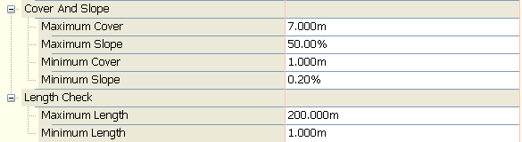
Fælles
Regnvand
Spildevand

Pipe Label Styles | Description | Screen grab / DWF / DWG | Default
Plan Profile
Dræn | Label dimension, material and grade in per mille with green color along pipes.
Fælles | Label dimension, material and grade in per mille with red color along pipes.
Regnvand | Label dimension, material and grade in per mille with blue color along pipes.
Spildevand | Label dimension, material and grade in per mille with red color along pipes.
Crossing Section
<None>

Pipe Table Styles | Description | Screen grab / DWF / DWG | Default
<None>

Structure Styles | Description | Screen grab / DWF / DWG | Default
Dræn | Structure are green colored.
Fælles | Structure are red colored.
Regnvand | Structure are blue colored.
Spildevand | Structure are red colored.

Structure Rule Styles | Description | Screen grab / DWF / DWG | Default
Regnvand |  | 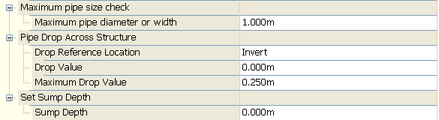
Spildevand |  | 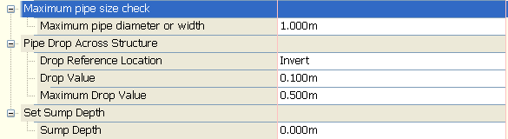

Structure Label Styles | Description | Screen grab / DWF / DWG | Default
Dræn | <None>
Child of Dræn | <None>
Fælles | Display number on right side of Structure with red color.
Child of Fælles | Display number, top and bottom elevation in a rounded box on right side of Structure with red color.  Label can be dragged.
Regnvand | Display number on right side of Structure with blue color.
Child of Regnvand | Display number, top and bottom elevation in a rounded box on right side of Structure with blue color.  Label can be dragged.
Spildevand | Display number on right side of Structure with red color.
Child of Spildevand | Display number, top and bottom elevation in a rounded box on right side of Structure with red color.  Label can be dragged.

Structure Table Styles | Description | Screen grab / DWF / DWG | Default
<None>

Corridors

Corridor Styles | Description | Screen grab / DWF / DWG | Default
<None>

Assembly Styles | Description | Screen grab / DWF / DWG | Default
Basis |  |  | Yes

Mass Haul Line Styles | Description | Screen grab / DWF / DWG | Default
<None>

Mass Haul View Styles | Description | Screen grab / DWF / DWG | Default
Masse | Standard ”Profile” for Mass Haul Diagram. | 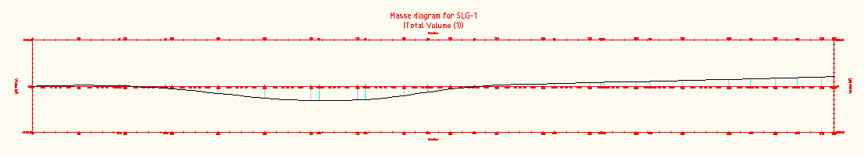 | Yes

Quantity Takeoff Criteria | Description | Screen grab / DWF / DWG | Default
4 lag |  | 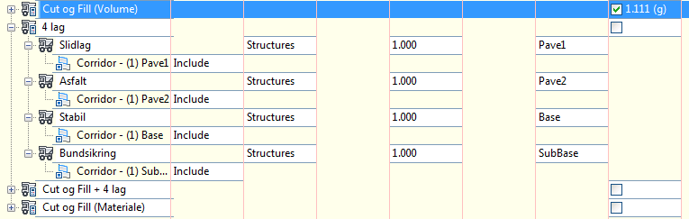
Cut og Fill (Materiale) |  | 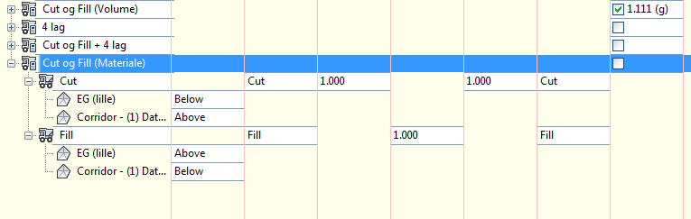
Cut og Fill (Volume) |  | 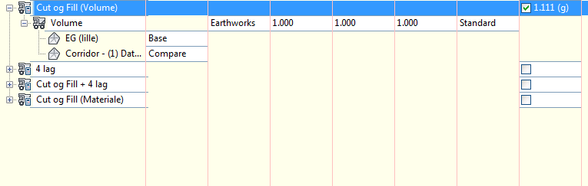
Cut og Fill + 4 lag |  | 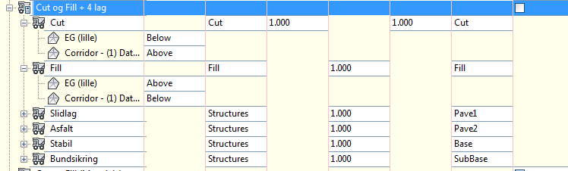

QTO Table Styles | Description | Screen grab / DWF / DWG | Default
Total Volume
Cut og Fill | Table with Cut and Fill volumes (per section). | 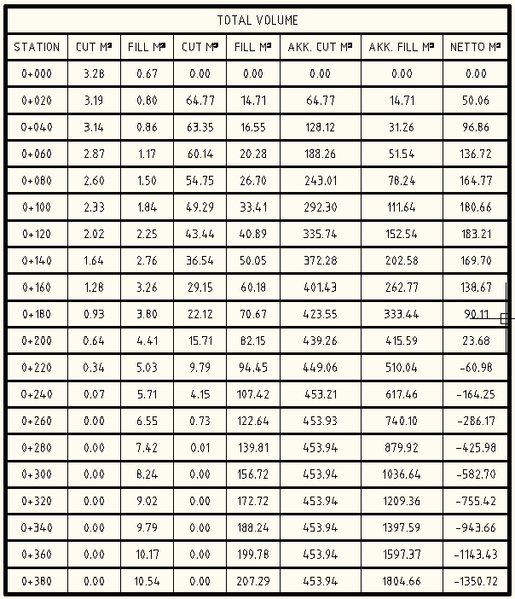
Material
Areal og volume | Area and total volume per section. | 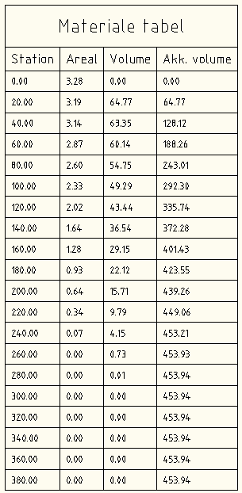
Asfalt | Pave 2 area and volume per section. | 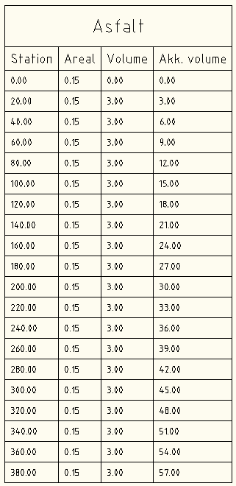
Bundsikring | SubBase area and volume per section. | 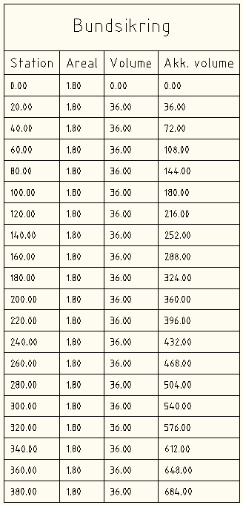
Cut | Cut area and volume per section. | 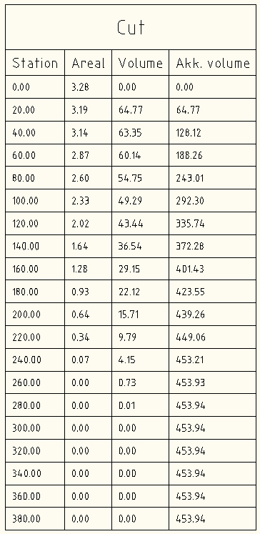
Fill | Fill area and volume per section. | 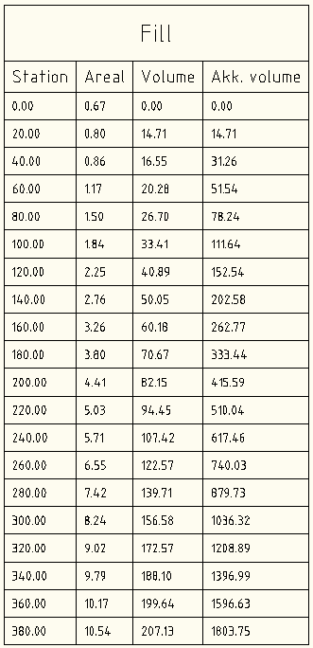
Slidlag | Pave 1 area and volume per section. | 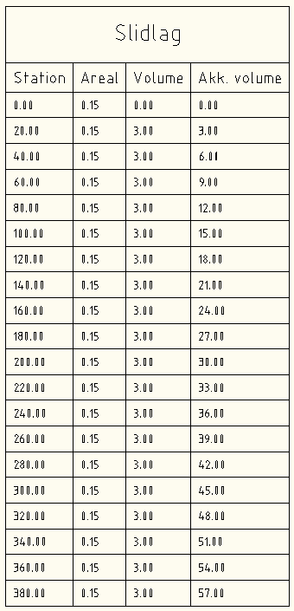
Stabil | Base area and volume per section. | 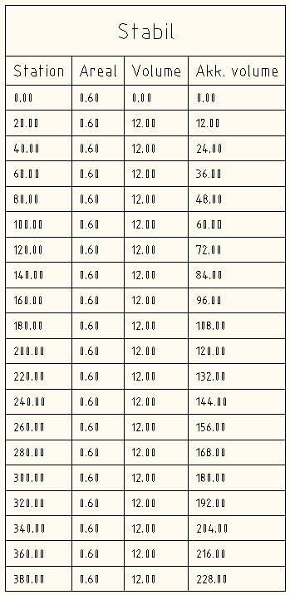

Plan and Profile Sheets

View Frame Styles | Description | Screen grab / DWF / DWG | Default
<None>

View Frame Label Styles | Description | Screen grab / DWF / DWG | Default
<None>

Match Line Styles | Description | Screen grab / DWF / DWG | Default
<None>

Match Line Label Styles | Description | Screen grab / DWF / DWG | Default
Match Line Left
<None>
Match Line Right
<None>

Survey

Network Styles | Description | Screen grab / DWF / DWG | Default
<None>

Figure Styles | Description | Screen grab / DWF / DWG | Default
<None>

Tool palette(s)

Assemblies

Subassemblies
<None>

Assemblies
Figur nedenfor viser liste med tegninger med dansk standard tværprofiler, som kan anvendes i forbindelse med automatisk opret af kryds.

Figure below lists CKD drawings with assemblies for automatically creation of intersections.

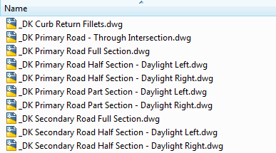

Material styles

<None>

Drawing symbols and (MV) Blocks

<None>

Pipe and Structure Catalog
The CKD contains 4 Parts Lists for designing Pipes and Structures. It is Spildevand (Waste), Regnvand (Rain), Fælles (Common) and Dræn (Drain). See the figure below.

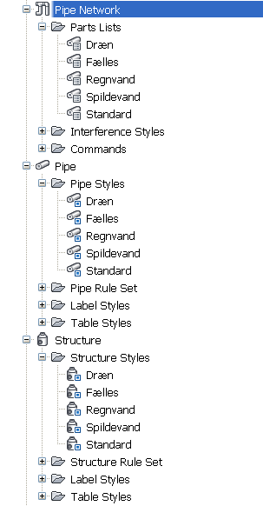

Hver Parts Lists er oprettet egne Civil 3D styles, som styrer udseende og farver. Lag ved start af netværk og dermed også Parts List (system) er 0. Der findes lag til de enkelte Parts Lists. Tabel nedenfor viser dette.
Each Parts Lists is created with thier own Civil 3D object style who manage appearance and color. Layers are 0 when start up a new Pipe Networks and therefore choosing Parts Lists. The template contains pre-defined layers that can be used. See the figure below.
Parts Liste | Color | AutoCAD Layer
Spildevand | Rød | C-PIPE-SPV
Regnvand | Blå | C-PIPE-RGV
Fælles | Rød | C-PIPE-FLS
Dræn | Grøn | C-PIPE-DRN
Standard | Sort/hvid | 0

Section below describe each Parts Lists listed in the table above.

Spildevand

Figure below lists material and dimension for Pipes.
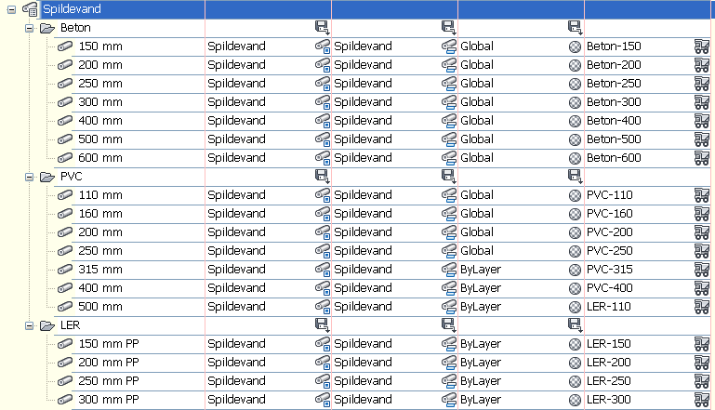

Figure below lists type and dimension for Structures.

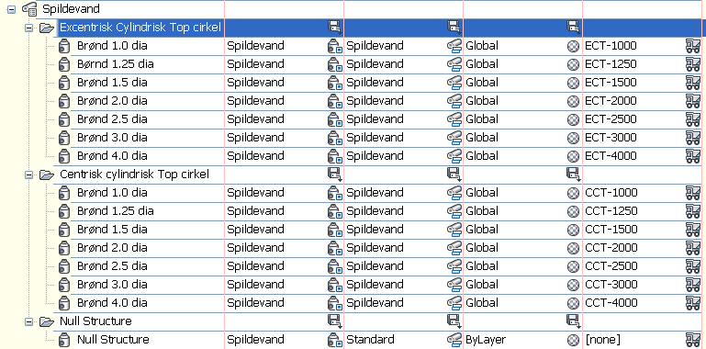

Regnvand

Figure below lists material and dimension for Pipes.

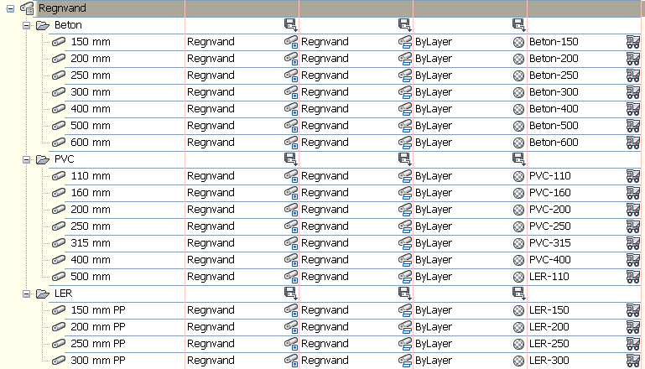

Figure below lists type and dimension for Structures.

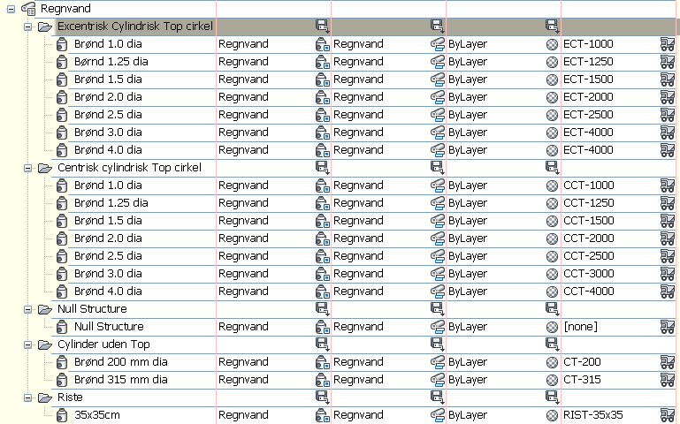

Fælles

Figure below lists material and dimension for Pipes.

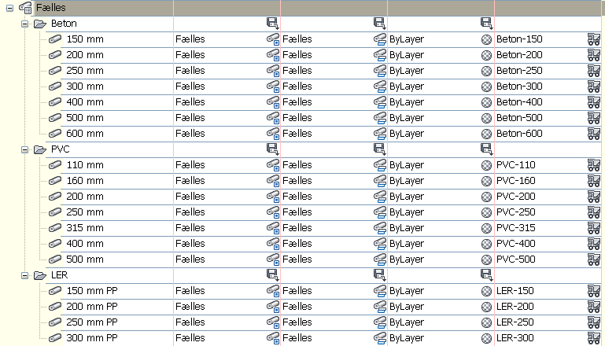

Figure below lists type and dimension for Structures.

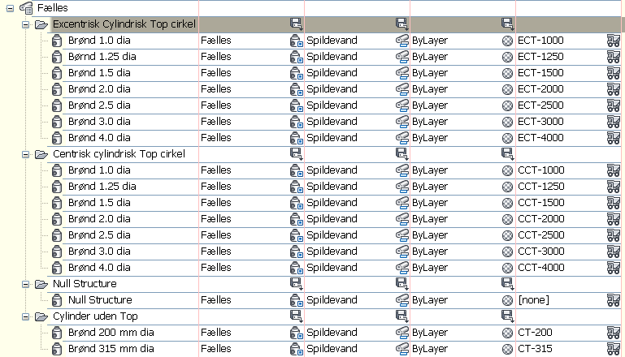

Dræn

Figure below lists material and dimension for Pipes.

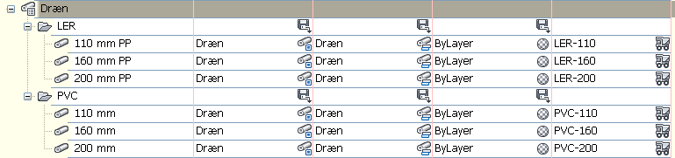

Figure below lists type and dimension for Structures.

Labels

Each Parts Lists contains label (Structures and Pipes) that can be dragged for plot purpose. Fiugre below is an example in Plan view.

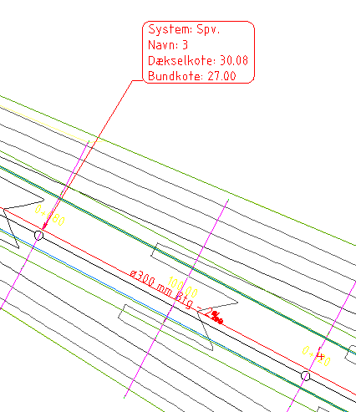

The dragged labels for plot purpose can also be used in Model, Profile and Section view.

Tables

Figure below is a table containing Pipes data for a Pipe Network.

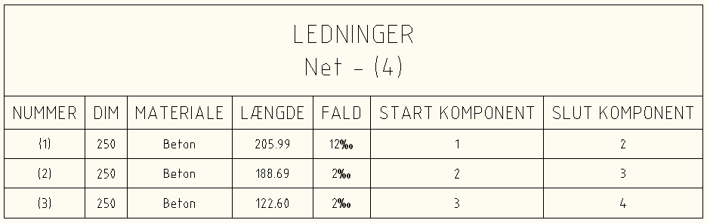

Figure below is a table containing Structure data for a Pipe Network.

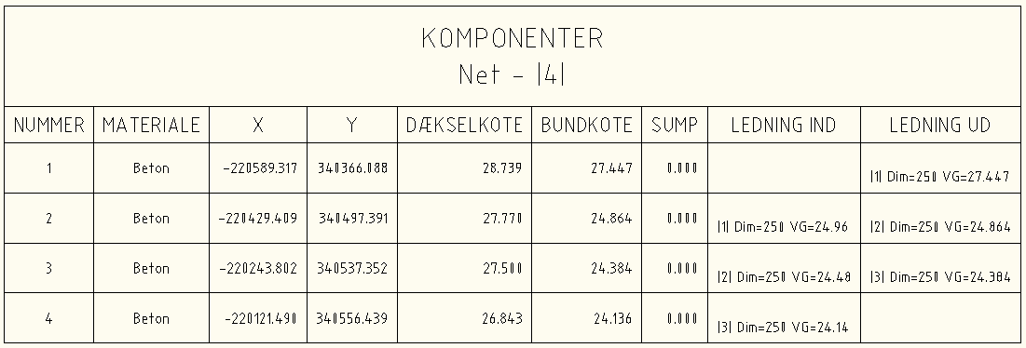

For both table counts that they are dynamic and will be updated when the Corridor model is adjusted.

Highway design check files
Design Criteria is used for alignments and profiles used in corridor models for road design. The design will therefore follow the local standard for road design.

If violate the design criteria Civil 3D gives you a warning in the drawing for curves that are violated. The figure below is an example of violating the design criteria.

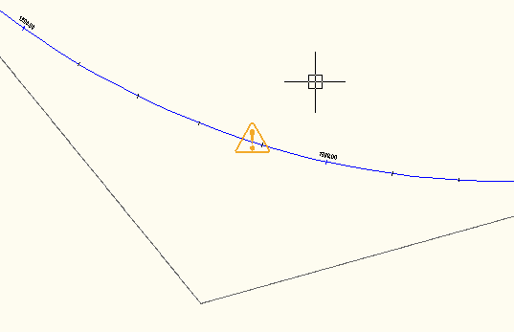

Design Criteria is also used for calculating super elevation for spirals and curve in road design. Figure below is an example for automatic calculation of super elevation in a right curve.

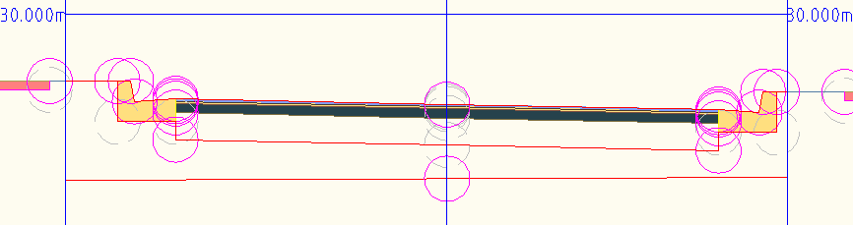

CKD design criteria are saved in <_DK Civil 3D Metric Roadway Design Standards.xml>. Figure below show CKD design criteria.

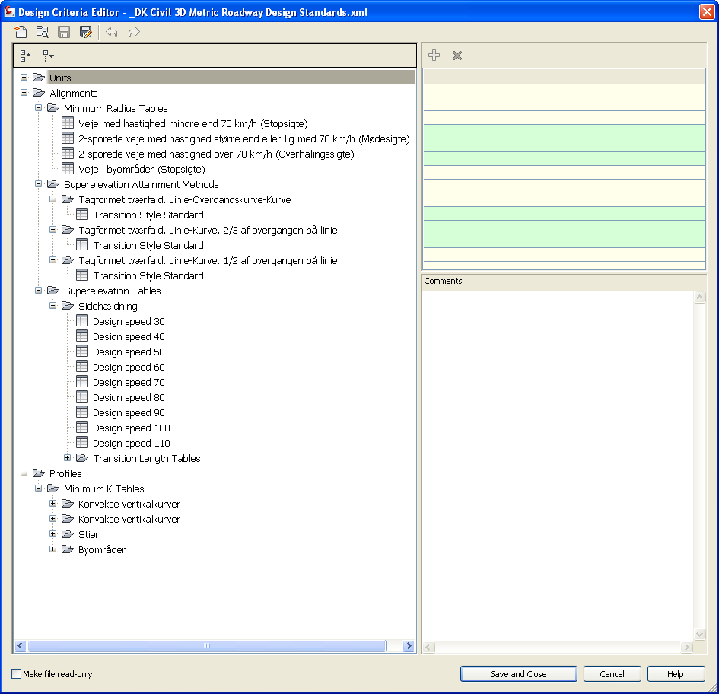

Figure below shows where Civil 3D internal editor can be found.

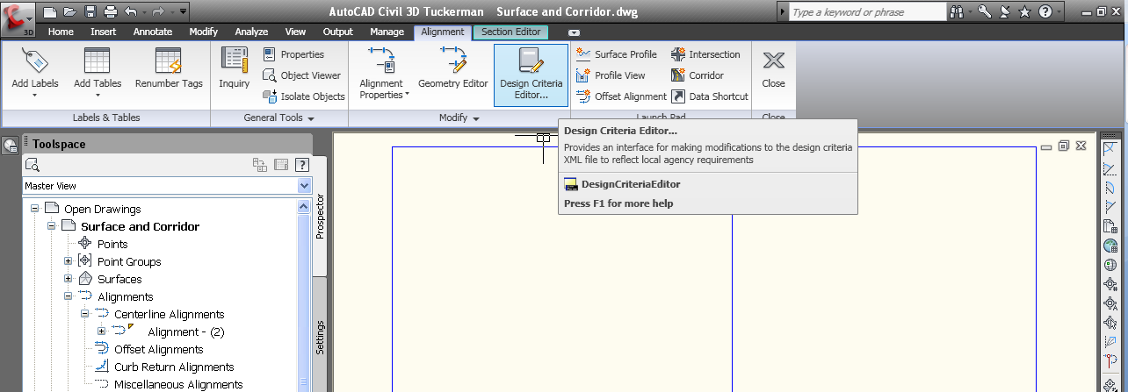

Quantity Take Off

Introduction of QTO

In Civil 3D it is possible til create a link between an Pay Item list and Civil 3D objects as well as AutoCAD objects. The link is on 2 levels:

- Settings in the template. Corridor (Subassemblies), Pipes and Structures are automatically linked to the Pay Item list.
- Select objects. Select polygon, polylines, lines or Feature Lines by manual select in the Pay item list.

If objects in the Civil 3D drawing are linked to the pay Item list, then it is possible to run a report that prints areas and length for objects, that are linked.

Figure below shows a report with summary of Pay Items.
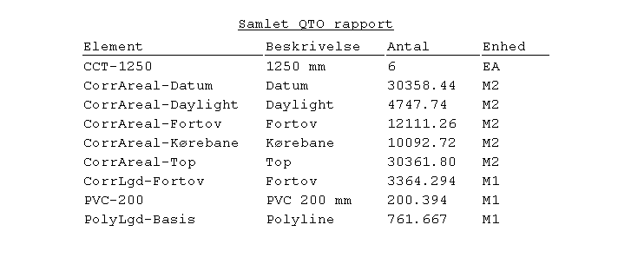
It is possible to summary different types based on count, area or length. Fx was found 761.667m polyline(s) in the Civil 3D drawing that is not a Corridor Subassembly or Pipe or Structure.

The Pay Item can contain a formula that fx can multiply the summary with a price. This can be a very easy way to calculate prices on fx curbs.

Information from QTO can be shown in reports (CSV, HTML or TXT) or be exported to use in third part calc. application.

QTO Settings

Pay Items List
<Pay Item Data\Denmark\_DK standard.csv> is the Pay Item list.

This is an CSV file that can be edited with Microsoft Excel or Notepad. The CSV file contains Pay Items that can be linked directly to Civil 3D objects or common AutoCAD objects for counting in meters and areas.

Pay Items Index
<..\Pay Item Data\Denmark\_DK standard.xml> contains Setting of the Pay Item list. Fx. Is it possible to group by by:

- Pipes
- Structures
- Corridor Subassemblies
- Uncategorized

The file can be edited with Notepad.

Enheder - Units Mapping Fil
<Pay Item Data\Units\QTOUnits.xml> contains the ”units” definition for the Pay Item list in general.

Unit | Description
EA | Each (count)
M1 | Meter (length)
M2 | Kvadrat meter (area)
M3 | Kubik meter (volume)

Reports
QTO reports to an HTML style sheets (.XSL) files with the QTO counting from the current drawing. After this is it possible to change format to CSV, HTML or TXT format.

CKD style sheets are saved in the folder <Takeoff Report Style Sheets> under %DataDir% folder.

Superelevation
Design Criteria, se chapter 10, is also used for automatic calculation of super elevation for curve with or without spirals. The design criteria are stored in <_DK Civil 3D Metric Roadway Design Standards.xml>.

Figure below show settings for calculation of super elevation in curves and spirals.

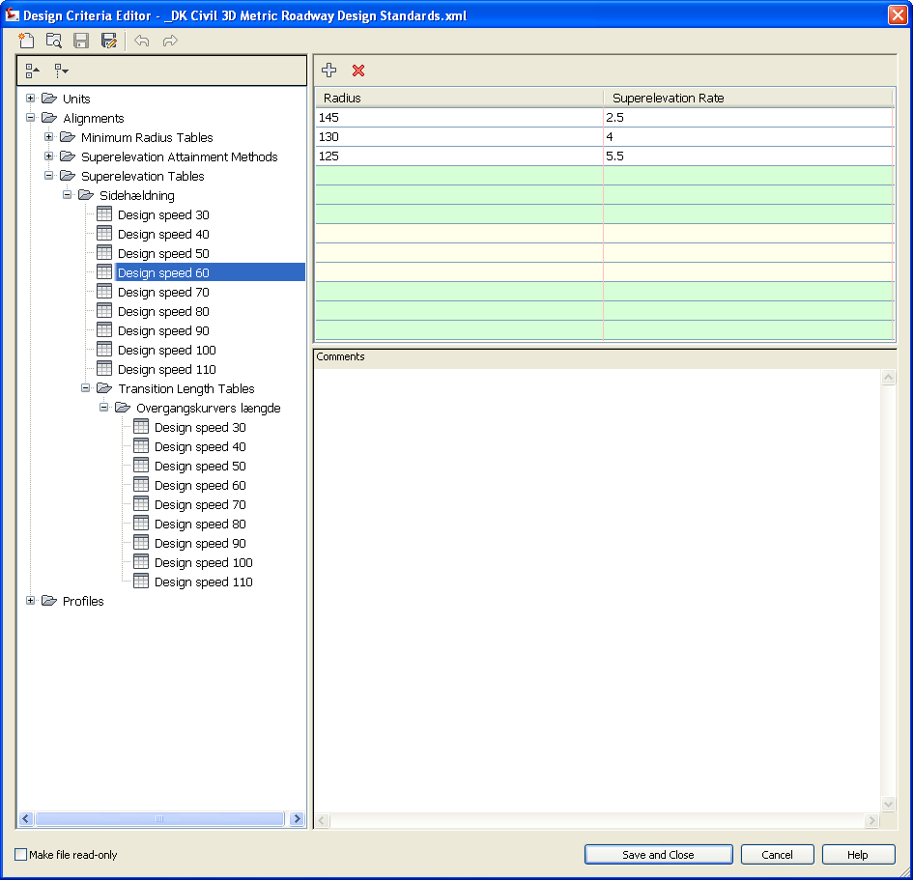

Figure below is an example for automatic calculation of super elevation in a right curve.

Intersections
Table below lists settings for automatically creation of intersections.

General type | Name | Value | Comments
Default Styles
 | Intersection Style | Basis
 | Intersection Label Style | Basis
 | Offset Alignment Style | Veje parallelt | Som Veje, men linetype er HIDDEN
 | Curb Return Alignment Style | Veje parallelt | Som Veje, men linetype er HIDDEN
 | Offset Profile Style | Vejprofil
 | Curb Return Profile Style | Vejprofil
 | Offset Alignment Label Set | Basis
 | Curb Return Alignment Label Set | Basis
Default Name Format
 | Intersection Name Format | Kryds - (<[Next Counter(CP)]>)
 | Intersection Quadrant Name Format | <[Quadrant Location]> - Quadrant
 | Offset Alignment Name Format | <[Parent Alignment Name(CP)]>-<[Side]>-<[Offset Value(Um|P3|RN|Sn|OF|AP)]>
 | Curb Return Alignment Name Format | <[Intersection Name(CP)]> - <[Intersection Quadrant Name(CP)]>
 | Offset Profile Name Format | <[Parent Alignment Name(CP)]> - <[Side]> - <[Cross Slope Value(FRise|P2|RN|Sn|OF|AP)]>
 | Curb Return Profile Name Format | <[Alignment Name(CP)]> - Profile
 | Corridor Region Name Format | RG - <[Assembly Name(CP)]> - (<[Next Counter(CP)]>)

<_Autodesk (Metric) Assembly Sets DK.xml> is the setting file that contains links to drawings with Danish Assemblies. Section 9.1 contains the Danish Subassemblies used for create an Civil 3D intersection.

It is possible to select between different Settings (Assemblies) in the Wizard window used for creating Intersection.

