AutoCAD® Civil 3D® 2010
“Country Kit”
Workbook
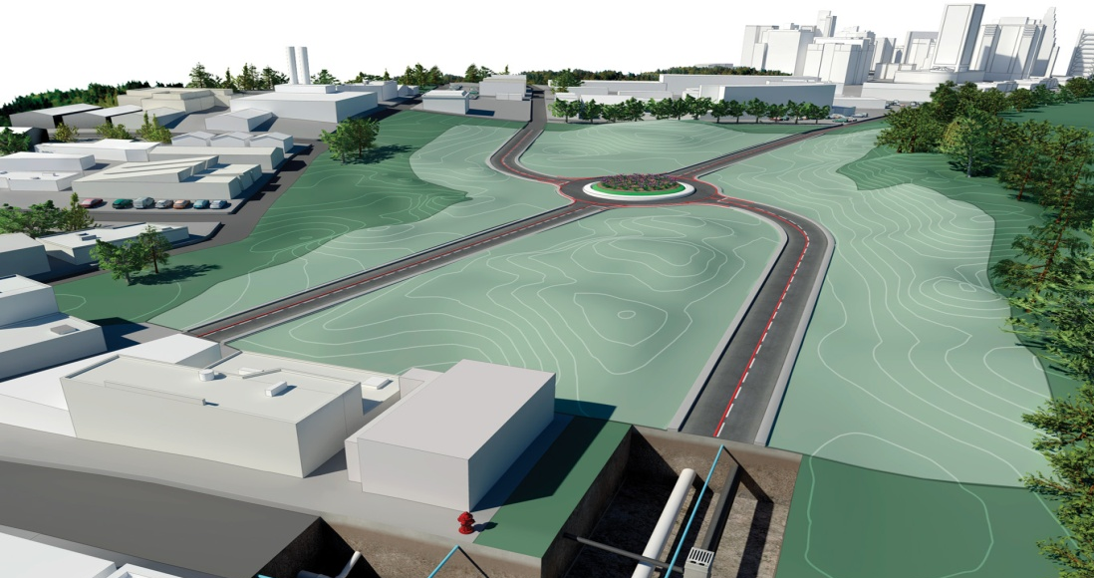
Purpose of this document:
This document provides guidelines for development and documentation of Civil 3D Country kits

Revision History | Status

Country Kit Workbook

1 Overview 3
1.1 Introduction 3
1.2 Content Development Precaution 3
2 Fonts and Text Styles 4
3 Hatch Patterns 5
4 Layers 6
5 Reports 7
6 Drawing Settings > Object Layers 8
6.1 Object Layers 9
6.2 Ambient Settings 10
7 Object Styles 11
7.1 Multi-purpose Styles 11
7.2 Points 12
7.3 Surfaces 13
7.4 Parcels 13
7.5 Grading 14
7.6 Alignments 14
7.7 Profiles 16
7.8 Sections 18
7.9 Pipe Networks 19
7.10 Corridors 21
7.11 Plan and Profile Sheets 21
7.12 Survey 22
7.13 General - Multipurpose Styles – Shape Styles 22
8 Object Defaults 24
9 Tool palette(s) 25
9.1 Subassemblies and assemblies 25
9.2 Material styles 25
9.3 Drawing symbols and (MV)Blocks 25
10 Pipe and Structure Catalogs 26
11 Highway design check files 27
12 Quantity Take Off 28
12.1 Overview of QTO 28
12.2 Creation of QTO 28
12.3 Installation of QTO 29
13 Superelevation standards 30
14 Intersection feature – Styles, Names and Assembly sets 31
15 Installation 33

Overview

Introduction

This document is intended to provide a comprehensive guide to building and installing a country kit on AutoCAD Civil 3D 2010 and AutoCAD Civil 2010. It also serves as the building block from which the user country kit help document should be created.
It provides a skeleton overview of everything that can be provided to make Civil 3D appear as a local product and a detailed view of new functionality in the latest release of Civil 3D. This somewhat assumes that a country kit of sorts already exists for the previous version, but if it doesn’t exist for your local language then it is recommended to select the country kit deemed closest to your requirements from www.autodesk.com/civil3d-countrykits and proceed from there as your starting point.
This document should be provided in both English and your local language (where appropriate). Screen grabs are only required in local language, but descriptions of screen grabs should be provided in both English and local language.
Where a section is not provided for in your template(s) or kit, please do not delete the section or leave blank, but write “Not provided” to ensure that Autodesk know the section has been considered.

Content Development Precaution
It is important that you add, incrementally to existing country kits, various styles as noted in this document – using Civil 3D 2009 templates that have been converted to Civil 3D 2010 as a baseline. Key things to note in developing these are:
- Autodesk require that all styles are stamped with the creator name as Autodesk. To automate this, set your system log-in name as “Autodesk” so that Created By and Modified By are not stamped with other user names
- Make sure AutoCAD Architecture is not loaded, so that unnecessary dbx modules are not stamped in. Each time – make sure that you save and exit current acad.exe session and reopen the dwt in new session to verify AutoCAD Architecture dbx modules are not loaded. It is good practice to save back multiple versions of your temlate so that we can go back to the previous good one. Autodesk will use Buzzsaw features to help automate this for you at Autodesk provided workshops.
- Please set PLINEGEN variable to 1.

Fonts and Text Styles
List any additional fonts and text styles created and/or delivered with the country kit. Screen grabs are strongly recommended to illustrate usage.
You must ensure and guarantee you can deliver the intellectual property rights, to Autodesk, of any fonts you are proposing to distribute.
Text Style | Description | Font | Plotted Size

Hatch Patterns
List any additional hatch patterns and styles created and/or delivered with the country kit. Screen grabs are strongly recommended to illustrate usage.
Hatch Pattern Name | Description | Hatch Pattern File

Layers
List any layer names created in the country kit template(s) you provide.
Screen grabs are strongly recommended to illustrate usage.

Layer Name | Description | Color | Linetype | Style(s) using this layer (this column is not optional here (see section 6))

Reports
List any reports you are either requesting creation of or you are creating in the country kit. You should provide sample output along with description of header fields in both English and your local language (where appropriate)

Report Name | Description | Sample File Name | Priority

Drawing Settings > Object Layers

Object | Default Layer
Alignment | C3D-TRAC
Alignment-Labeling | C3D-TRAC-ETICH
Alignment Table
Assembly | C3D-ASSIEME-SEZ-TIPO
Corridor | C3D-MODEL
Corridor Section
Feature Line | C3D-TOPO
General Note Label
General Segment Label
Grading | C3D-SCARP
Grading-Labeling | C3D-SCARP -ETICH
Grid Surface
Grid Surface-Labeling
Interference | C3D-RETE-BLOCO INTERF
Mass Haul Line | C3D-TRAC-MOVOMTERRA
Mass Haul View | C3D-TRAC-MOVOMTERRA-VISTA
Match Line | C3D-RIQUADRO
Match Line-Labeling | C3D-RIQUADRO-LINEE_PASSAGGIO
Material Section
Material Table
Parcel | C3D-PROP
Parcel-Labeling | C3D-PROP-ETICH
Parcel Segment | C3D-PROP-LINEE
Parcel Segment-Labeling | C3D-PROP-LINEE-ETICH
Parcel Table | C3D-PROP-TAB
Pipe | C3D-RETE-CONDOTTA
Pipe-Labeling | C3D-RETE-CONDOTTA-ETICH
Pipe and Structure Table | C3D-SEZ-TAB
Pipe Network Section
Pipe or Structure Profile
Point Table | C3D-PUNTI-TAB
Profile | C3D-PROF
Profile-Labeling | C3D-PROF-ETICH
Profile View | C3D-PROF-TAB
Profile View-Labeling | C3D-PROF-ETICH
Sample Line | C3D-SEZ
Sample Line-Labeling | C3D-SEZ
Section | C3D-SEZ-TERR
Section-Labeling | C3D-SEZ-ETICH
Section View | C3D-SEZ-TAB
Section View-Labeling | C3D-SEZ-ETICH
Section View Quantity Takeoff Table | C3D-SEZ-TAB
Sheet
Structure | C3D-RETE-POZZETTO
Structure-Labeling | C3D-RETE-SEZ
Subassembly
Surface Legend Table
Survey Figure | C3D-RILIEVO-FIGURA
Survey Network | C3D-RILIEVO-PUNTI CONTROLLI NODI
Tin Surface | C3D-TOPO-BORDI
Tin Surface-Labeling | C3D-TOPO-ETICH
View Frame | C3D-BORDO-RIQUADRO
View Frame-Labeling | C3D-RIQUADRO-ETICHETTA

Object Layers
The following table lists all new object types added to the object layers tab in Tuckerman and their content for “out of the box” templates.
Object | Layer | Modifier | Value
Building Site | C3D-EDIF
Intersection | C3D-TRAC-INCRO
Intersection-Labeling | C3D-TRAC-INCRO-ETICH
Grading-Labeling
Parcel-Labeling
Parcel Segment-Labeling

The following table lists existing object types on the object layers tab that should have their content for “out of the box” templates updated for Tuckerman.
Object | Layer | Modifier | Value
Pipe | C3D-RETE-CONDOTTA
Pipe Network Section

Ambient Settings
The following are the new drawing level ambient settings introduced in Tuckerman.
Node | Setting | Default
General | Driving Direction | Right Side of the Road (Commonwealth country kits should change this to “Left Side of the Road”)

Object Styles
List all object styles you include in the country kit template(s) you are providing. You should provide a screen grab (in local language) (and optionally a drawing file) along with description and usage of the style in both English and your local language.
You must also indicate the name of the template file(s) that the style is saved in.

Multi-purpose Styles
<Template file name, start a new table for each template file>
Feature Line Styles | Description | Screen grab / DWF / DWG | Default
 |  | 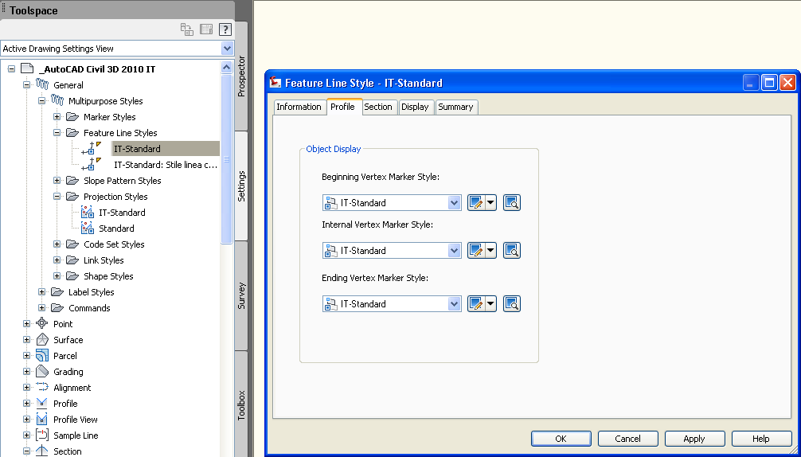

Code Set Styles | Description | Screen grab / DWF / DWG | Default

Marker Styles | Description | Screen grab / DWF / DWG | Default
 |  | 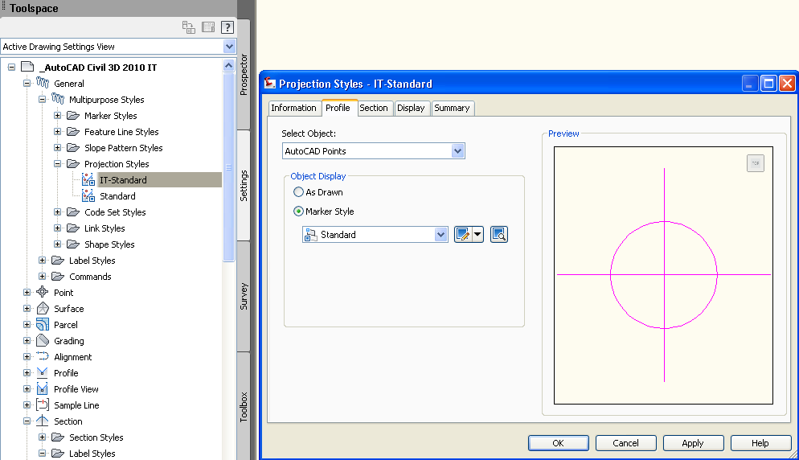

Link Styles | Description | Screen grab / DWF / DWG | Default

Shape Styles | Description | Screen grab / DWF / DWG | Default

Slope Pattern Style | Description | Screen grab / DWF / DWG | Default
IT-standard | C3D-SCARP-BARBETTE | 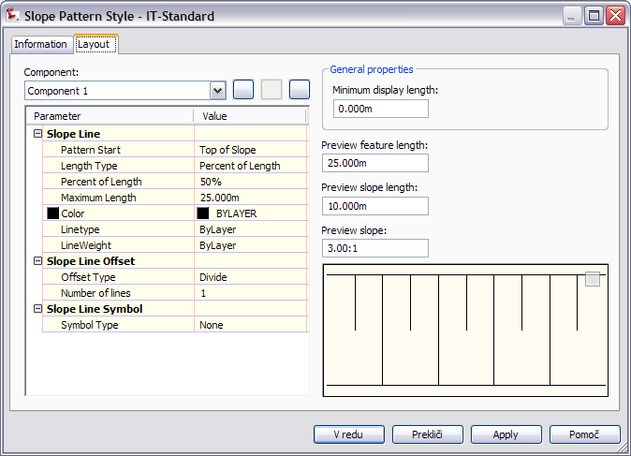

Multipurpose Label Styles | Description | Screen grab / DWF / DWG | Default
Note
Line
Curve
Marker
Link
Shape

Points
<Template file name, start a new table for each template file>
User Defined Attribute Classifications | Description | Screen grab / DWF / DWG | Default
Inclassified

Point Styles | Description | Screen grab / DWF / DWG | Default
IT-Standard | Stile Metrico | 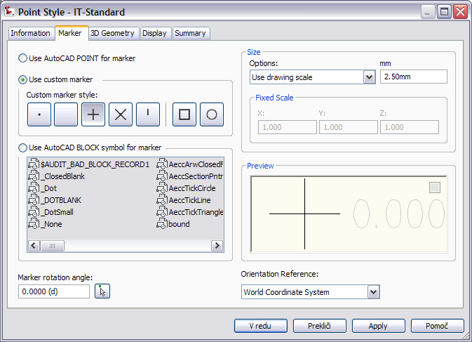
IT-Standard 2 | Stile Standard Metrico generico | 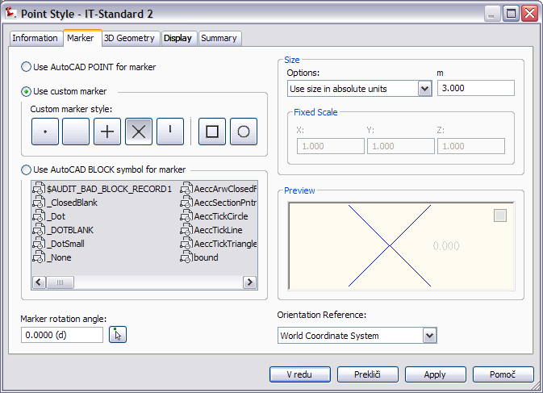
Topographic points:
Albero - 6mt | Stile per albero di 6 mt. | 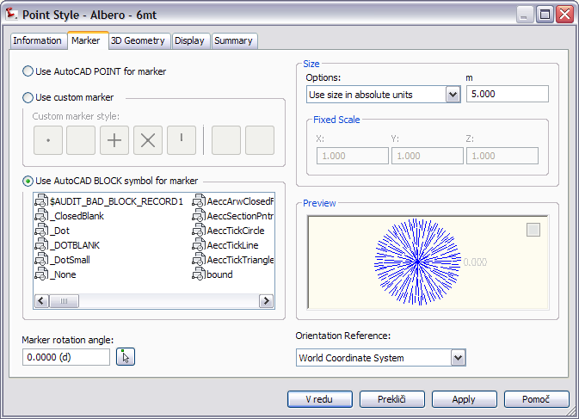
Other points define :
Arbusto, bacino di presa, confine, foro di sondaggio, foro ti trivellazione, idrante, invisibile, misura, palo elettricità, palo luce, palo recinzione, pozzetto fognatura, pozzetto raccolta acqua, punto curva altimetrica, punto curva planimetrica, rubinetto, segnale, standard, valvole del gas, valvole del acqua, vertice planimetrico

Point Label Styles | Description | Screen grab / DWF / DWG | Default
IT-Standard: Nome Quota Codice Descrizione | Stile Metrico: visualizza nome, quota, descrizione e codice del punto | 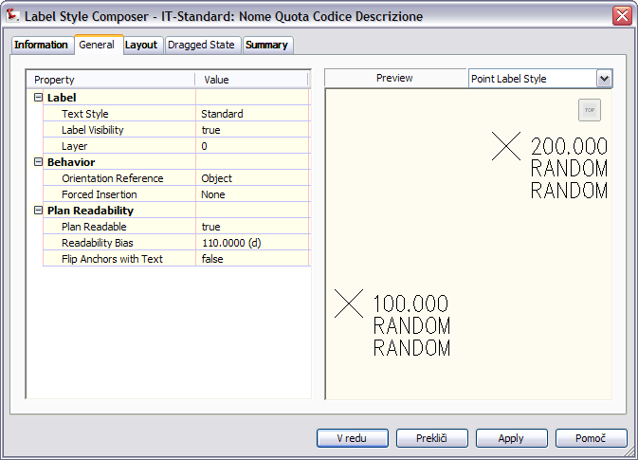

Description Key Sets | Description | Screen grab / DWF / DWG | Default
none

Point Table Styles | Description | Screen grab / DWF / DWG | Default
IT-Standard |  | 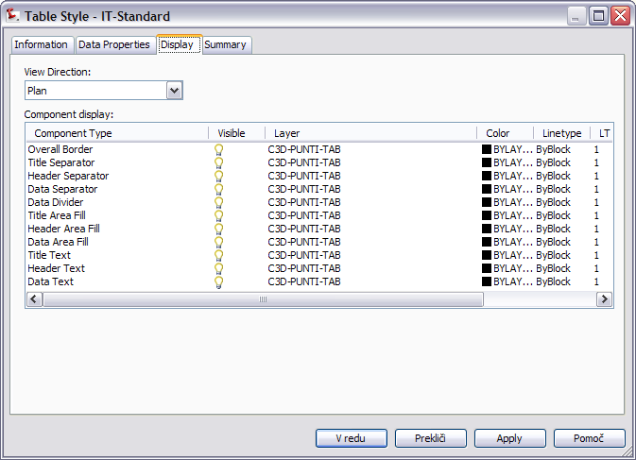

Surfaces
<Template file name, start a new table for each template file>
Surface Styles | Description | Screen grab / DWF / DWG | Default
IT-Standard: Triangoli | Stile Metrico Standard: visualizza triangoli con bordi. | 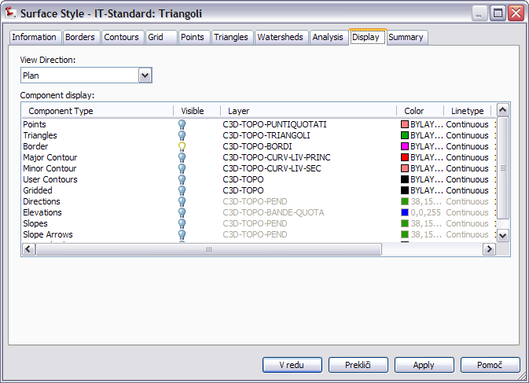
IT-Standard: Curve di livello 2D (1-5m) | Stile Metrico: visualizza le isoipse ad intervalli di 1 m con curve di livello principali ogni 5 m senza bordi interni in 2 dimensioni | 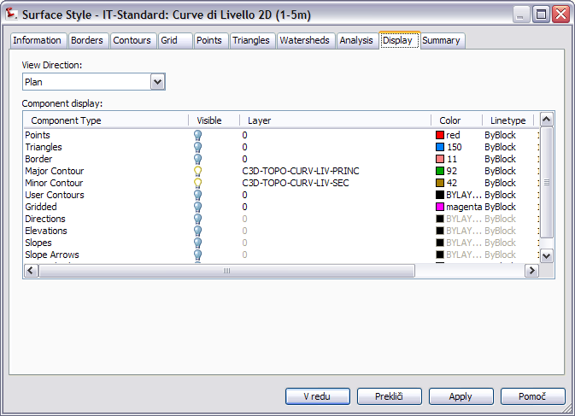
Other surface styles also defined:
Curve di livello 2D (5-10m), Curve di livello 3D (0.5-2.5m), Curve di livello 3D (1-5m), Curve di livello 3D (10-50m), Maglia regolare con quote, triangoli con bordi e direzioni, triangoli con bordi e freccie delle pendenze, triangoli con bordi e punti, triangoli con bordi e punti amplificata, vuoto

Surface Label Styles Name/Type | Description | Screen grab / DWF / DWG | Default
Contour
IT Standard | Stile Metrico Standard | 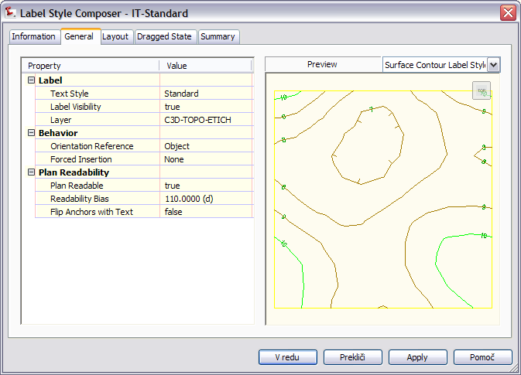
Slope
IT Standard | Stile Metrico Standard | 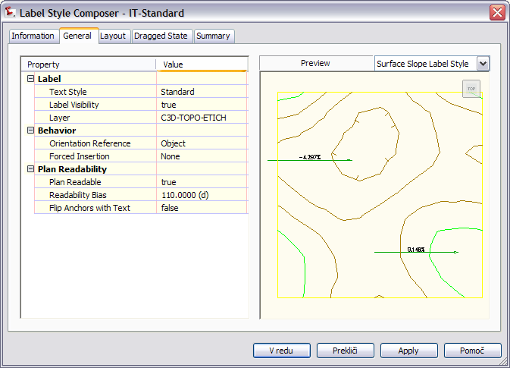
Spot Elevation
IT Standard | Stile Metrico Standard | 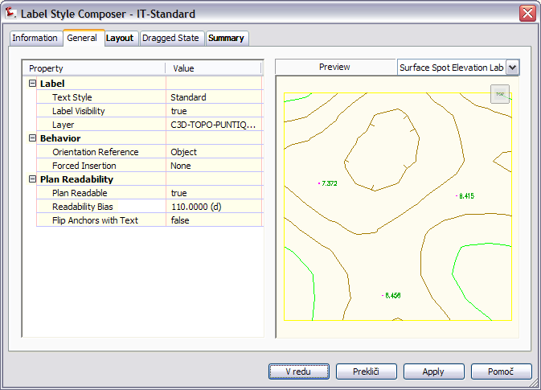
Watershed
IT Standard | Stile Metrico Standard | 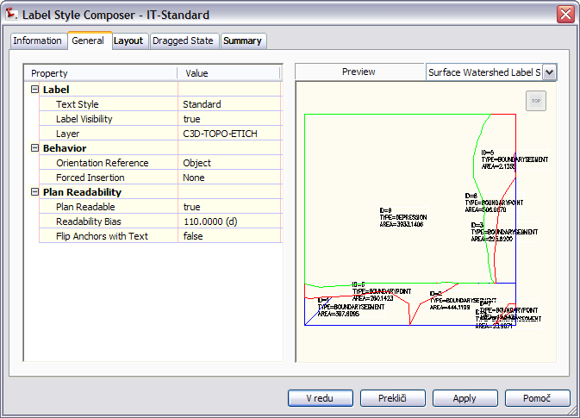

Surface Table Styles Name/Type | Description | Screen grab / DWF / DWG | Default
Direction
IT Standard | Stile Metrico Standard: Numero, Minima e Massima Direzione, Colore | 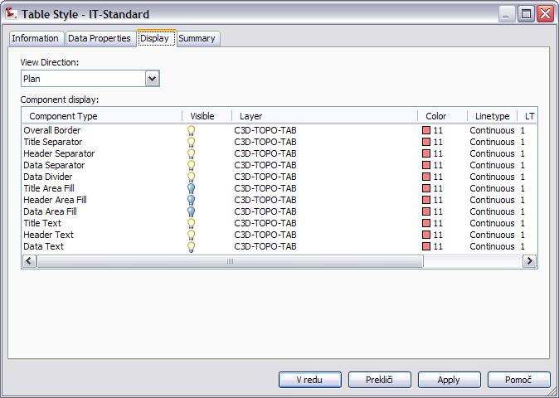
Elevation
IT Standard | Stile Metrico Standard: Numero, Minima e Massima Elevazione, Colore | 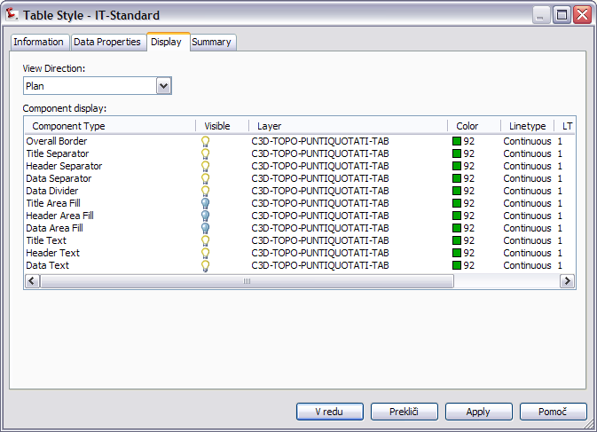
Slope
IT Standard | Stile Metrico Standard: Numero, Minima e Massima Pendenza, Colore | 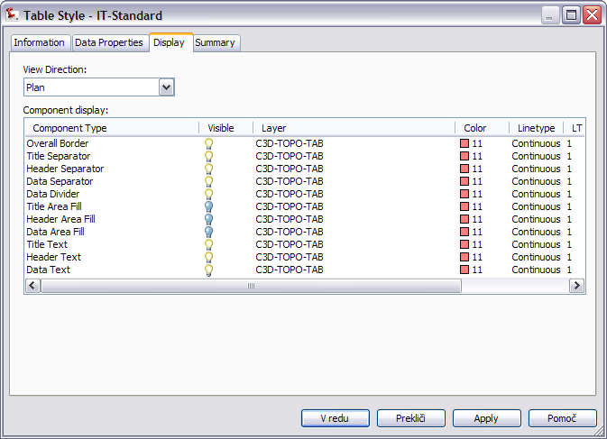
Slope Arrow
IT Standard | Stile Metrico Standard: Numero, Minima e Massima Pendenza della Freccia, Colore | Same as slope
Contour
IT Standard | Stile Metrico Standard: Numero, Minima e Massima Quota delle Curve di Livello | Same as slope
Watershed
IT Standard | Stile Metrico Standard: descrizione, tipo, Compluvio, Forma, Area | Same as slope
User Defined Contour |  | 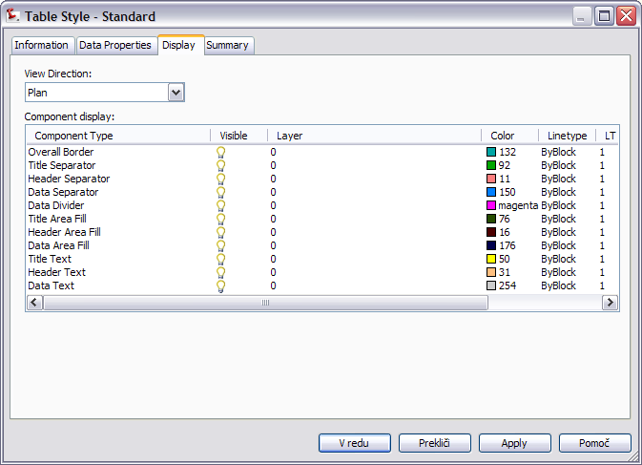

Parcels
<Template file name, start a new table for each template file>
User-Defined Attributes | Description | Screen grab / DWF / DWG | Default
unclassified

Parcel Styles | Description |  | Screen grab / DWF / DWG |  | Default
IT Standard: senza riempimento | Stile Metrico: senza riempimento della particella |  | 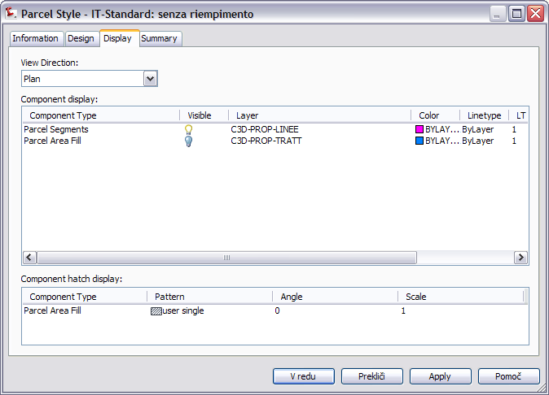
IT Standard: con riempimento A | Stile Metrico: particella con riempimento a retino solido A |  | 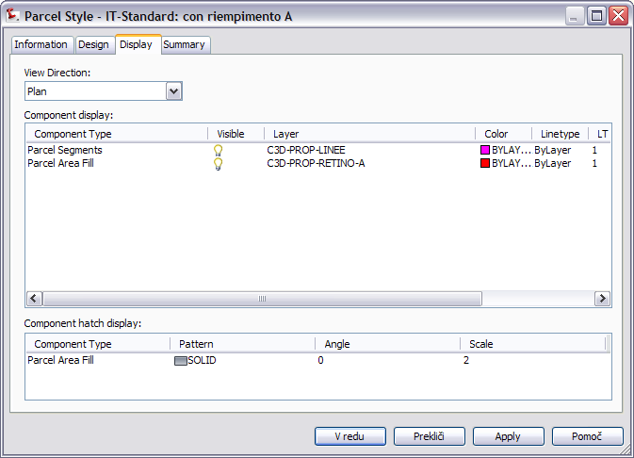
Other styles defined:
IT Standard: con riempimento B
IT Standard: con riempimento C
IT Standard: con riempimento D
IT Standard: con riempimento E
IT Standard: con tratteggio A
IT Standard: con tratteggio B
IT Standard: con tratteggio C
Parcel Label Styles |  | Description |  | Screen grab / DWF / DWG | Default
Area
IT Standard: Numero |  | Stile Metrico: visualizza il numero della particella |  | 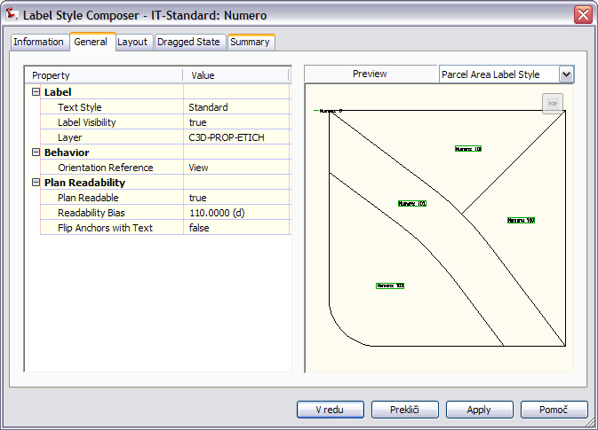
Line
IT Standard |  | Stile Metrico: Riporta lo sviluppo della linea di delimitazione della particella |  | 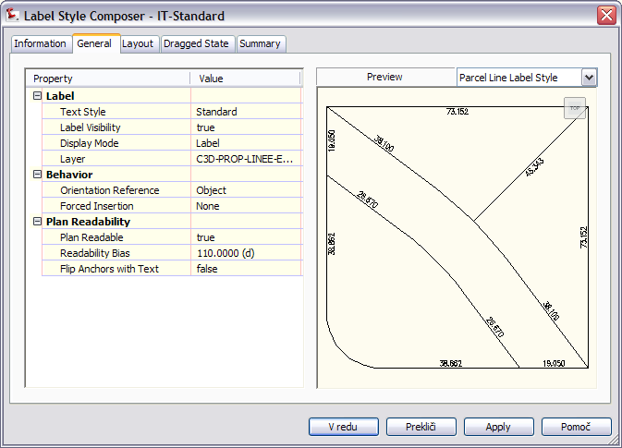
Curve
IT Standard |  | Stile Metrico: Riporta sviluppo raggio e delta del segmento curvilineo di una particella |  | 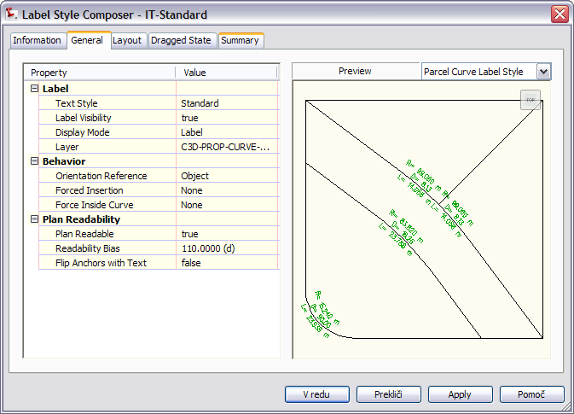

Parcel Table Styles | Description | Screen grab / DWF / DWG | Default
Line
IT Standard | Stile Metrico: disegna una tabella con lunghezza, descrizione e direzione dei segmenti delle particelle | 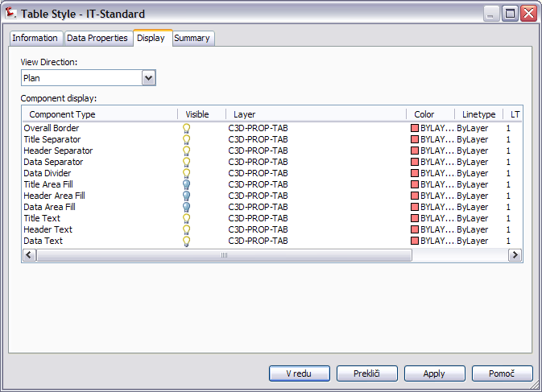
Curve
IT Standard | Stile Metrico: Disegna una tabella con lunghezza, raggio e delta relativa ai contorni curvi di una particella | Same as line
Segment
IT Standard |  | 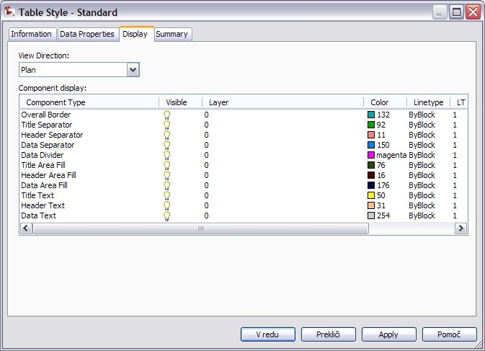
Area
IT Standard | Stile Metrico tabella: riporta le informazioni delle particelle | Same as line

Grading
<Template file name, start a new table for each template file>
Grading Styles | Description | Screen grab / DWF / DWG | Default
IT-Standard: Stile scarpata |  | 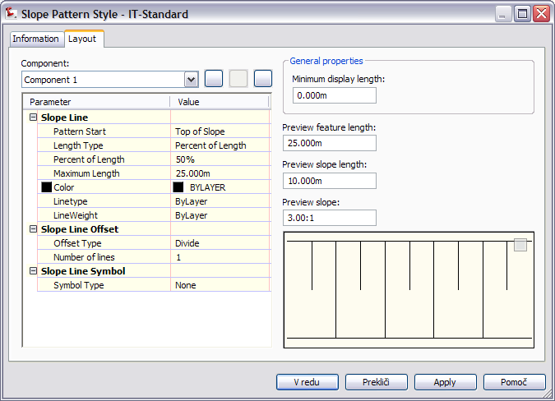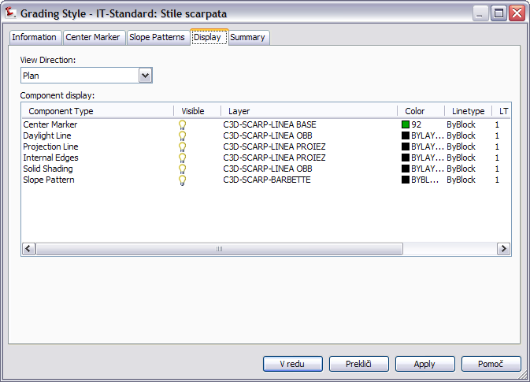

Grading Criteria Sets | Description | Screen grab / DWF / DWG | Default
IT-Standard Banca di riposo |  | 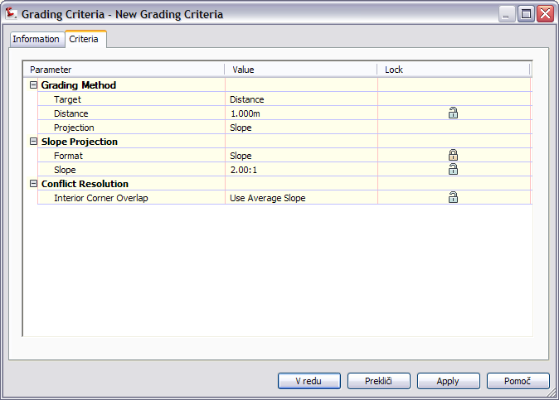
Serie standard,
Set criteri per costruzione scarpate

Alignments
<Template file name, start a new table for each template file>
Alignment Style | Description | Screen grab / DWF / DWG | Default
- Design Style
- Local Road

Alignment Design Checks | Description | Screen grab / DWF / DWG | Default
Design Check Sets
IT-Standard |  | 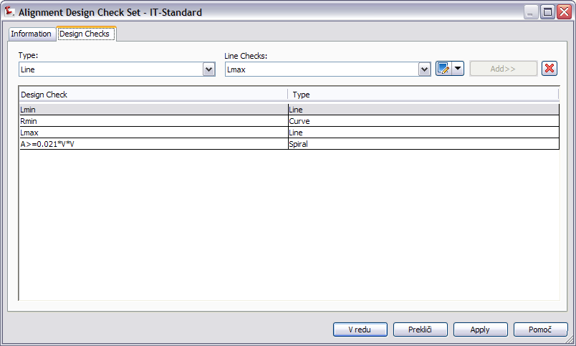
Line
 | Lman, Lmin
Curve
 | Smin, Rmin
Spiral
A>R/3
A<R
R/3<A>R
A>0,021*V*V
Tangent Intersection

Alignment Label Type/Name | Description | Screen grab / DWF / DWG | Default
Alignment Label Sets
- All Labels
- Major & Minor |  | 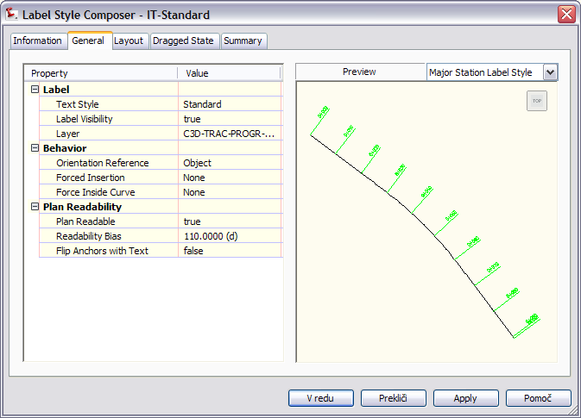
- Major Minor & Geometry Point |  | 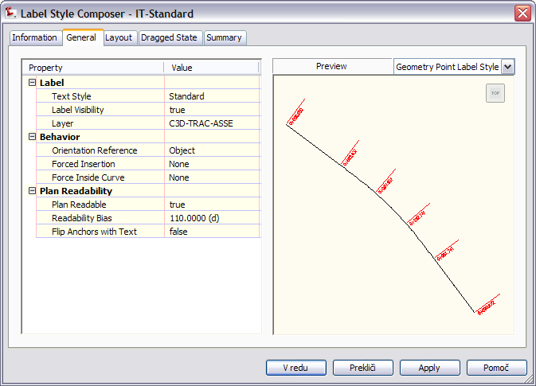
Major Station | Label at Major Stations
- Parallel with Tick |  | 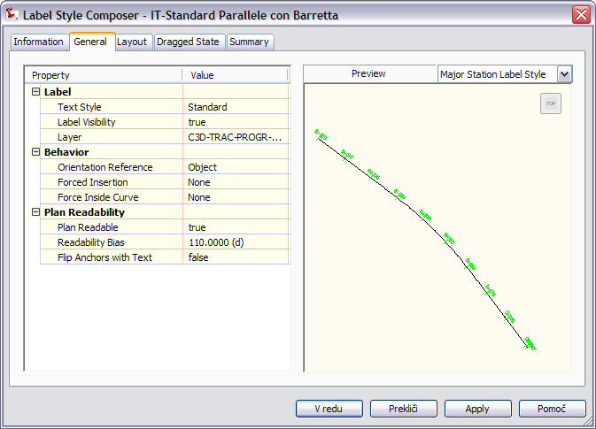
- Perpendicular with Line
- Perpendicular with Tick |  | 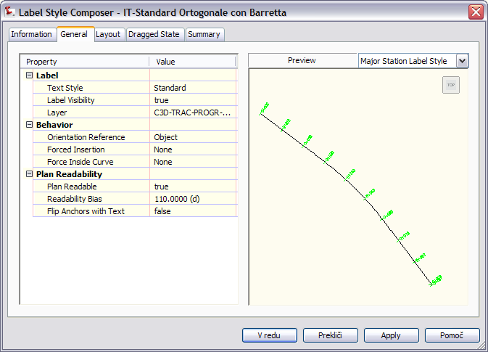
Minor Station | Label at Minor Stations
- Tick |  | 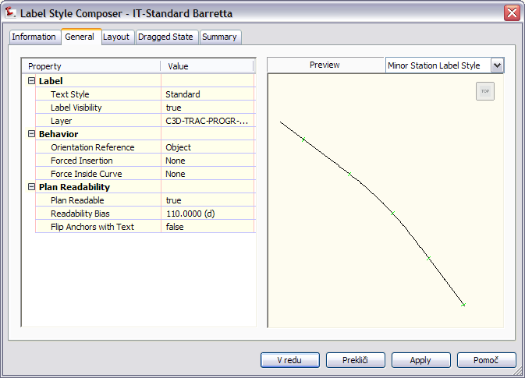
Geometry Point | Label at Geometry Points
- Perpendicular with Tick & Line |  | 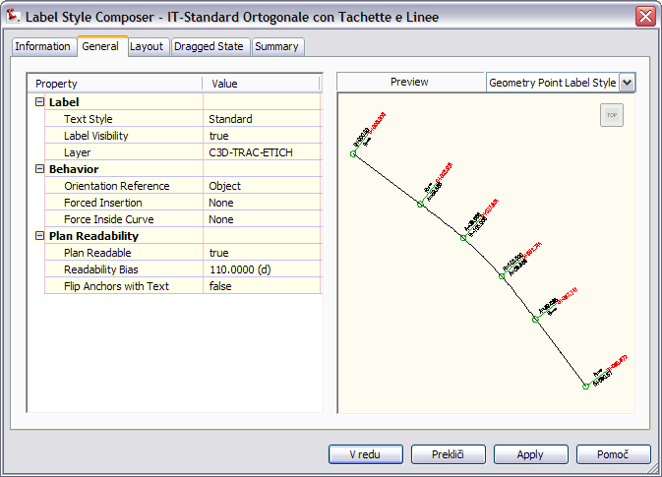
Profile Geometry Point | Labels at the profile geometry points on the alignment
 |  | 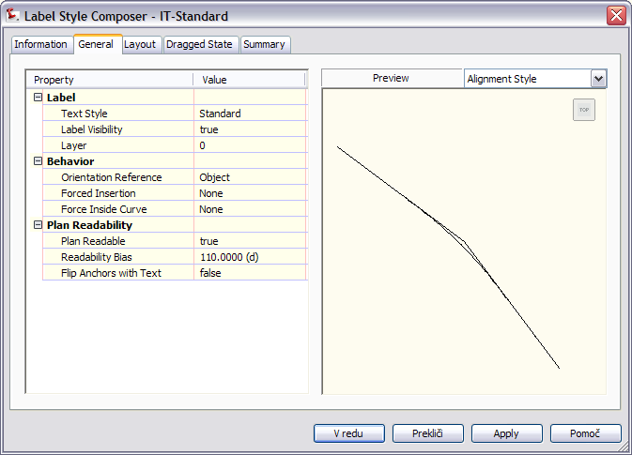
Station Equation | Station equation Labels
- Station Ahead & Back |  | 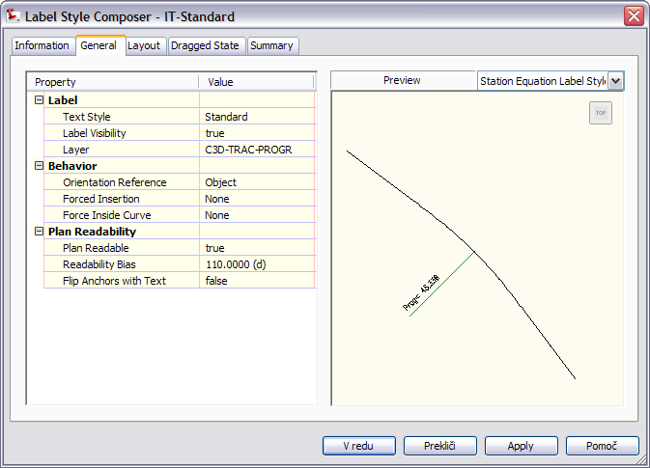
Design Speed | Design Speed labels
- Station over Speed |  | 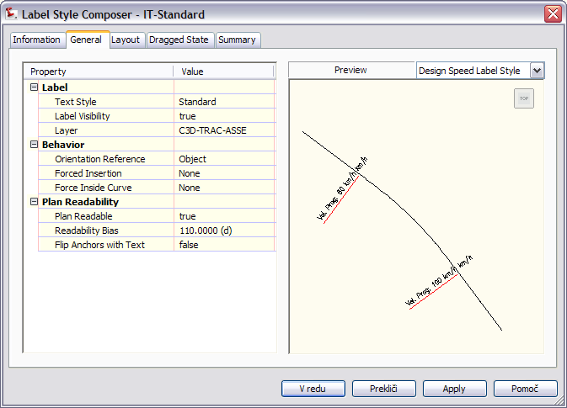
Superelevation Critical Points | Labels at the critical Superelevation points on the alignment
 |  | 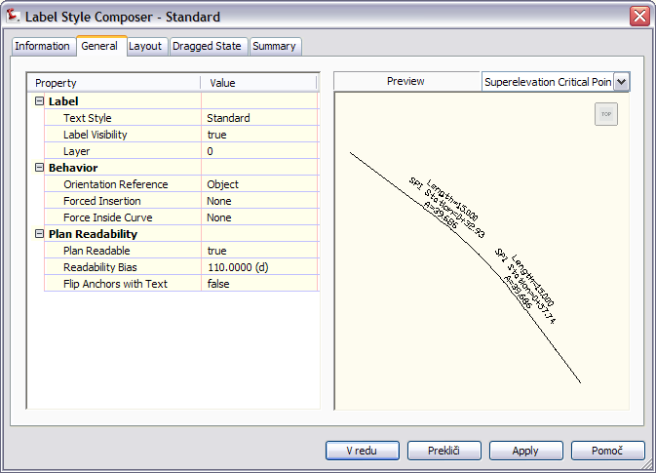
Station Offset | Station Offset Labels
 |  | 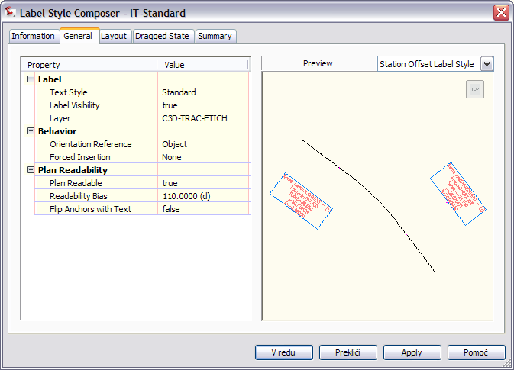
Line | Tangent labels
IT-Standard Definitivo-Esecutivo |  | 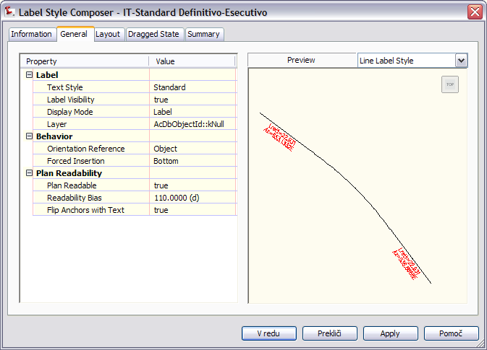
Curve | Arc Labels
IT-Standard Definitivo-Esecutivo |  | 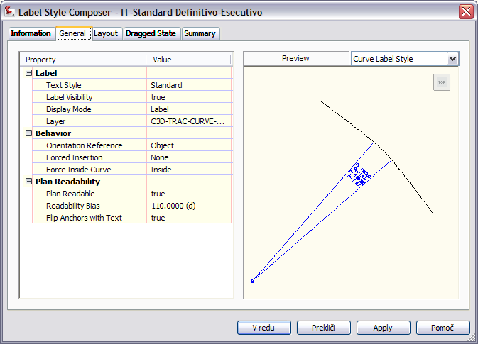
Spiral | Spiral Labels
IT-Standard Definitivo-Esecutivo |  | 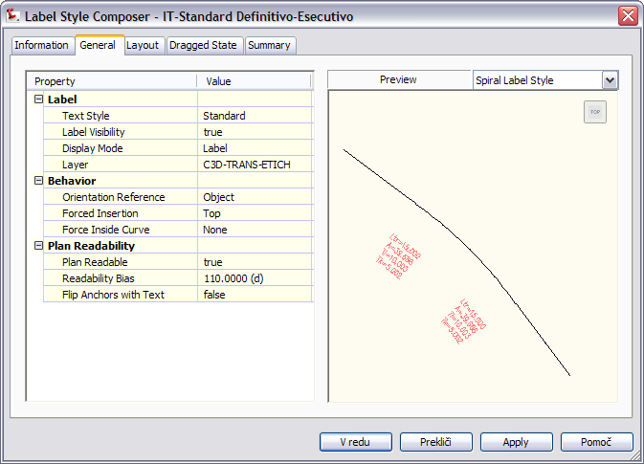
Tangent Intersection | PI Labels
• Tangent Intersection  IT-Standard Definitivo-Esecutivo | <[Alignment Name(CP)]>  <[Alignment Description(CP)]>  _____________________  Xv=<[PI Easting(Um|P4|RN|Sn|OF|AP)]>  Yv=<[PI Northing(Um|P4|RN|Sn|OF|AP)]>  Alfa=<[Delta Angle(Udeg|FD|P4|RN|AP|OF)]>  Az1=<[Tangent In Direction(Udeg|FD|MB|P6|RN|DSn|CP|AP|OF)]>  Az2=<[Tangent Out Direction(Udeg|FD|MB|P6|RN|DSn|CU|AP|OF)]>  _____________________  Xin=<[Spiral 1 PI Easting(Um|P3|RN|AP|Sn|OF)]>  Yin=<[Spiral 1 PI Northing(Um|P3|RN|AP|Sn|OF)]>  TLin=<[Spiral 1 Long Tangent(Um|P3|RN|AP|Sn|OF)]>  TKin=<[Spiral 1 Short Tangent(Um|P3|RN|AP|Sn|OF)]>  L1=<[Spiral 1 Length(Um|P3|RN|AP|Sn|OF)]>  A1=<[Spiral 1 A(P3|RN|Sn|OF)]>  _____________________  Xc=<[Curve PI Easting(Um|P4|RN|Sn|OF|AP)]>  Yc=<[Curve PI Northing(Um|P4|RN|Sn|OF|AP)]>  R=<[Curve Radius(Um|P3|RN|AP|Sn|OF)]>  Tc=<[Curve External Tangent(Um|P3|RN|AP|Sn|OF)]>  Sv=<[Curve Length(Um|P3|RN|AP|Sn|OF)]>  _____________________  Xout=<[Spiral 2 PI Easting(Um|P3|RN|AP|Sn|OF)]>  Yout=<[Spiral 2 PI Northing(Um|P3|RN|AP|Sn|OF)]>  TLout=<[Spiral 2 Long Tangent(Um|P3|RN|AP|Sn|OF)]>  TKout=<[Spiral 2 Short Tangent(Um|P3|RN|AP|Sn|OF)]>  L2=<[Spiral 2 Length(Um|P3|RN|AP|Sn|OF)]>  A2=<[Spiral 2 A(P3|RN|Sn|OF)]> | 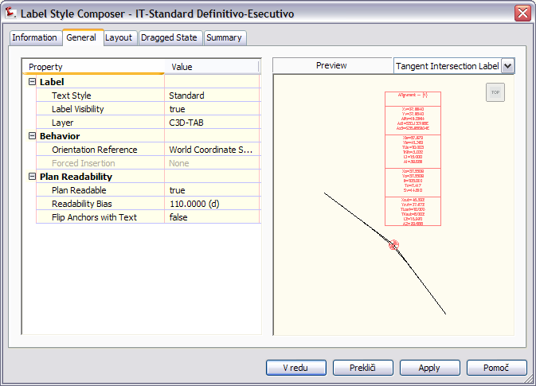

Alignment Table Type/Name | Description | Screen grab / DWF / DWG | Default
Line
Standard Definitivo-Esecutivo | Stile Metrico per progetto Definitivo-Esecutivo: lunghezza, azimut, E-N punto iniziale, E-N punto finale. | 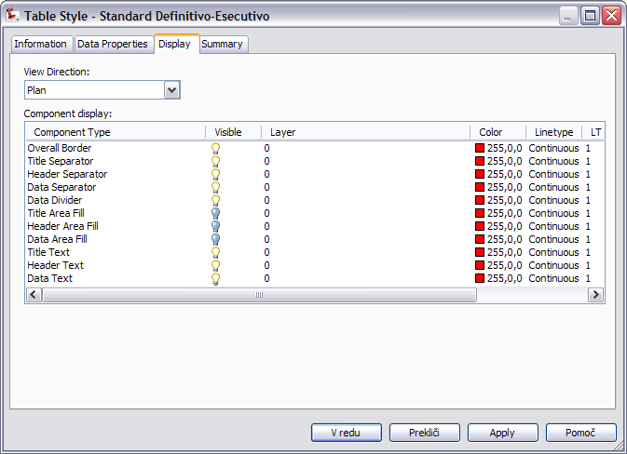
Curve
Standard Definitivo-Esecutivo | Stile Metrico per progetto Definitivo-Esecutivo: raggio, lunghezza, azimut della corda, il punto iniziale e finale. | 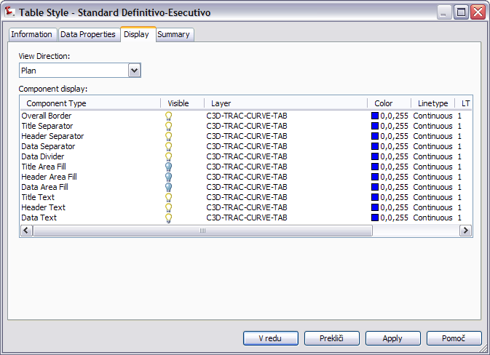
Spiral
Standard Definitivo-Esecutivo | Stile Metrico per progetto Definitivo-Esecutivo: lunghezza, A, l'azimut iniziale, il punto iniziale e finale. La tabella non è visibile nella vista 3D. | 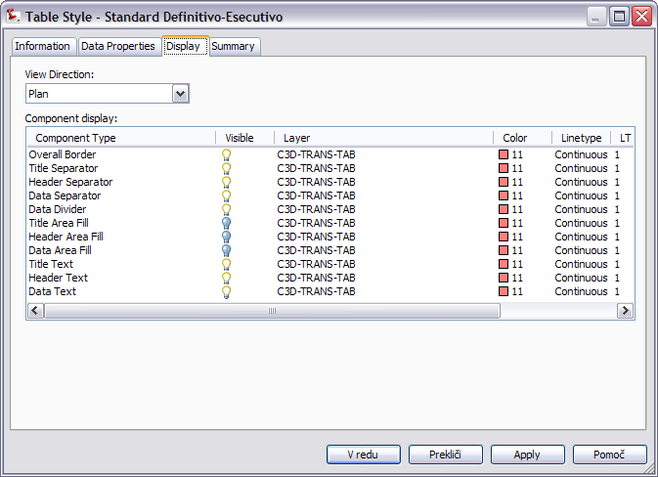
Segment | Line, curve or spiral element in a single table

Profiles
<Template file name, start a new table for each template file>
Profile Style | Description | Screen grab / DWF / DWG | Default
- Design Style  IT-Standard Profilo Progetto | Stile Metrico: Profilo di progetto per l'Italia | 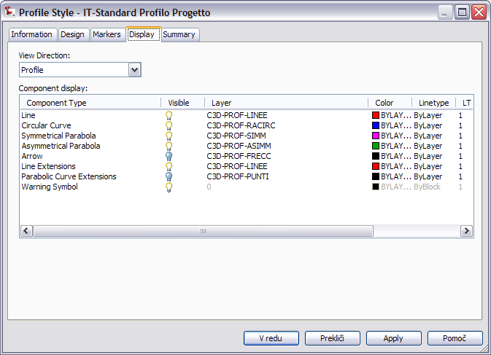
- Local Road

Profile Design Checks | Description | Screen grab / DWF / DWG | Default
Design Check Sets
IT-standard |  | 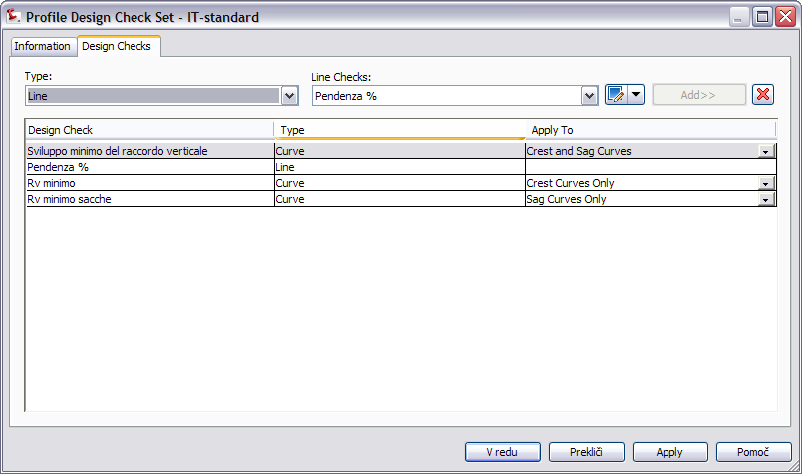
Line
Pendenza % |  | 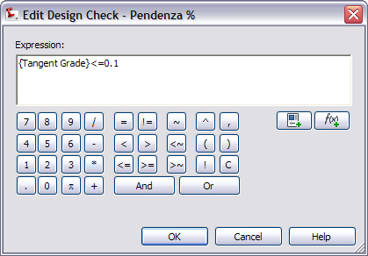
Curve
Sviluppo minimo del raccordo vertical  Rv minimo  Rv minimo sacche |  | 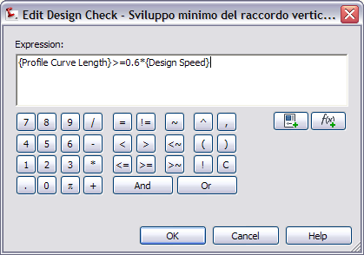

Profile Label Type/Name | Description | Screen grab / DWF / DWG | Default
Profile Label Sets
IT-Standard Serie Etich Profilo Progetto Definitivo-Esecutivo | Stile Metrico: visualizza le info dei raccordi altimetrici (in tabelle) e progressiva e quota dei punti di inizio e fine raccordi, sul profilo di progetto | 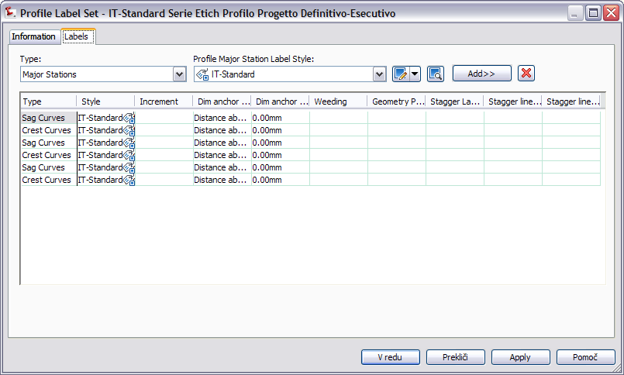
Major Station
IT-Standard | Stile Metrico: visualizza le progressive sul profilo | 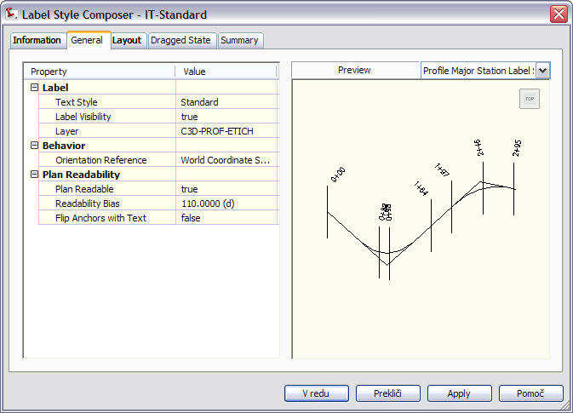
Minor Station
IT-Standard |  | 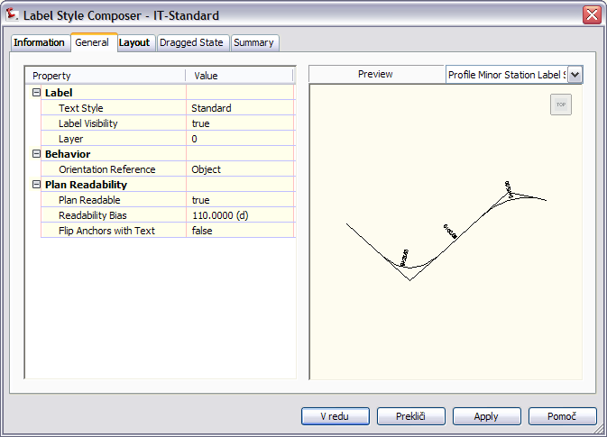
Horizontal Geometry Point
IT-Standard | Stile Metrico: permette di riportare nel profilo la progressiva e la quota di punti notevoli del tracciato planimetrico. | 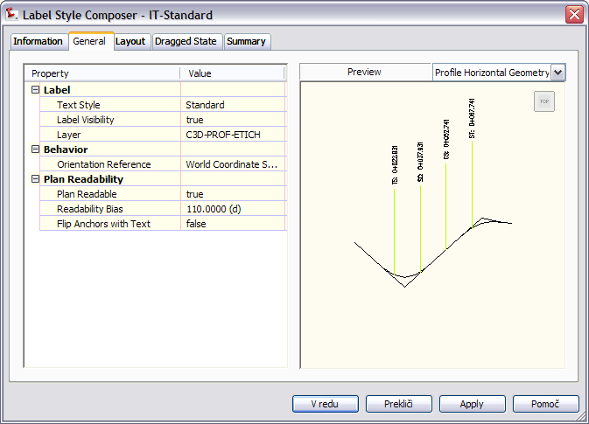
Grade Breaks
IT-Standard | Stile Metrico: non riporta informazioni sul profilo dell'esistente. | 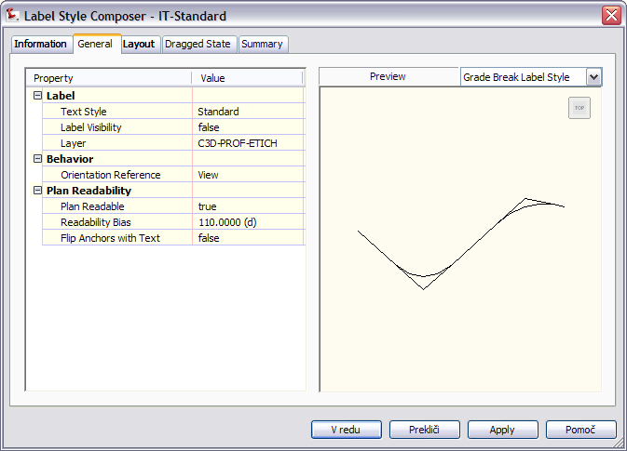
Line | Tangent Labels
IT-Standard: Livelletta | Stile Metrico: riporta le pendenze sulle livellette disegnate nel profilo | 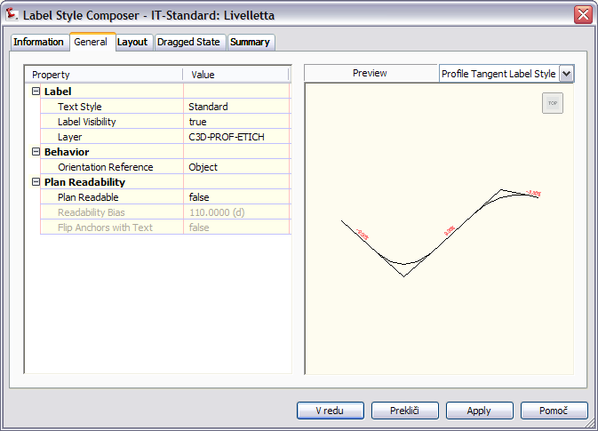
IT-Standard: Terreno | Stile Metrico: riporta le pendenze sulle livellette disegnate nel profilo | 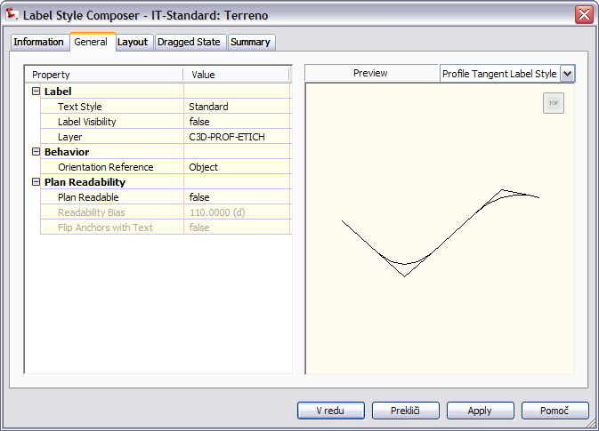
Curve
IT-Standard Informazioni Raccordo | Stile Metrico: tabella raccordi con nome tracciato planimetrico, progressiva, quota del vertice, sviluppo e delta pendenze, indicazione di inizio e fine raccordo con quota e progressiva | 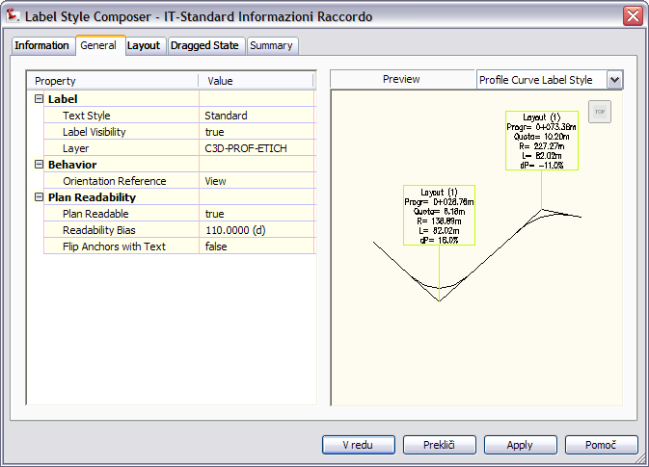

Profile View Type/Name | Description | Screen grab / DWF / DWG | Default
IT-Standard Vista Profilo | Stile Metrico: stile del cartiglio vista profilo. | 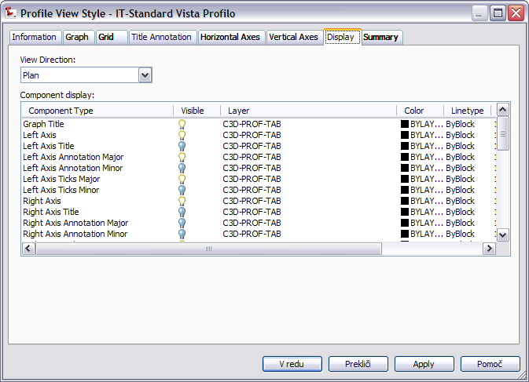

Profile View Label Type/Name | Description | Screen grab / DWF / DWG | Default
Station Elevation
IT-Standard Progr Quota Profilo | Stile metrico che visualizza la progressiva e la quota del punto selezionato all'interno della vista profilo. | 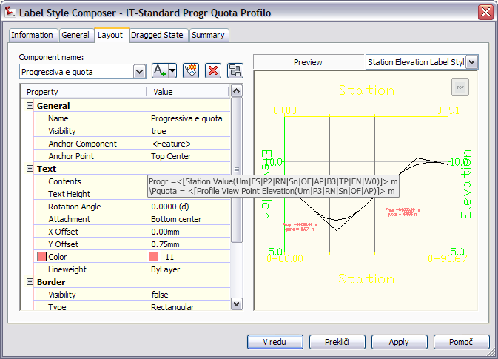
Depth
IT-Standard |  | 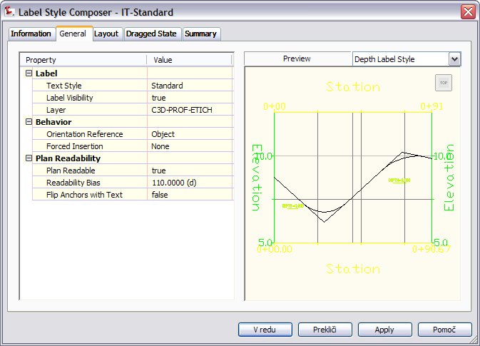

Profile Band Type/Name | Description | Screen grab / DWF / DWG | Default
Profile Band Set
IT-Standard Serie di Finche | Stile Metrico: riporta nome delle sezioni, distanze parziali, progressive di progetto, ettometriche, quote terreno, quote progetto, andamento cigli ed andamento planimetrico nelle finche inferiori; i dati della livelletta nell'unica finca superiore. | 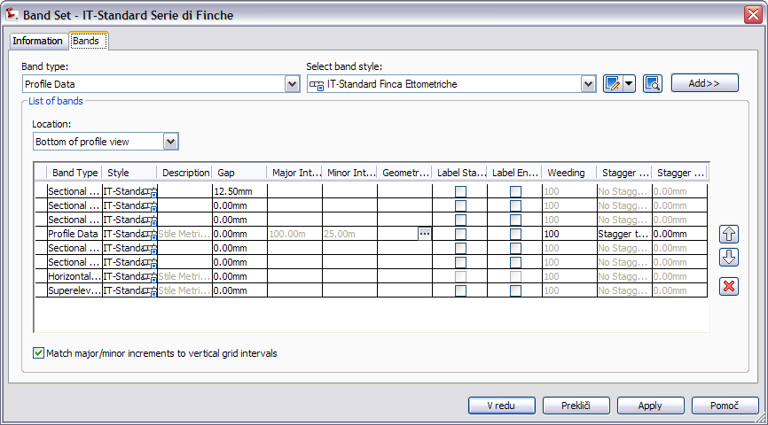
Profile Data
IT-Standard Finca Ettometriche | Stile Metrico: finca per la quotatura delle ettometriche | 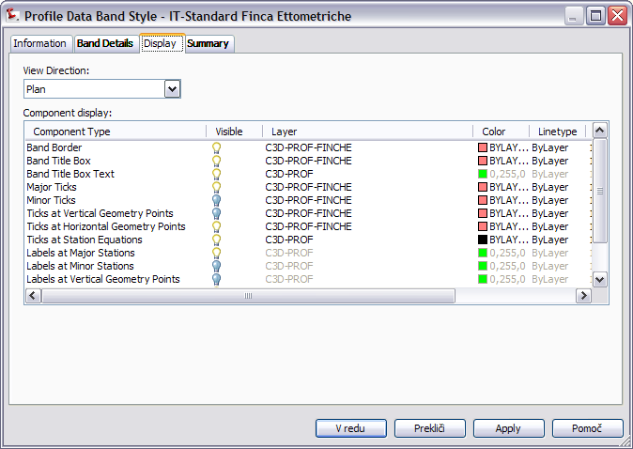
Vertical Geometry
IT-Standard Finca Livellette | Stile Metrico: finca con i parametri delle livellette | 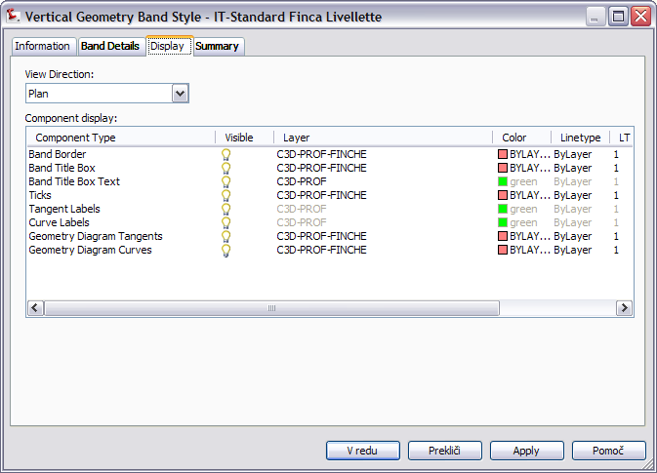
Horizontal Geometry
IT-Standard Finca Andamento Planimetrico | indicazione della lunghezza rettifili, sviluppo, raggio ed angolo al centro curve, parametro A | 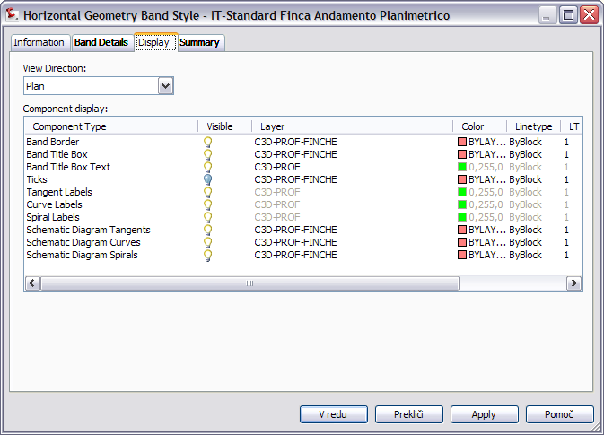
Superelevation Data
IT-Standard Finca Andamento Cigli | Stile Metrico: indica rotazioni e sopraelevazioni dei cigli destro e sinstro e la loro progressiva. | 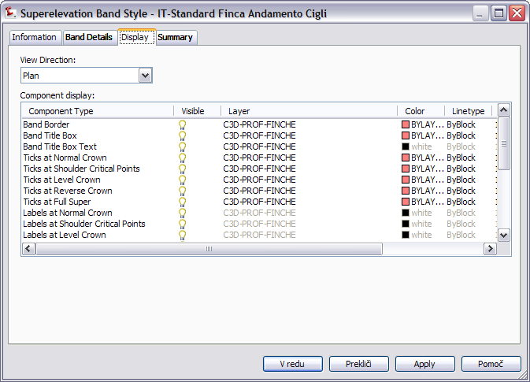
Sectional Data
IT-Standard Finca Distanze Parziali  IT-Standard Finca Distanze Progressive  IT-Standard Finca Numero Sezione  IT-Standard Finca Quote Progetto  IT-Standard Finca Quote Terreno |  | 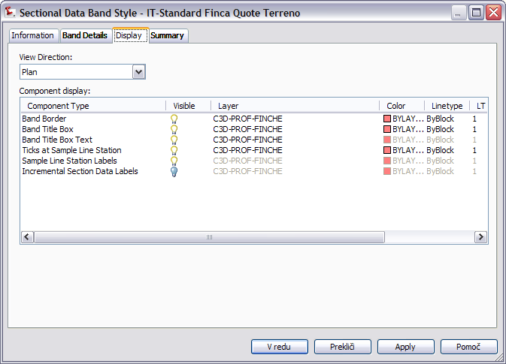
Pipe Network
IT-Standard |  | 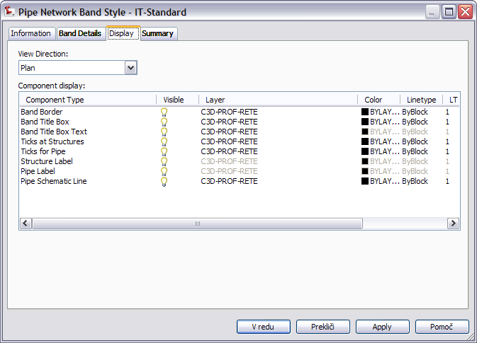

Sections
<Template file name, start a new table for each template file>
Sample Line Styles | Description | Screen grab / DWF / DWG | Default
IT-Standard | Stile Metrico: inserisce le linee di sezione trasversali | 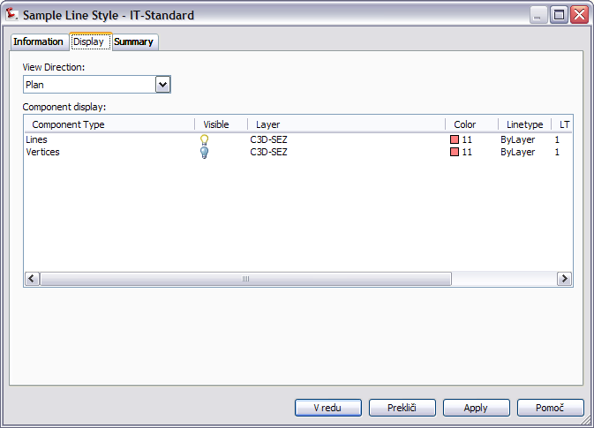

Sample Line Label Styles | Description | Screen grab / DWF / DWG | Default
IT-Standard | Stile Metrico: visualizza solo il nome della sezione perpendicolarmente alla linea | 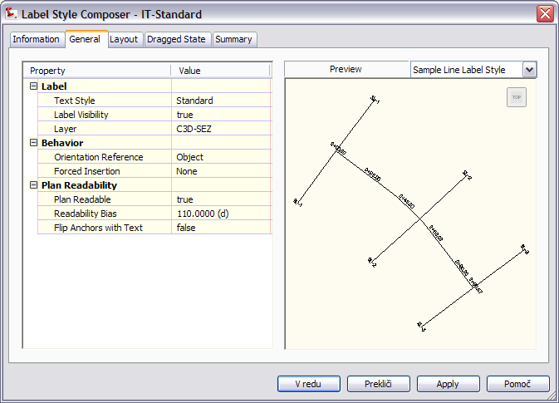
IT-Standard Nome Sezioni con Simboli
IT-Standard Profilname
IT Standard Nome Sezioni con Simboli e Progressiva

Section Styles | Description | Screen grab / DWF / DWG | Default
IT-Standard | Stile Metrico: contiene lo stile per la visualizzazione della sezione del terreno | 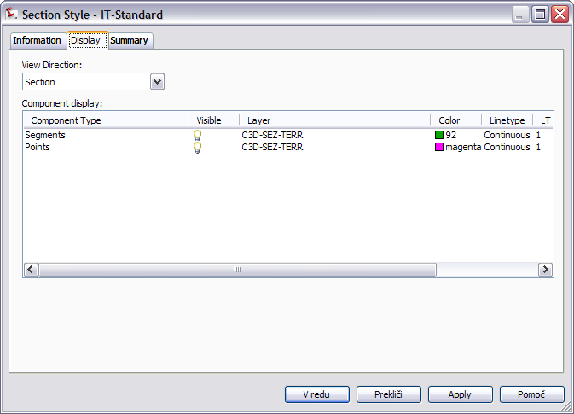

Section Label Styles | Description | Screen grab / DWF / DWG | Default
Label Sets
IT-Standard |  | 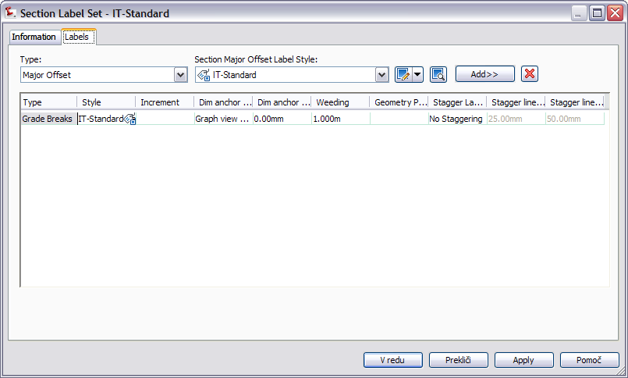
Major Offset
IT Standard |  | 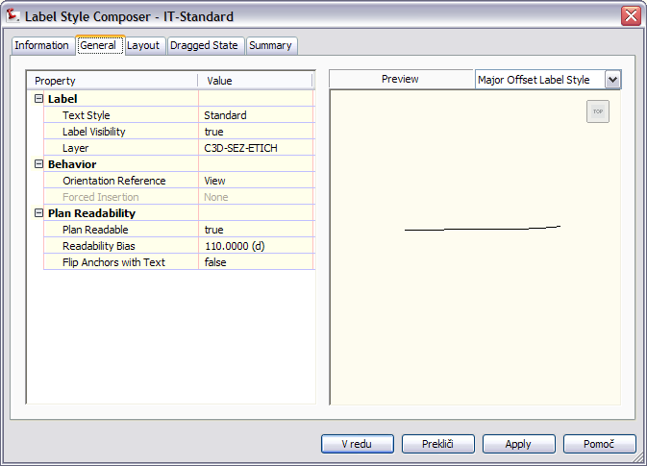
Minor Offset
IT-Standard |  | 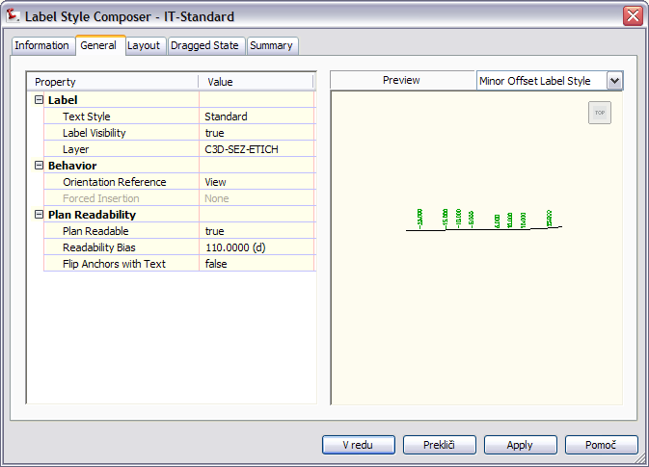
Grade Break
IT-Standard Candele |  | 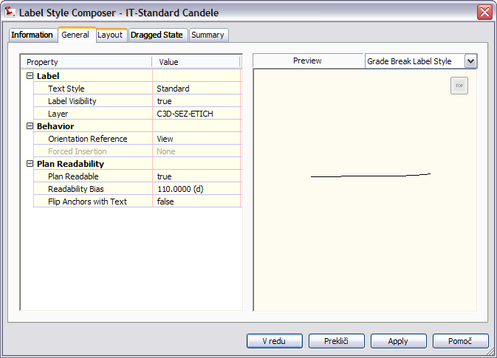
IT-Standard Candele Progetto Etichetta
IT-Standard Candele Terreno Etichetta
IT-Standard Progessive terreno
IT-Standard Quote terreno
Segment
IT-Standard Pendenze Polilinee | Stile Metrico: visualizza le pendenze della polilinea | 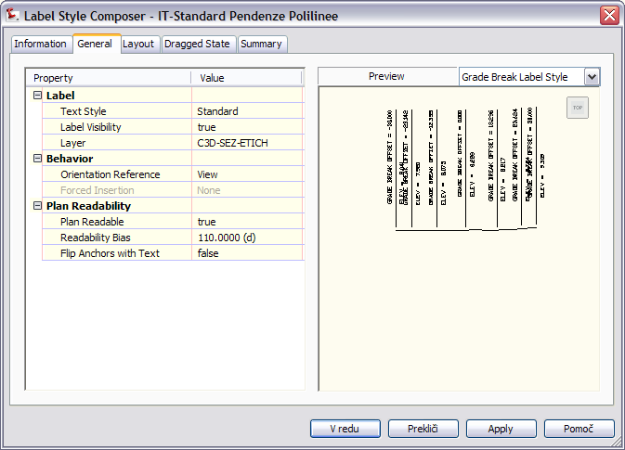

Section View Styles | Description | Screen grab / DWF / DWG | Default
IT-Standard Vista Sezioni | Stile Metrico: visualizza le pendenze della polilinea | 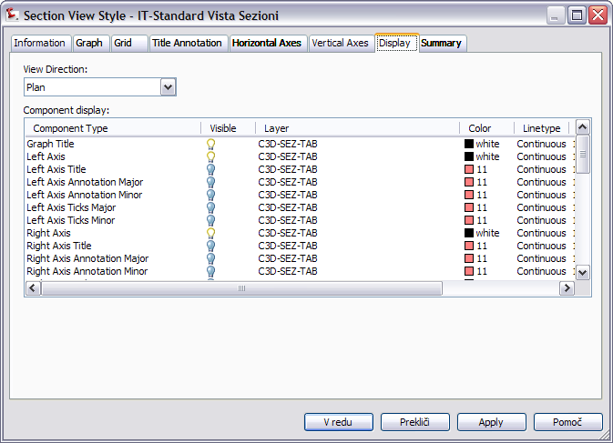
IT-Standard Vista Sezioni Quattro Finca | Stile Metrico: imposta il riquadro-vista nel cartiglio di una sezione

Group Plot Styles | Description | Screen grab / DWF / DWG | Default
IT-Standard Tutto |  | 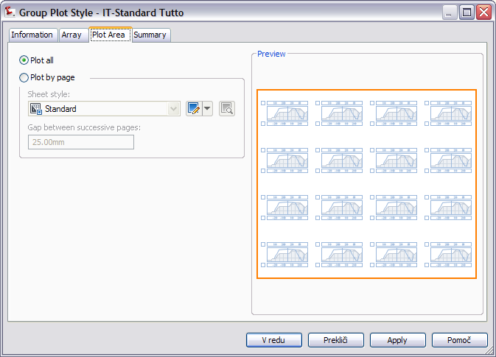
IT-Standard A0 Scala 50 | Stile Metrico: visualizza le sezioni trasversali organizzate in righe e colonne. | 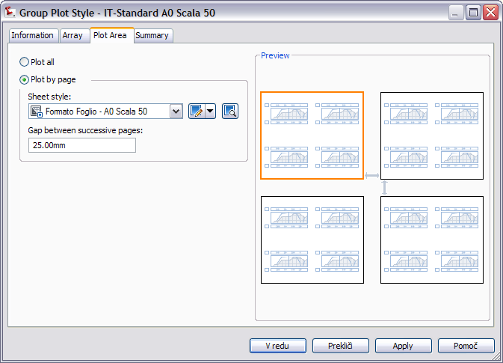
IT-Standard A0 Scala 50  IT-Standard A0 Scala 100  IT-Standard A0 Scala 200  IT-Standard A4 | 1:50  1:100  1:200  1:A4

Sheet Styles | Description | Screen grab / DWF / DWG | Default
Formato Foglio - A0 Scala 50 | Stile Metrico: ISO A0 (841.00 x 1189.00 mm)
Formato Foglio - A0 Scala 100
Formato Foglio - A0 Scala 200
Formato Foglio – A1 Scala 50
Formato Foglio – A1 Scala 100
Formato Foglio – A1 Scala 200
Formato Foglio – A4

Label Styles | Description | Screen grab / DWF / DWG | Default
Offset Elevation
IT-Standard |  | 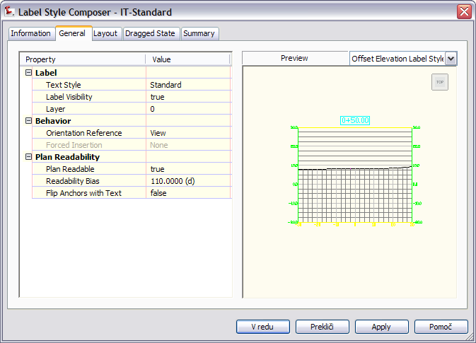
Grade
IT-Standard |  | 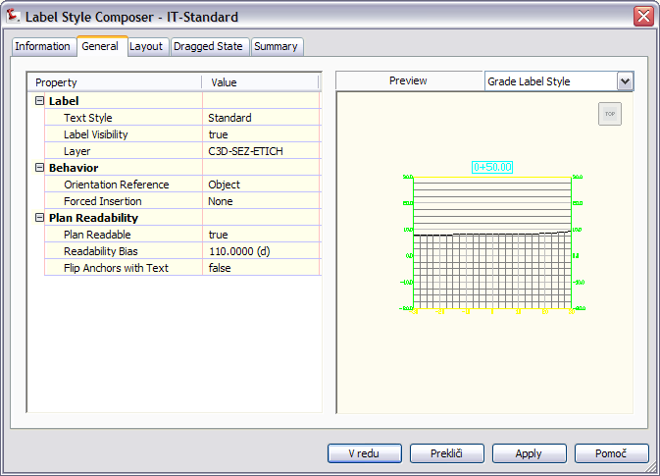

Section Band Styles | Description | Screen grab / DWF / DWG | Default
Band Sets
IT-Standard Serie di Finche vista sezioni | Stile metrico con la serie di finche delle sezioni | 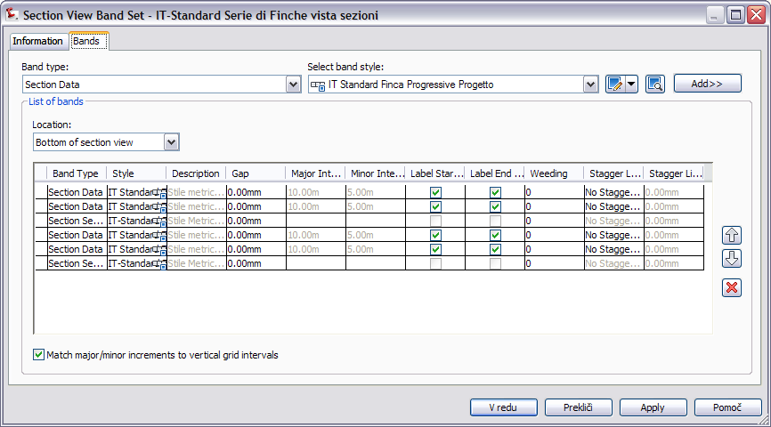
IT-Standard Serie di Finche vista sezioni Quattro | Stile metrico con la serie di finche delle sezioni | 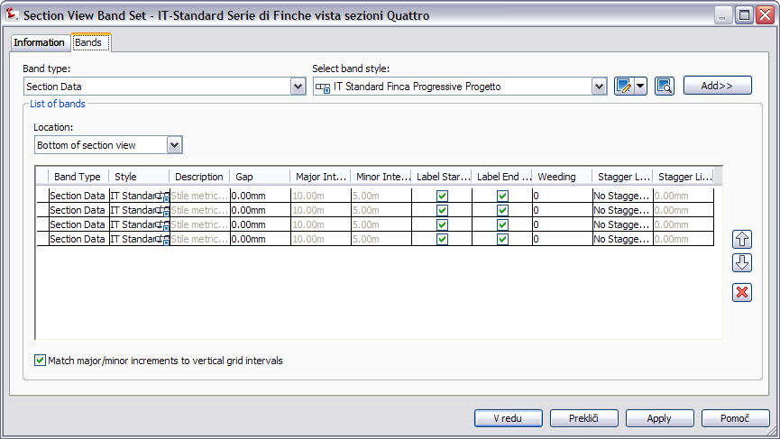
Section Data
IT Standard Finca Progressive Progetto | Stile metrico per la finca delle progressive di progetto | 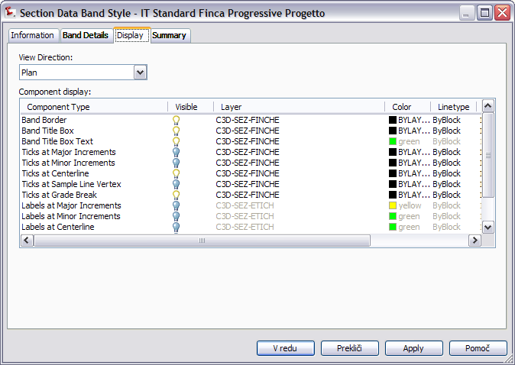
IT Standard Finca Progressive Progetto Vuoto
IT Standard Finca Progressive Terreno
IT Standard Finca Progressive Terreno Vuoto
IT Standard Finca Quote Progetto
IT Standard Finca Quote Progetto Vuoto
IT Standard Finca Quote Terreno
IT Standard Finca Quote Terreno Vuoto

Section Table Styles | Description | Screen grab / DWF / DWG | Default
Total Volume
IT-Standard |  | 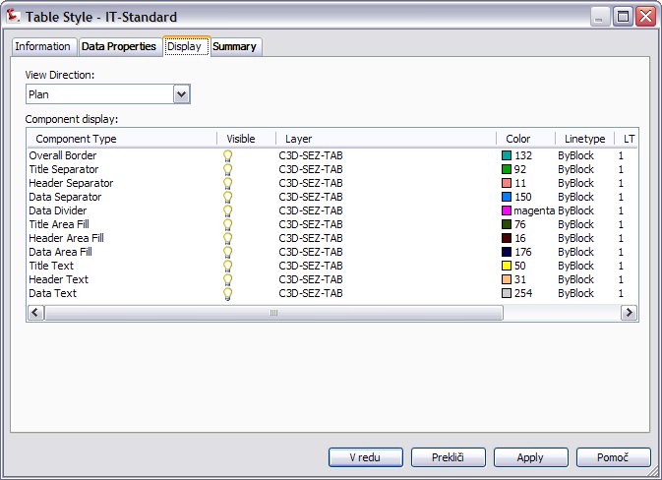
Material
IT-Standard |  | 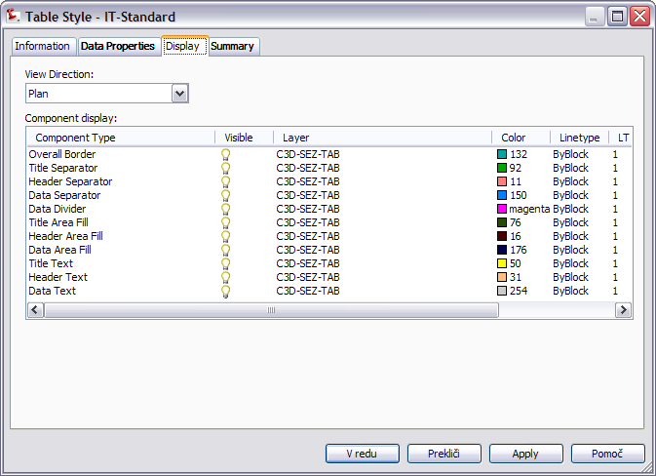

Pipe Networks
<Template file name, start a new table for each template file>
Parts Lists | Description | Screen grab / DWF / DWG | Default
IT-Standard Elenco componenti |  | 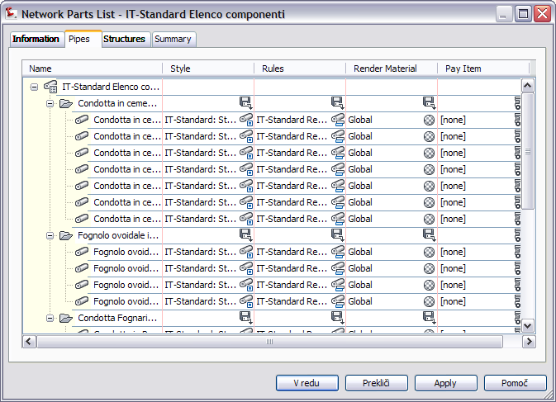

Interference Styles | Description | Screen grab / DWF / DWG | Default
IT-Standard stile interferenza | Stile metrico per la visualizzazione dell'interferenza tra condotte. | 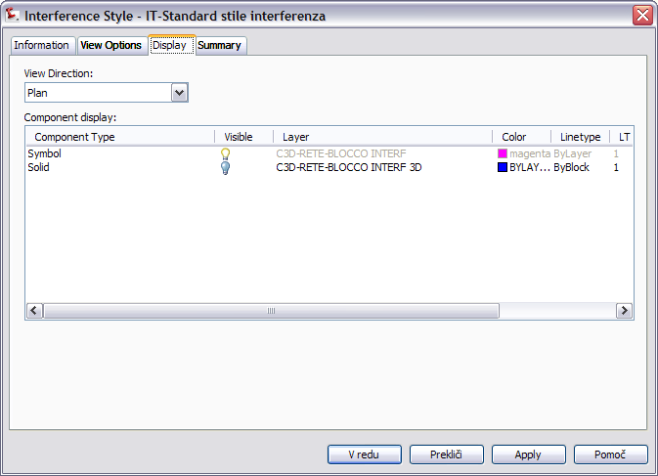

Pipe Styles | Description | Screen grab / DWF / DWG | Default
IT-Standard: Stile Condotta Fognaria | Stile Metrico: imposta la visualizzazione della condotta. | 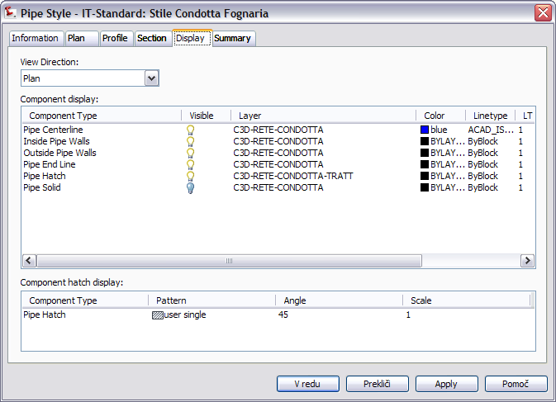

Pipe Rule Set | Description | Screen grab / DWF / DWG | Default
IT-Standard Regole Condotta Fognaria | Stile Metrico: regole sulla pendenza minima e massima, sul ricoprimento minimo e massimo, sulla lunghezza... | 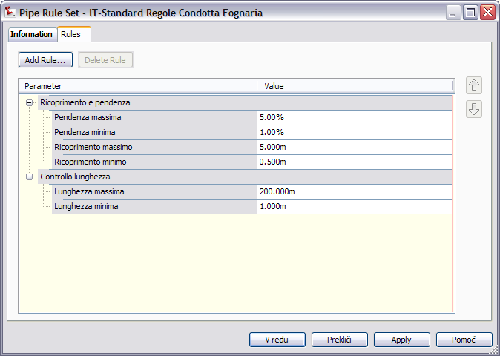

Pipe Label Styles | Description | Screen grab / DWF / DWG | Default
Plan Profile
IT-Standard Stile Etichetta Condotta Fognaria Planimetria | Stile Metrico:visualizza nome, descrizione,pendenza lunghezza di una condotta in planimetria e le quote di scorrimento iniziale e finale. | 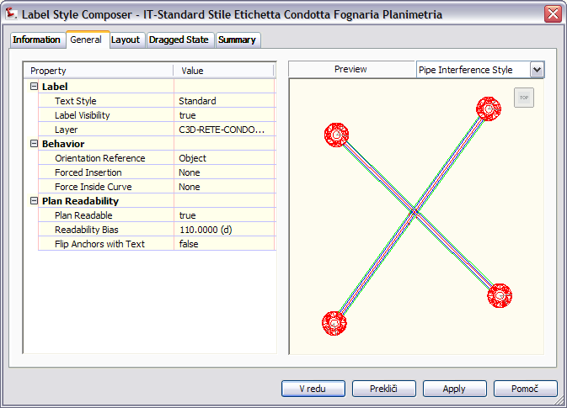
IT-Standard Stile Etichetta Condotta Fognaria Profilo | Stile Metrico: visualizza Nome, Descrizione, Lunghezza, Pendenza e Quota di scorrimento iniziale e finale
Crossing Section
IT-Standard |  | 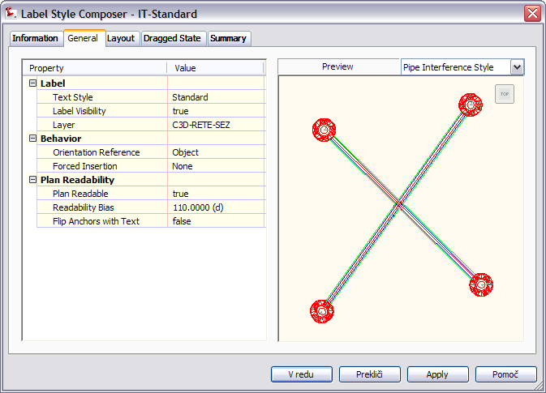

Pipe Table Styles | Description | Screen grab / DWF / DWG | Default
IT Standard |  | 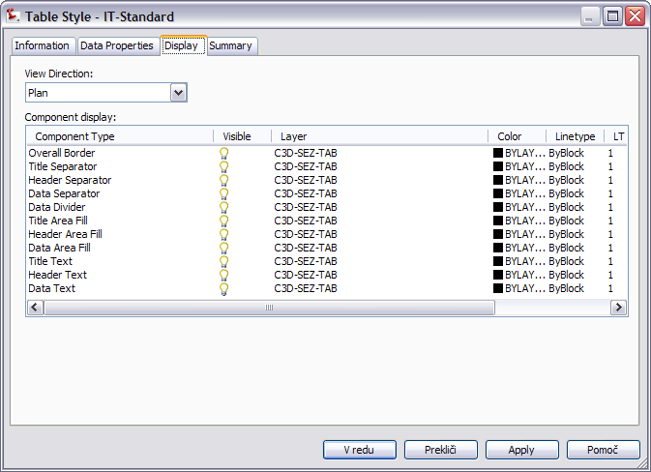

Structure Styles | Description | Screen grab / DWF / DWG | Default
IT-Standard: Stile Pozzetto Rete Fognaria | Stile Metrico: stile per la visualizzazione del nodo | 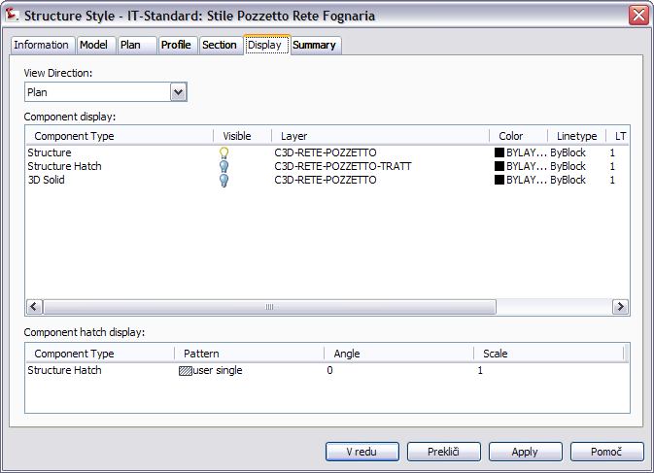

Structure Rule Styles | Description | Screen grab / DWF / DWG | Default
IT-Standard: Regole Pozzetto Rete Fognaria | Stile Metrico: stabilisce dislivello e diametro del pozzetto. | 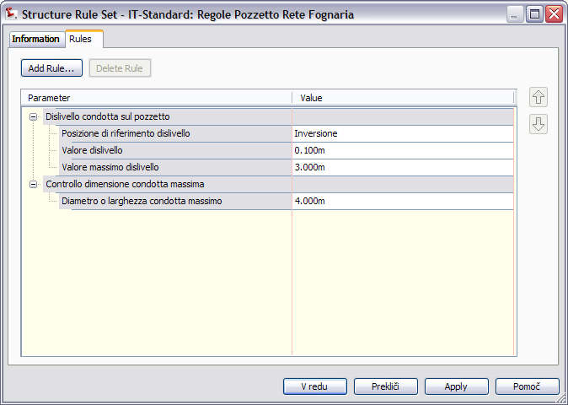

Structure Label Styles | Description | Screen grab / DWF / DWG | Default
IT-Standard |  | 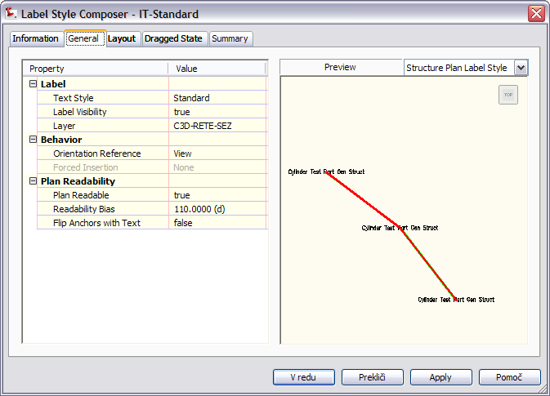
IT-Standard Stile Etichetta Pozzeto Planimetria | Stile Metrico: visualizza Nome, Descrizione, Quota Terreno e Quota di Fondo Pozzetto. | 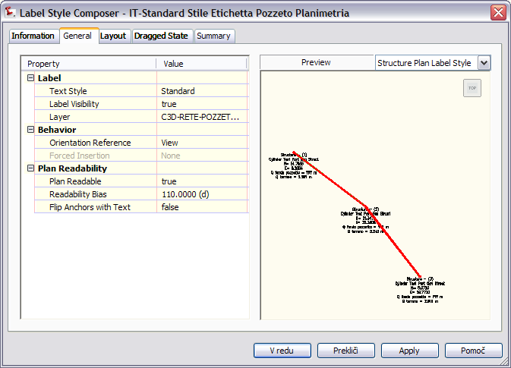
IT-Standard Stile Etichetta Pozzetto Profilo | Stile Metrico: visualizza Nome, Descrizione, Quota Fondo Pozzetto e Quota Terreno. | 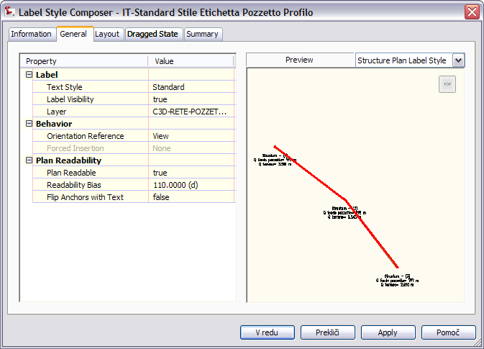

Structure Table Styles | Description | Screen grab / DWF / DWG | Default
IT-Standard |  | 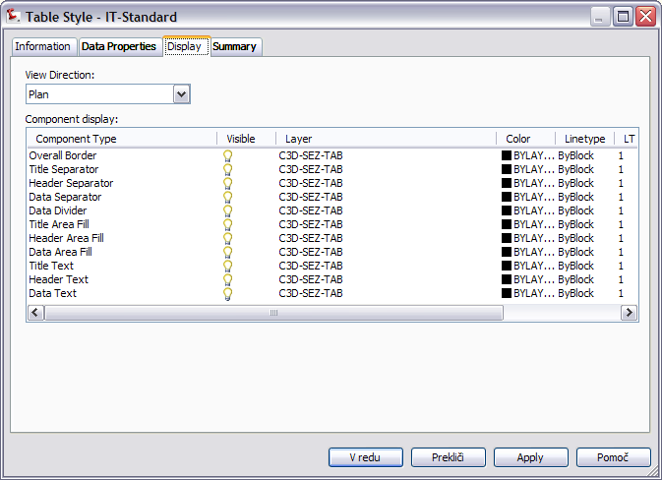

Corridors
<Template file name, start a new table for each template file>
Corridor Styles | Description | Screen grab / DWF / DWG | Default
IT-Standard Modellatore | Stile metrico per la visualizzazione del modellatore | 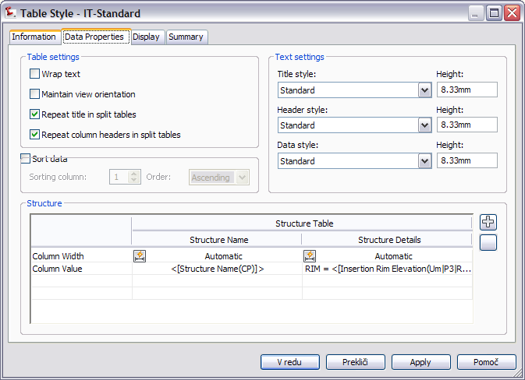  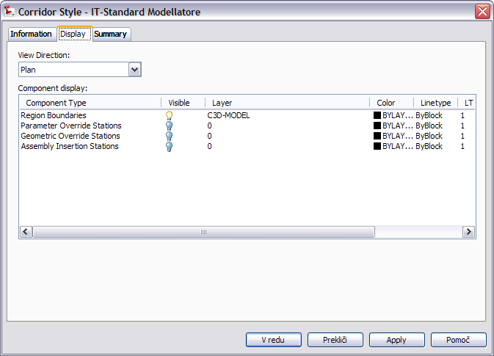

Assembly Styles | Description | Screen grab / DWF / DWG | Default
IT-Standard | Stile Metrico: stile per la visualizzazione dell'assieme | 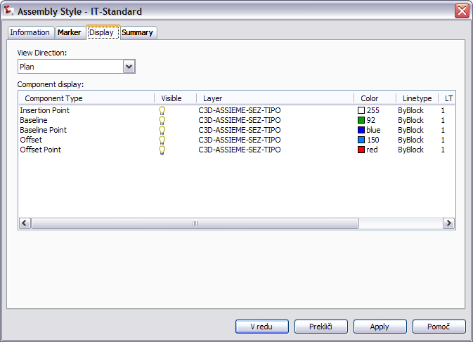

Mass Haul Line Styles | Description | Screen grab / DWF / DWG | Default
IT-Standard |  | 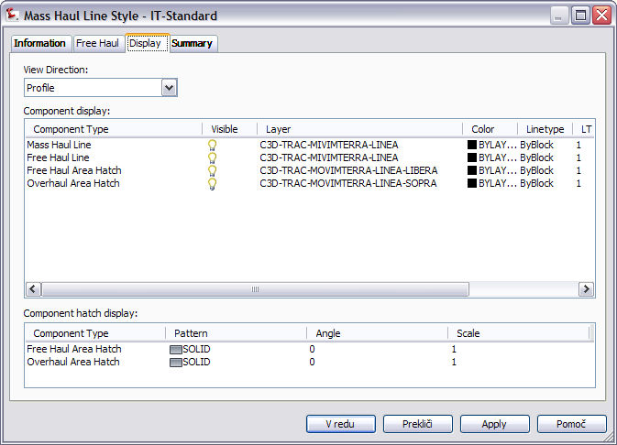

Mass Haul View Styles | Description | Screen grab / DWF / DWG | Default
IT-Standard |  | 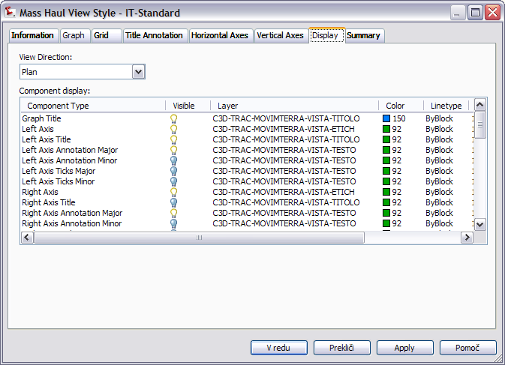

Quantity Takeoff Criteria | Description | Screen grab / DWF / DWG | Default
IT-Standard | Stile Metrico: un esempio di come organizzare gli articoli volume | 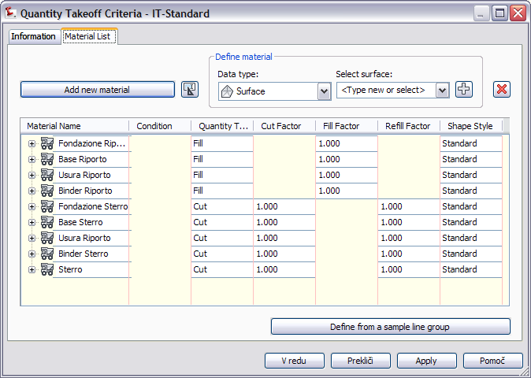
IT-Standard Scavo Rilevato |  | 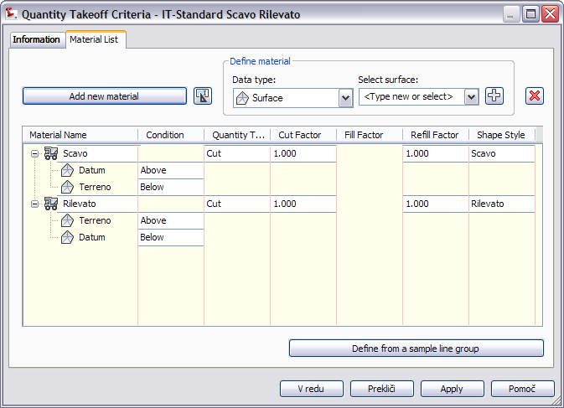

QTO Table Styles | Description | Screen grab / DWF / DWG | Default
Total Volume
IT-Standard |  | 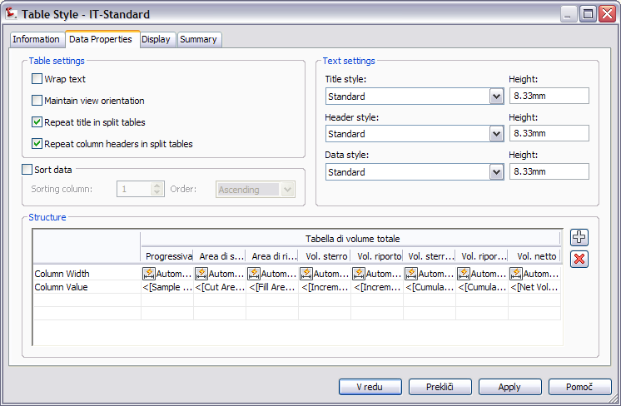
Material
IT-Standard |  | 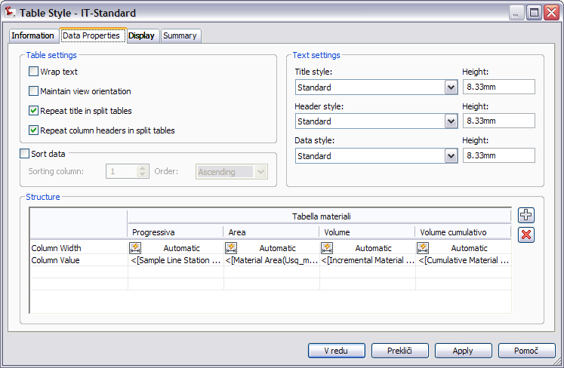

Plan and Profile Sheets
<Template file name, start a new table for each template file>
View Frame Styles | Description | Screen grab / DWF / DWG | Default
IT-Standard |  | 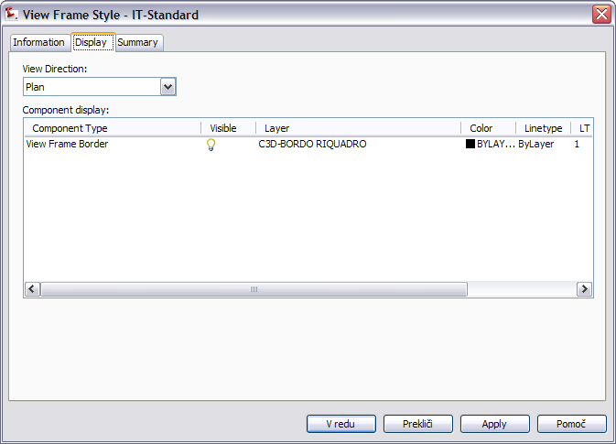

View Frame Label Styles | Description | Screen grab / DWF / DWG | Default
IT-Standard |  | 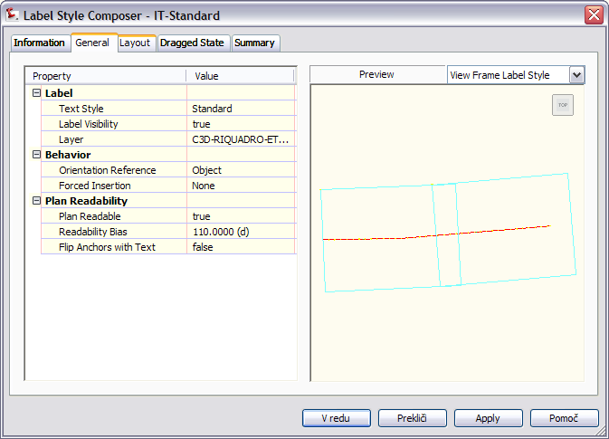

Match Line Styles | Description | Screen grab / DWF / DWG | Default
IT-Standard |  | 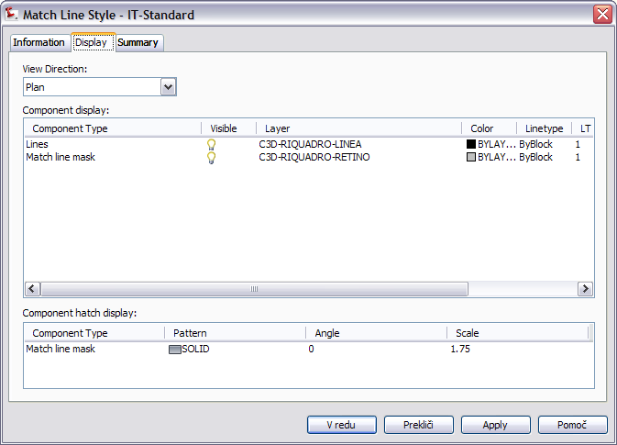

Match Line Label Styles | Description | Screen grab / DWF / DWG | Default
Match Line Left
IT-Standard |  | 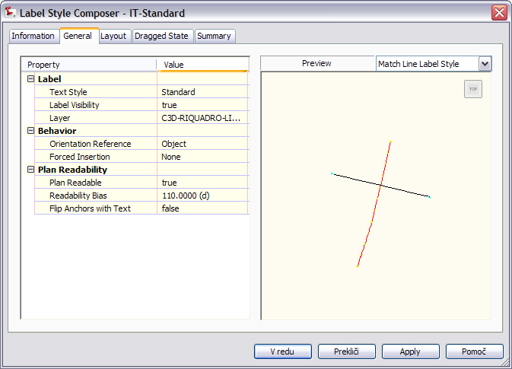
Match Line Right
IT-Standard |  | Same as Match Line Left

Survey
<Template file name, start a new table for each template file>
Network Styles | Description | Screen grab / DWF / DWG | Default
IT-Standard Rete di Rilievo | Stile metrico | 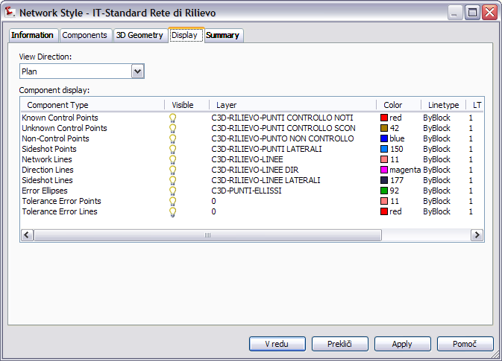

Figure Styles | Description | Screen grab / DWF / DWG | Default
IT-Standard Figura di Rilievo | Stile metrico per la visualizzazione di una figura di rilievo. | 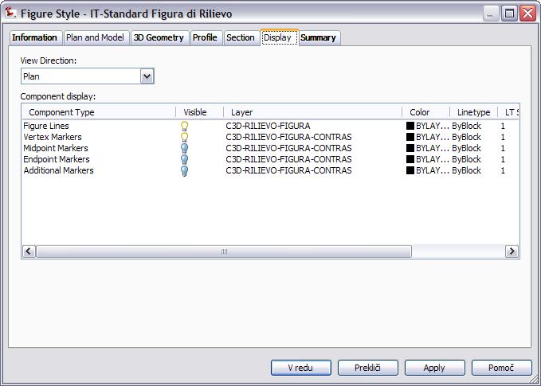

General - Multipurpose Styles – Shape Styles
This group contains the general component object styles and label styles. The following needs to be noted: (Generally all styles should be included with key description about them)
Add new Shape Style to all DWTs
Name: Multiple Boundary Material
Display Component | Visible | Layer | Color | Linetype | LTScale | Lineweight | Plot Style
All View Directions:
Shape Border Line | On | C-ROAD-SHAP | Blue | ByLayer | 1.0000 | ByLayer | NA
Shape Area Fill | On | C-ROAD-SHAP-PATT | Blue | ByLayer | 1.0000 | ByLayer | NA

Hatch Display Component Type | Pattern | Angle | Scale
All View Directions:
Shape Area Fill | ANSI31 | 0 | 1.7500

Object Defaults

Object | Description | Default Style
General Note Label Style
General Line Label Style
General Curve Label Style
Point Style
Point Label Style
Point Table Style
Surface Style
Surface Marker Style
Surface Spot Elevation Label Style
Surface Slope Label
Contour Label Major
Contour Label Minor
Contour label User-defined
Parcel Style
Parcel Area Label
Parcel Line label
Parcel Curve Label
Feature Line Style
Grading
Cut Slope Grading
Fill Slope Grading

Tool palette(s)

Subassemblies and assemblies
List names of files created and provide screengrab with description and usage

Material styles
List names of files created and provide screengrab with description and usage

Drawing symbols and (MV)Blocks
List names of files created and provide screengrab with description and usage

Pipe and Structure Catalogs
Describe additions and changes to pipe and structure catalogs here, with screen grabs.

Highway design check files
Civil3D Roadway Design Standards IT.xml (according to “Norme funzionali e geometriche per le construzione delle strade” (DM_05_11_2001))

Quantity Take Off

Overview of QTO
The QTO feature of Civil 3D “Tuckerman” is designed to create links between pay items from a DOT master pay items list and elements in the Civil 3D model. After the links are created, the QTO tools can extract the information and create reports or export the information to be used in estimation applications.

For the CK, there are four things that will be needed to make QTO work: a master pay items file, a pay items index file, a units mapping file and a series or custom report templates.

Creation of QTO

Master Pay Items List
The Master Pay Items List can have three formats, but the most common will be a CSV file (comma separated file) that contains three fields of information: Pay Item Number, Pay Item Description and Units. The program will use the Windows regional setting for the “List Separator” to split the file on. By default in English (US) this is a “,”.

Getting Started IT.csv CSV file prepared
Pay Item | Item Description-USC | UNIT_E
1.01.2.a. | Irruvidimento di pavimentazione stradale di qualsiasi tipo realizzato mediante incisione meccanica della superficie d'usura: Per superfici superiori a 3.000 m2 | M2
1.01.2.b. | Irruvidimento di pavimentazione stradale di qualsiasi tipo realizzato mediante incisione meccanica della superficie d'usura: Per superfici inferiori a 3.000 m2 | M2
1.01.3.a. | Demolizione di sottopavimentazioni e pavimentazioni in conglomerato bituminoso, escluso il trasporto a discarica , eseguita con mezzi meccanici: tappeto d'usura in bitume | M2
1.01.3.b. | Demolizione di sottopavimentazioni e pavimentazioni in conglomerato bituminoso, escluso il trasporto a discarica , eseguita con mezzi meccanici: binder | M2
1.01.3.c. | Demolizione di sottopavimentazioni e pavimentazioni in conglomerato bituminoso, escluso il trasporto a discarica , eseguita con mezzi meccanici: tappeto d'usura e binder | M2
1.01.3.d. | Demolizione di sottopavimentazioni e pavimentazioni in conglomerato bituminoso, escluso il trasporto a discarica , eseguita con mezzi meccanici: tappeto d'usura, binder e massicciata | M2
1.01.3.e. | Demolizione di sottopavimentazioni e pavimentazioni in conglomerato bituminoso, escluso il trasporto a discarica , eseguita con mezzi meccanici: tappeto d'usura, binder, massicciata e sottofondo di scapoli di pietra posti a mano | M2
1.01.3.f. | Demolizione di sottopavimentazioni e pavimentazioni in conglomerato bituminoso, escluso il trasporto a discarica , eseguita con mezzi meccanici: tappeto d'usura, binder, massicciata e sottofondo a materasso | M2
.
.
.

Pay Items Index
The Pay Items Index file is used to categorize the Master Pay Items file from a flat list to a tree structure.

Getting Started Categories IT.xml file prepared
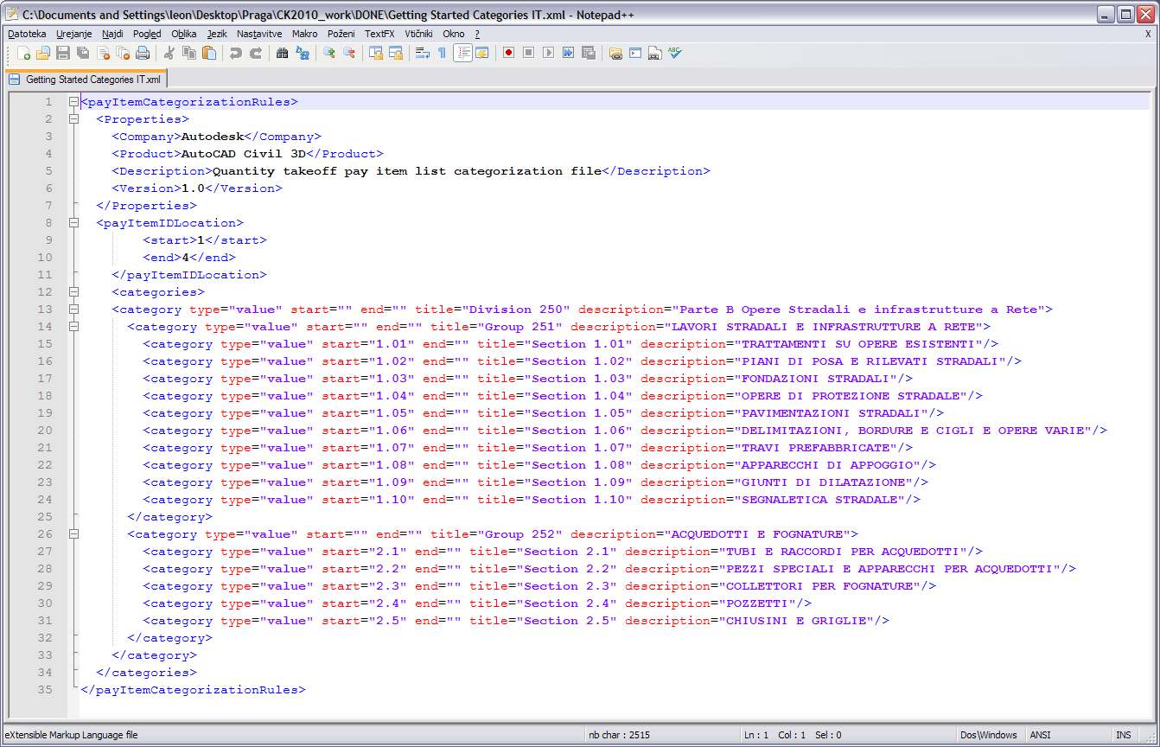

Units Mapping File
The Units Mapping file will map the strings for the units from the local to the system units.

Unit | Description
EA | Each
LF | Linear Feet
SF | Square Feet

Existing Mapping file was used.

Reports
Reports for the QTO feature are made using HTML style sheets (.XSL) files to format the QTO output. The output will be formatted by Civil 3D using the ambient settings for the QTO command. The report will list all the QTO items found in the model for the region specified.

Following reports created:

Summary (TXT)_IT.xsl
Summary (HTML)_IT.xsl
Summary (CSV)_IT.xsl

Detailed Linear (TXT)_IT.xsl
Detailed Linear (HTML)_IT.xsl
Detailed Linear (CSV)_IT.xsl

Detailed Area (TXT)_IT.xsl
Detailed Area (HTML)_IT.xsl
Detailed Area (CSV)_IT.xsl

QTO Command Settings
The command settings for the QTO are used to control the output of the xml file that will be published when the user makes a quantity takeoff. The primary settings are:

Setting | Description
Linear Unit | Each
Area Unit | Linear Feet
Volume Units | Square Feet
Station

QTO Command Settings:
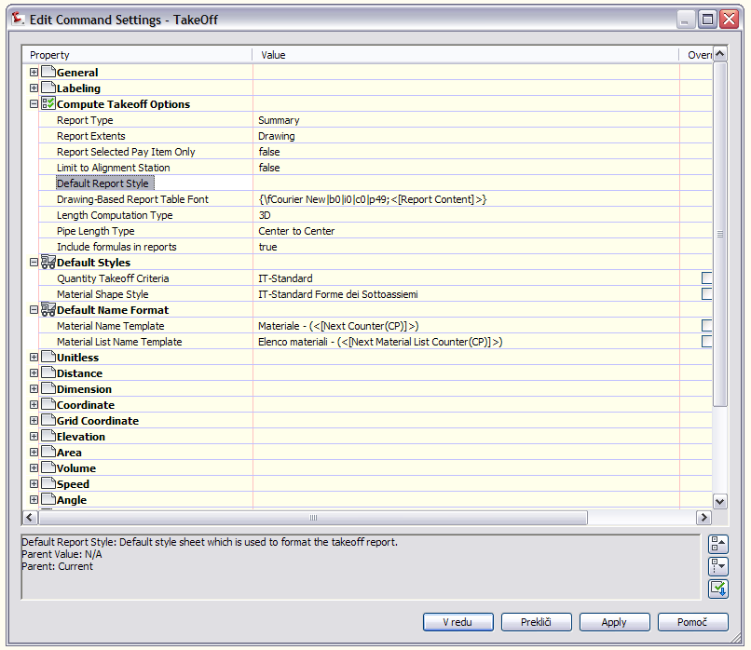

Installation of QTO
Future
See section 5.5 of content spec for information on style sheets provided to format quantity reports – provide details here of additional reports required.

Superelevation standards
Describe the XML file provided?
Civil3D Roadway Design Standards IT.xml

Superelevations adapted to “Norme funzionali e geometriche per le construzione delle strade” (DM_05_11_2001)

<?xml version="1.0" encoding="utf-8"?>
<Civil3DRoadwayDesignStandards xmlns="urn:Civil3DRoadwayDesignStandards-schema" version="" language="" date="" time="">
<Units>
<Metric areaUnit="squareMeter" linearUnit="meter" volumeUnit="cubicMeter" speedUnit="kilometersPerHour" temperatureUnit="celsius" pressureUnit="milliBars" diameterUnit="meter" widthUnit="meter" heightUnit="meter" flowUnit="literPerSecond" angularUnit="radians" directionUnit="radians" />
</Units>
<Alignments>
<MinimumRadiusTables>
<MinimumRadiusTable name="Strade Ae">
<MinimumRadius speed="90" radius="339"></MinimumRadius>
<MinimumRadius speed="100" radius="437"></MinimumRadius>
<MinimumRadius speed="120" radius="667"></MinimumRadius>
<MinimumRadius speed="140" radius="964"></MinimumRadius>
</MinimumRadiusTable>
<MinimumRadiusTable name="Strade Au">
<MinimumRadius speed="80" radius="252"></MinimumRadius>
<MinimumRadius speed="90" radius="339"></MinimumRadius>
<MinimumRadius speed="100" radius="437"></MinimumRadius>
<MinimumRadius speed="120" radius="667"></MinimumRadius>
<MinimumRadius speed="140" radius="964"></MinimumRadius>
</MinimumRadiusTable>
<MinimumRadiusTable name="Strade B">
<MinimumRadius speed="70" radius="178"></MinimumRadius>
<MinimumRadius speed="80" radius="252"></MinimumRadius>
<MinimumRadius speed="90" radius="339"></MinimumRadius>
<MinimumRadius speed="100" radius="437"></MinimumRadius>
<MinimumRadius speed="120" radius="667"></MinimumRadius>
</MinimumRadiusTable>
<MinimumRadiusTable name="Strade C, Fe">
<MinimumRadius speed="40" radius="45"></MinimumRadius>
<MinimumRadius speed="60" radius="118"></MinimumRadius>
<MinimumRadius speed="70" radius="178"></MinimumRadius>
<MinimumRadius speed="80" radius="252"></MinimumRadius>
<MinimumRadius speed="90" radius="339"></MinimumRadius>
<MinimumRadius speed="100" radius="437"></MinimumRadius>
</MinimumRadiusTable>
<MinimumRadiusTable name="Strade D">
<MinimumRadius speed="50" radius="77"></MinimumRadius>
<MinimumRadius speed="80" radius="240"></MinimumRadius>
</MinimumRadiusTable>
<MinimumRadiusTable name="Strade E, Fu">
<MinimumRadius speed="25" radius="19"></MinimumRadius>
<MinimumRadius speed="40" radius="51"></MinimumRadius>
</MinimumRadiusTable>
</MinimumRadiusTables>
<SuperelevationAttainmentMethods>
<SuperelevationAttainmentMethod name="Planar">
<TransitionStylePlanar>
<Continuing>
<TransitionFormula type="NCtoFS" formula="{l}-{l}*{c}/{e}" />
<TransitionFormula type="NCtoBC" formula="{l}*{0.67}-{c}/{e})" />
</Continuing>
<Opposing>
<TransitionFormula type="LCtoFS" formula="{l}" />
<TransitionFormula type="LCtoBC" formula="0.67*{l}" />
<TransitionFormula type="NCtoLC" formula="{l}*{c}/{s}" />
</Opposing>
</TransitionStylePlanar>
</SuperelevationAttainmentMethod>
<SuperelevationAttainmentMethod name="Crowned">
<TransitionStyleStandard>
<TransitionFormula type="LCtoFS" formula="{l}-{25.0}" />
<TransitionFormula type="LCtoBC" formula="{l}-{25.0}" />
<TransitionFormula type="NCtoLC" formula="{25.0}" />
<TransitionFormula type="LCtoRC" formula="{25.0}" />
<TransitionFormula type="NStoNC" formula="0" />
</TransitionStyleStandard>
</SuperelevationAttainmentMethod>
</SuperelevationAttainmentMethods>
<SuperelevationTables>
<SuperelevationTable name="Strade Ae">
<SuperelevationDesignSpeed speed="140">
<SuperelevationRate radius="4820" eRate="2.5" />
<SuperelevationRate radius="964" eRate="7.0" />
</SuperelevationDesignSpeed>
<SuperelevationDesignSpeed speed="120">
<SuperelevationRate radius="4820" eRate="2.5"></SuperelevationRate>
<SuperelevationRate radius="964" eRate="7.0" />
<SuperelevationRate radius="667" eRate="7.0" />
</SuperelevationDesignSpeed>
<SuperelevationDesignSpeed speed="100">
<SuperelevationRate radius="4820" eRate="2.5"></SuperelevationRate>
<SuperelevationRate radius="964" eRate="7.0" />
<SuperelevationRate radius="437" eRate="7.0" />
</SuperelevationDesignSpeed>
<SuperelevationDesignSpeed speed="90">
<SuperelevationRate radius="4820" eRate="2.5" />
<SuperelevationRate radius="964" eRate="7.0"></SuperelevationRate>
<SuperelevationRate radius="339" eRate="7.0" />
</SuperelevationDesignSpeed>
<TransitionLengthTables>
<TransitionLengthTable name="2corsie">
<TransitionLengthDesignSpeed speed="90">
<TransitionLength radius="339" tLength="156" />
<TransitionLength radius="2187" tLength="0" />
</TransitionLengthDesignSpeed>
<TransitionLengthDesignSpeed speed="100">
<TransitionLength radius="437" tLength="212" />
<TransitionLength radius="2187" tLength="0" />
</TransitionLengthDesignSpeed>
<TransitionLengthDesignSpeed speed="120">
<TransitionLength radius="667" tLength="312" />
<TransitionLength radius="3334" tLength="0" />
</TransitionLengthDesignSpeed>
<TransitionLengthDesignSpeed speed="140">
<TransitionLength radius="964" tLength="456" />
<TransitionLength radius="4820" tLength="0" />
</TransitionLengthDesignSpeed>
</TransitionLengthTable>
</TransitionLengthTables>
</SuperelevationTable>
.
.
.
continuing

Intersection feature – Styles, Names and Assembly sets
Name | DWT Value | Comments | Screengrab/DWG/DWF
Intersection Style | Intersection Marker | New Style Needed (see below)
Intersection Label Style | Intersection Label | New Style Needed (See below)
Offset Alignment Style | Design
Curb Return Alignment Style | Basic
Offset Profile Style | Design Profile
Curb Return Profile Style | Design Profile
Offset Alignment Label Set | Major and Minor Only
Curb Return Alignment Label Set | Major and Minor Only
Offset Profile Label Set | _No Labels
Curb Return Profile Label Set | _No Labels
Intersection Name Format | (Intersection) - (Next Counter)
Intersection Quadrant Name Format | (Intersection Name) –(Quadrant Location) – QUADRANT
Offset Alignment Name Format | (Parent Alignment Name) – (Side) – (Offset Distance)
Curb Return Alignment Name Format | (Intersection Name) – (Intersection Quadrant Name)
Offset Profile Name Format | (Parent Alignment Name) – (Side) – (Offset Profile Nominal Cross Slope)
Curb Return Profile Name Format | (Parent Alignment Name) - (Intersection Name) – (Intersection Quadrant Name)
Corridor Region Name Format | (Intersection Name) – (Baseline Name) – (Assembly Name)
See section 5.4 of content spec for instructions on developing an assembly set for the intersection feature.

Installation
The following table is used to catalog all the files that are part of the CK along with a brief description, the current location and the folder where they will be installed, and if the file is added to the user cache for second and subsequent restricted rights user installation. This information will be used when the install is created for the CK.

File Name | Description | Path | Installation Folder |  | User Cache

