AutoCAD® Civil 3D® 2010
“SWE Country Kit”
Workbook
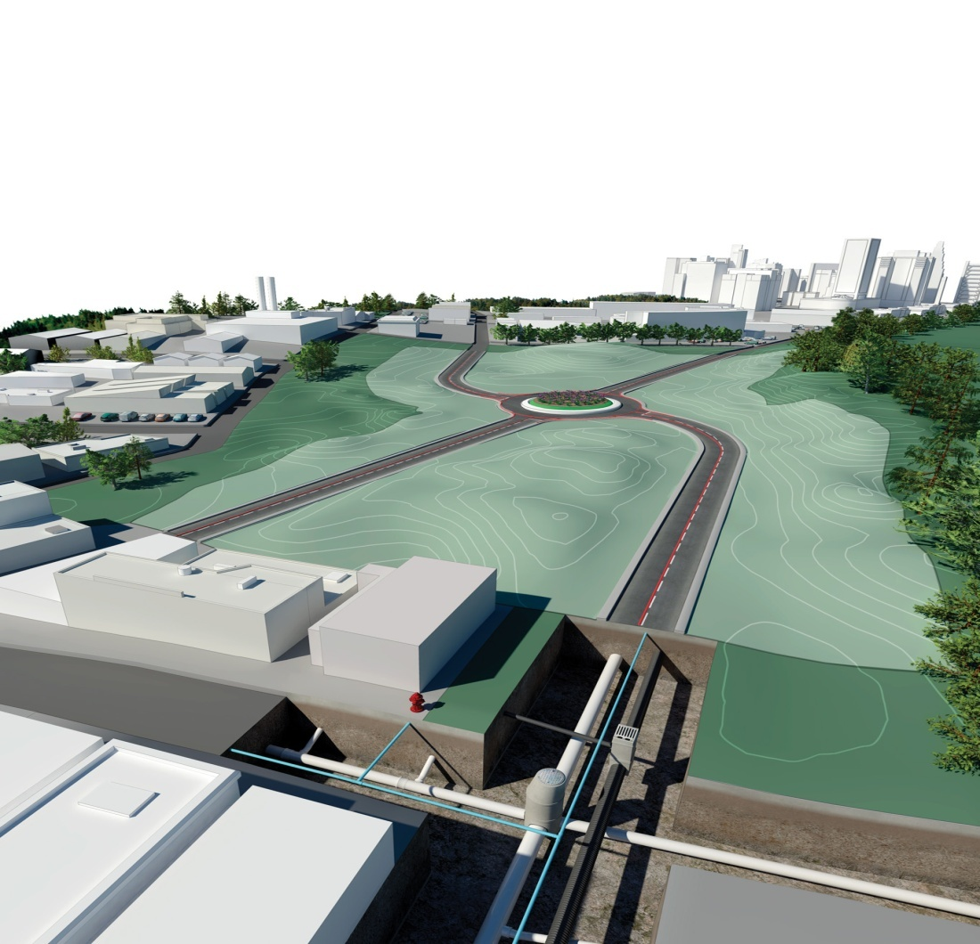
Purpose of this document:
This document provides guidelines for development of Civil 3D Country kits

Authors: Kevin Stewart, Peter Funk, Jessica Tarr, Ian McGregor
Revision History | Status
December 10 2008 | Draft 1 – reviewed by PF JT IDM
Jan 12 2009 | Draft 1.a by Thomas Nilsson Augustin Konsult HB

Country Kit Workbook

1 Overview 3
1.1 Introduction 3
1.2 Content Development Precaution 3
2 Fonts and Text Styles 4
3 Hatch Patterns 5
4 Layers 6
5 Reports 7
6 Drawing Settings > Object Layers 8
6.1 Object Layers 9
6.2 Ambient Settings 10
7 Object Styles 11
7.1 Multi-purpose Styles 11
7.2 Points 12
7.3 Surfaces 13
7.4 Parcels 13
7.5 Grading 14
7.6 Alignments 14
7.7 Profiles 16
7.8 Sections 18
7.9 Pipe Networks 19
7.10 Corridors 21
7.11 Plan and Profile Sheets 21
7.12 Survey 22
7.13 General - Multipurpose Styles – Shape Styles 22
8 Object Defaults 24
9 Tool palette(s) 25
9.1 Subassemblies and assemblies 25
9.2 Material styles 25
9.3 Drawing symbols and (MV)Blocks 25
10 Pipe and Structure Catalogs 26
11 Highway design check files 27
12 Quantity Take Off 28
12.1 Overview of QTO 28
12.2 Creation of QTO 28
12.3 Installation of QTO 29
13 Superelevation standards 30
14 Intersection feature – Styles, Names and Assembly sets 31
15 Installation 33

Overview

Introduction

This document is intended to provide a comprehensive guide to building and installing a country kit on AutoCAD Civil 3D 2010 and AutoCAD Civil 2010. It also serves as the building block from which the user country kit help document should be created.
It provides a skeleton overview of everything that can be provided to make Civil 3D appear as a local product and a detailed view of new functionality in the latest release of Civil 3D. This somewhat assumes that a country kit of sorts already exists for the previous version, but if it doesn’t exist for your local language then it is recommended to select the country kit deemed closest to your requirements from www.autodesk.com/civil3d-countrykits and proceed from there as your starting point.
This document should be provided in both English and your local language (where appropriate). Screen grabs are only required in local language, but descriptions of screen grabs should be provided in both English and local language.
Where a section is not provided for in your template(s) or kit, please do not delete the section or leave blank, but write “Not provided” to ensure that Autodesk know the section has been considered.

Content Development Precaution
It is important that you add, incrementally to existing country kits, various styles as noted in this document – using Civil 3D 2009 templates that have been converted to Civil 3D 2010 as a baseline. Key things to note in developing these are:
- Autodesk require that all styles are stamped with the creator name as Autodesk. To automate this, set your system log-in name as “Autodesk” so that Created By and Modified By are not stamped with other user names
- Make sure AutoCAD Architecture is not loaded, so that unnecessary dbx modules are not stamped in. Each time – make sure that you save and exit current acad.exe session and reopen the dwt in new session to verify AutoCAD Architecture dbx modules are not loaded. It is good practice to save back multiple versions of your temlate so that we can go back to the previous good one. Autodesk will use Buzzsaw features to help automate this for you at Autodesk provided workshops.
- Please set PLINEGEN variable to 1.

Fonts and Text Styles
Svenskt country kit använder standard AutoCAD text styles och fonts. Tabellen nedan visar dessa.
Swedish country kit uses standard AutoCAD text styles and fonts, displayed in the table below.

Text Style | Description | Font | Plotted Size
Standard |  | SIMPLEX | 1.5mm > 5.0mm
ISOCP |  | ISOCP | 1.5mm > 5.0mm

Hatch Patterns
Svenskt country kit använder standard AutoCAD raster (Hatch Patterns).
Swedish country kit uses standard AutoCAD Hatch Patterns.
Hatch Pattern Name | Description | Hatch Pattern File

Layers
Nedanstående tabell visar de lager som används. De flesta lagernamn är självförklarande.
Det viktiga att förstå med lagerhanteringen är att själva Civil-objektet hamnar på ett lager enligt inställningen på Drawing Settings, fliken Object Layers (högerklicka på ritningsnamnet i Toolspace/Settings-fliken). Se mer om detta i avsnitt 6. Civil 3D:s olika stilar kan sedan använda andra lager för de olika objektdelarna som ingår i varje objekt.

Table below displayes used layers. The layer name guides in swedish and the description guides in english.

Färgstandard/Color standard:
Pen width, Color, Name
0.08, nr 8, grå/Grey
0.12, 12, mörkröd/deep red
0.18, 4, cyan
0.25, 1, röd/red
0.35, 3, grön/green
0.50, 7, vit/sv/white
0.70, 6, magenta
1.00, 2, gul/yellow
1.40, 5, blå/blue

Name | Description | Color | Linetype | Used by style
Ahp |  | red | Continuous
BYGGNAD |  | cyan | Continuous | Building Site
BYGGNAD-FGRANS |  | cyan | Continuous | Building Site
BYGGNAD-FINPLAN |  | cyan | Continuous | Building Site
BYGGNAD-INSTALLATIONER |  | cyan | Continuous | Building Site
BYGGNAD-MODELL |  | cyan | Continuous | Building Site
Defpoints |  | white | Continuous
FEATURELINE-2D |  | green | Continuous | Feature Line Styles
FEATURELINE-3D |  | red | Continuous | Feature Line Styles
FEATURELINE-PROFIL |  | red | Continuous | Feature Line Styles
FEATURELINE-SEKTION |  | red | Continuous | Feature Line Styles
KORRIDOR | Roadways: corridor | green | Continuous | Corridor Style
KORRIDOR-GRANS | Roadways: corridor boundary | red | CENTER2 | Corridor Style
KORRIDOR-MOD |  | green | Continuous | Corridor Style
KORRIDOR-NORMSEKT |  | magenta | Continuous | Assembly style
KORRIDOR-RASTER | Roadways: corridor patterns | 8 | Continuous | Corridor Style
KORRIDOR-SEKT-PROFIL |  | red | CENTER2 | Corridor Style
KORRIDOR-SEKT-TERR |  | green | CENTER2 | Corridor Style
KORRIDOR-SEKT-VAGMITT |  | red | CENTER2 | Corridor Style
KORRIDOR-TEXT |  | red | Continuous | Corridor Labels
KORSNING |  | red | Continuous | Intersection Style
KORSNING-TEXT |  | red | Continuous | Intersection Labels
MATDATA | Survey Control points: traverse | green | Continuous | Survey Data
MATDATA-BYGGNAD | Survey Buildings: outline | red | Continuous | Survey Data
MATDATA-LINJE | Survey: lines | red | Continuous | Survey Data
MATDATA-PKT | Survey Control points: unknown points | cyan | Continuous | Survey Data
MATDATA-SEKTION |  | red | Continuous | Survey Data
MATDATA-SKYLT | Survey Node: sign. | red | Continuous | Survey Data
MATDATA-STAKET | Survey Site: fences | red | FENCELINE2 | Survey Data
MATDATA-STOMNAT-BAKATRIKT | Survey Control points: sideshots | cyan | Continuous | Survey Data
MATDATA-STOMNAT-FEL | Survey Control points: traverse errors | 30 | Continuous | Survey Data
MATDATA-STOMNAT-FIXPKT | Survey Control points: benchmark. | green | Continuous | Survey Data
MATDATA-STOMNAT-HOJDFIX | Survey Control points: vertical. | green | Continuous | Survey Data
MATDATA-STOMNAT-KONTRPKT | Survey Control points: known points | blue | Continuous | Survey Data
MATDATA-STOMNAT-NAT | Survey Control points: traverse network | green | Continuous | Survey Data
MATDATA-STOMNAT-PIKE | Survey Control points: traverse sideshot | yellow | Continuous | Survey Data
MATDATA-STOMNAT-POLYGONPKT | Survey Control points: horizontal. | magenta | Continuous | Survey Data
MATDATA-STOMNAT-POLYGONPKT-OKAND | Survey Control points: unknown points | 40 | Continuous | Survey Data
MATDATA-STOMNAT-RIKTER | Survey: figure geometry | 9 | Continuous | Survey Data
MATDATA-TEXT | Survey: text | red | Continuous | Survey Labels
MATDATA-TRAD | Survey Node: tree points. | red | Continuous | Survey Data
MATDATA-VAG-CENTR | Survey Road: centerline | red | BH90_VAGMITT_BEF | Survey Data
MATDATA-VAG-KANT | Survey Road: curbs | red | BH90_KBK_BEF | Survey Data
MATDATA-VEG | Survey Site: vegetation, trees, shrubs | red | Continuous | Survey Data
NORMSEKT | Roadways: assemblies and subassemblies | cyan | Continuous | Subassemblies
NORMSEKT-BLIN | Roadways: assembly baseline | white | Continuous | Subassemblies
NORMSEKT-CIRKEL |  | cyan | Continuous | Subassemblies
NORMSEKT-OFFS | Roadways: assembly offset | green | Continuous | Subassemblies
NORMSEKT-TEXT | Roadways: assembly text | red | Continuous | Subassemblie Labels
NOT-KONNEKTION | C-ANNO-MTCH | green | DASHED | Match Line Styles/  Konnektionslinjer
NOT-KONNEKTION-RASTER | C-ANNO-MTCH-HATCH | green | Continuous | Match Line Hatch/  Konnektionslinjer
NOT-KONNEKTION-TEXT | C-ANNO-MTCH-TEXT | green | Continuous | Match Line Labels/  Konnektionslinjer
NOT-RITRAM | C-ANNO-VFRM | green | Continuous | View Frames/ Ritningsramar
NOT-RITRAM-TEXT | C-ANNO-VFRM-TEXT | green | Continuous | View Frame Labels/ Ritningsram-text
NOT-TABELL | Civil: Table | green | Continuous | General tables  Tabeller
NOT-TABELL-RAM | Civil: Table Borders | green | Continuous | General tables-Frame  Tabeller
NOT-TABELL-RASTER | Civil: Table Hatch | green | Continuous | General tables- Hatch  Tabeller
NOT-TABELL-TEXT | Civil: Table Text | green | Continuous | General tables-Text  Tabeller
NOT-TABELL-TITEL | Civil: Table Title | green | Continuous | General tables-Title  Tabeller
NOTERING | Civil: Label | red | Continuous | General Labels  Noteringar
PROFIL-ASMK | Roadways: profile assymetrical curves | white | Continuous | Profile styles
PROFIL-BERG | Roadways: profiles | red | BERG | Profile styles
PROFIL-DIAG | Roadways: profile band diagrams | red | Continuous | Profile styles
PROFIL-DIAG-DOLD |  | red | Continuous | Profile styles
PROFIL-DIAG-TVARFALL-H | Roadways: profile right offset sample line | green | CENTER2 | Profile styles
PROFIL-DIAG-TVARFALL-V | Roadways: profile left offset sample line | red | DASHED | Profile styles
PROFIL-HSIDA | Roadways: profile right offset sample line | green | CENTER2 | Profile styles
PROFIL-KURVA | Roadways: profile vertical curves | white | Continuous | Profile styles
PROFIL-LANGDM-GEOM | Roadways: profile geometry point labels | red | Continuous | Profile styles
PROFIL-LANGDM-HUVUD | Roadways: profile major station labels | red | Continuous | Profile styles
PROFIL-LANGDM-STOD | Roadways: profile minor station labels | red | Continuous | Profile styles
PROFIL-LINE | Roadways: profile vertical lines | red | Continuous | Profile styles
PROFIL-LINE-EXTN | Roadways: centerline extention | red | HIDDEN | Profile styles
PROFIL-MARK | Roadways: profiles | cyan | Continuous | Profile styles
PROFIL-MARK-NY |  | white | Continuous | Profile styles
PROFIL-NY | Roadways: profile new | white | Continuous | Profile styles
PROFIL-PARB | Roadways: profile parabolic curves | white | Continuous | Profile styles
PROFIL-PNKT | Roadways: profile geometry points | white | HIDDEN | Profile styles
PROFIL-PROJICERAT |  | red | Continuous | Projection styles
PROFIL-RAM | Roadways: profile border | red | Continuous | Profile Views
PROFIL-RUT | Roadways: profile grid | red | Continuous | Profile Views
PROFIL-RUT-GEOM | Roadways: profile gridline @ geometry points | red | Continuous | Profile Views
PROFIL-RUT-HUVUD | Roadways: profile gridline @ major stations | red | Continuous | Profile Views
PROFIL-RUT-STOD | Roadways: profile gridline @ minor stations | red | Continuous | Profile Views
PROFIL-TEXT | Roadways: profile text | red | Continuous | Profile Labels
PROFIL-TICK | Roadways: profile tick marks | red | Continuous | Profile Views
PROFIL-TITEL | Roadways: profile label | red | Continuous | Profile Views
PROFIL-VSIDA | Roadways: profile left offset sample line | red | DASHED | Profile Styles
PROFIL-VY | Roadways: profile view | red | Continuous | Profile Views
PUNKT | Survey Node | green | Continuous | Points
PUNKT-2D |  | white | Continuous | Point Styles Plan
PUNKT-3D |  | magenta | Continuous | Point Styles Model
PUNKT-TABELL | Node: tables | red | Continuous | Point Tables
PUNKT-TEXT | Survey Node: text | red | Continuous | Point Labels
QTO-RASTER |  | green | Continuous | QTO Hatch
RIT-BLANKETT |  | red | Continuous | View Frames in Layouts  Ritningsram i layout
RIT-NORRPIL |  | white | Continuous | North arrow in Layouts  Norrpil i layout
RIT-SKALST |  | red | Continuous | Scale bar in Layouts  Skalstock i layout
RIT-STAMPEL |  | red | Continuous | Text label in Layouts  Textruta i layout
RIT-STAMPEL-ATTR025 |  | yellow | Continuous | Text label in Layouts  Textruta i layout
RIT-STAMPEL-ATTR035 |  | green | Continuous | Text label in Layouts  Textruta i layout
RIT-STAMPEL-ATTR050 |  | white | Continuous | Text label in Layouts  Textruta i layout
RIT-STAMPEL-LINJE |  | red | Continuous | Text label in Layouts  Textruta i layout
RIT-STAMPEL-TEXT018 |  | red | Continuous | Text label in Layouts  Textruta i layout
SEKTION | Roadways: grade in sections | red | Continuous | Section styles
SEKTION-BERG | Roadways: profiles | red | BERG | Section styles
SEKTION-BET | Roadways: section labels | red | Continuous | Section styles
SEKTION-DIAG | Roadways: section diagram | red | Continuous | Section styles
SEKTION-KORR | Roadways: corridor in sections | red | Continuous | Section styles
SEKTION-MARK | Roadways: profiles | green | Continuous | Section styles
SEKTION-MARKERING | Roadways: sample lines | red | HIDDEN | Sample Lines  Sektionsmarkering
SEKTION-MARKERING-BET | Roadways: sample lines labels | red | Continuous | Sample Lines  Sektionsmarkering
SEKTION-MARKERING-TEXT | Roadways: sample lines text | red | Continuous | Sample Lines  Sektionsmarkering
SEKTION-NY | Roadways: section, NEW | white | Continuous | Section styles
SEKTION-PROJICERAT |  | red | HIDDEN | Projection styles
SEKTION-RAM | Roadways: section border | red | Continuous | Section styles
SEKTION-RUT | Roadways: section grid | red | Continuous | Section styles
SEKTION-SHET | Roadways: grade in section sheets | red | Continuous | Section styles
SEKTION-TEXT | Roadways: section text | red | Continuous | Section styles
SEKTION-TICK | Roadways: section tick marks | red | Continuous | Section styles
SEKTION-TITEL | Roadways: section title | green | Continuous | Section styles
SEKTION-VY | Roadways: section view | red | Continuous | Section styles
TERR-3D | Triangulated irregular network: triangle view | green | Continuous | Surface styles Model
TERR-AVRINN | Topography: watershed | blue | Continuous | Surface styles
TERR-AVRINN-OMRADE | Catchment areas | blue | Continuous
TERR-AVRINN-TEXT | Topography: watershed text | red | Continuous | Surface styles
TERR-FEAT | Topography: feature line | green | Continuous
TERR-GRANS | Triangulated irregular network: boundary | yellow | Continuous | Surface styles – Border  Gränslinje
TERR-NIV | Topography | red | Continuous | Surface styles
TERR-NIV-HUVUD | Topography: major contours | 9 | Continuous | Surface styles – Bef nivåkurvor
TERR-NIV-HUVUD-NY | Topography: major contours, NEW | green | Continuous | Surface styles – Nya nivåkurvor
TERR-NIV-STOD | Topography: minor contours | 8 | Continuous | Surface styles – Bef nivåkurvor
TERR-NIV-STOD-NY | Topography: minor contours, NEW | red | Continuous | Surface styles – Nya nivåkurvor
TERR-NIV-TEXT | Topography: contour labels | red | Continuous | Contour labels  Besiffring nivåkurvor
TERR-NIV-TEXT-LIN |  | 9 | Continuous | Contour label Line  Besiffringslinje för nivåkurvor
TERR-NIV-TEXT-NY | Topography: contours labels, NEW | red | Continuous | Contour labels  Besiffring nivåkurvor
TERR-NIV-USER | Topography: user contours | white | Continuous
TERR-RUT |  | 252 | Continuous | Surface styles Grid  Rutnät
TERR-SLNT | Topography: grading | green | Continuous | Grading styles
TERR-SLNT-BET |  | green | Continuous | Grading styles
TERR-SLNT-FYLL | Topography: grading fill material | green | Continuous | Grading styles
TERR-SLNT-SKAR | Topography: grading cut material | red | Continuous | Grading styles
TERR-TABELL | Topography: table | red | Continuous | Surface Table
TERR-TEXT | Topography: text | red | Continuous | Surface Lable
TERR-TIN | Triangulated irregular network | red | Continuous | Surface styles TIN  Triangelmodell
TERR-VATTENDROP | Topography: water drop | blue | Continuous
TOMT | Property: lots | green | Continuous | Parcel Styles
TOMT-BET | Property: label | green | Continuous | Parcel Styles
TOMT-BRNG | Property: bearing | green | Continuous | Parcel Styles
TOMT-GRANS | Property: boundary | green | Continuous | Parcel Styles
TOMT-KURVA-TEXT | Property: radii and distance for curve segment lables | red | Continuous | Parcel Styles
TOMT-LINJE | Property: parcel lines | green | Continuous | Parcel Styles
TOMT-LINJE-TEXT | Property: bearings and distance for line segment lables | red | Continuous | Parcel Segment Labels
TOMT-RASTER | Property: parcel hatching | green | Continuous | Parcel Styles
TOMT-RSRV | Property: reserved | green | Continuous | Parcel Styles
TOMT-TABELL | Property: tables | red | Continuous | Parcel Table
TOMT-TEXT | Property: label | red | Continuous | Parcel Labels
TOMT-VAGOMR | Easements: roadway | green | Continuous | Parcel Styles
VA-BRUNN |  | white | Continuous | Structures – Main object  Huvudlager för alla brunnar
VA-BRUNN-TEXT |  | red | Continuous | Structures – Labels  Text för brunnar
VA-DAGV-BRUNN | Storm Sewer: structures | green | Continuous | Structures style  Dagvattenbrunnar
VA-DAGV-BRUNN-PROF |  | green | Continuous | Structures style  Dagvattenbrunnar
VA-DAGV-BRUNN-RASTER | Storm Sewer: structures, hatching | red | Continuous | Structures style  Dagvattenbrunnar
VA-DAGV-CNTR | Storm Sewer: centerline | white | BH90_VA_D_PROJ_B | Pipe style  Dagvattenledning
VA-DAGV-LEDN | Storm Sewer: piping | white | BH90_VA_D_PROJ_B | Pipe style  Dagvattenledning
VA-DAGV-LEDN-PROF | Storm Sewer: profile | white | BH90_VA_D_PROJ_B | Pipe style  Dagvattenledning
VA-DAGV-LEDN-RASTER | Storm Sewer: piping, hatching | red | Continuous | Pipe style  Dagvattenledning
VA-DAGV-PROF-TEXT |  | red | Continuous | Pipe label style  Dagvattenledning
VA-DAGV-SEKT |  | green | BH90_VA_D_PROJ_B | Pipe style  Dagvattenledning
VA-DAGV-TEXT | Storm Sewer: text | red | Continuous | Pipe label style  Dagvattenledning
VA-DRAN-BRUNN | Storm Sewer: structures | green | Continuous | Structures style  Dränering
VA-DRAN-BRUNN-PROF |  | green | Continuous | Structures style  Dränering
VA-DRAN-BRUNN-RASTER | Storm Sewer: structures, hatching | red | Continuous | Structures style  Dränering
VA-DRAN-CNTR |  | white | Continuous | Pipe style  Dränering
VA-DRAN-LEDN |  | white | Continuous | Pipe style  Dränering
VA-DRAN-LEDN-PROF |  | white | Continuous | Pipe style  Dränering
VA-DRAN-LEDN-RASTER |  | red | Continuous | Pipe style  Dränering
VA-DRAN-SEKT |  | green | Continuous | Pipe style  Dränering
VA-DRAN-TEXT |  | red | Continuous | Pipe label style  Dränering
VA-KOLLISION |  | magenta | Continuous | Pipe Network -Interference Style
VA-LEDN |  | white | Continuous | Pipes – Main object  Huvudlager för alla ledningar
VA-LEDN-TEXT |  | red | Continuous | Pipe – Labels  Text för brunnar
VA-PROF |  | white | Continuous | Profile Styles
VA-PROFIL-ASMK |  | white | Continuous | Profile Styles
VA-PROFIL-KURVA |  | white | Continuous | Profile Styles
VA-PROFIL-LINE-EXTN |  | red | HIDDEN | Profile Styles
VA-PROFIL-LINJE |  | red | Continuous | Profile Styles
VA-PROFIL-PARB |  | white | Continuous | Profile Styles
VA-PROFIL-PNKT |  | white | HIDDEN | Profile Styles
VA-PROFIL-TEXT |  | red | Continuous | Profile Labels
VA-SEKT |  | white | Continuous | Section Styles
VA-SPILL-BRUNN | Sanitary Sewer: structures | green | Continuous | Structures style  Spillvatten
VA-SPILL-BRUNN-PROF | Sanitary Sewer: structure, profile | green | Continuous | Structures style  Spillvatten
VA-SPILL-BRUNN-RASTER | Sanitary Sewer: structures, hatching | red | Continuous | Structures style  Spillvatten
VA-SPILL-CNTR | Sanitary Sewer: centerline | white | Continuous | Pipe style Spillvatten
VA-SPILL-LEDN | Sanitary Sewer: piping | white | Continuous | Pipe style Spillvatten
VA-SPILL-LEDN-PROF | Sanitary Sewer: profile | white | Continuous | Pipe style Spillvatten
VA-SPILL-LEDN-RASTER | Sanitary Sewer: piping, hatching | red | Continuous | Pipe style Spillvatten
VA-SPILL-PROF-TEXT |  | red | Continuous | Pipe Labels Spillvatten
VA-SPILL-SEKT |  | green | Continuous | Pipe style Spillvatten
VA-SPILL-TEXT | Sanitary Sewer: text | red | Continuous | Pipe Labels Spillvatten
VA-TABELL |  | green | Continuous | Pipe network tabels
VA-TEXT |  | red | Continuous | Pipe Labels
VA-VAG-LINJE |  | cyan | BH90_VAGMITT_PROJ | Alignment Style for Pipe network
VA-VAG-PROFIL |  | cyan | BH90_VAGMITT_PROJ | Profile Style for Pipe network
VA-VATTEN-BRUNN |  | green | Continuous | Structures style Vatten
VA-VATTEN-BRUNN-PROF |  | green | Continuous | Structures style Vatten
VA-VATTEN-BRUNN-RASTER |  | red | Continuous | Structures style Vatten
VA-VATTEN-CNTR |  | white | BH90_VA_V_PROJ_B | Pipe style Vatten
VA-VATTEN-LEDN |  | white | BH90_VA_V_PROJ_B | Pipe style Vatten
VA-VATTEN-LEDN-PROF |  | white | BH90_VA_V_PROJ_B | Pipe style Vatten
VA-VATTEN-LEDN-RASTER |  | red | Continuous | Pipe style Vatten
VA-VATTEN-PROF-TEXT |  | red | Continuous | Pipe Label Vatten
VA-VATTEN-SEKT |  | green | BH90_VA_V_PROJ_B | Pipe style Vatten
VA-VATTEN-TEXT |  | red | Continuous | Pipe style Vatten
VAG | Roadways | white | Continuous | Alignments main object  Huvudlager för Väglinje
VAG-ALLM-NY |  | green | Continuous | Alignment Styles
VAG-BET | Roadways: labels | red | Continuous | Alignment Styles
VAG-BRNG | Roadways: bearings | red | Continuous | Alignment Styles
VAG-CNTR | Roadways: centerline | cyan | BH90_VAGMITT_BEF | Alignment Styles
VAG-CNTR-NY | Roadways: centerline, NEW | cyan | BH90_VAGMITT_PROJ | Alignment Styles
VAG-FEAT | Roadways: feature line | red | Continuous | Alignment Styles
VAG-KLOTOID | Roadways: spirals | blue | BH90_VAGMITT_PROJ | Alignment Styles
VAG-KURVA | Roadways: curves | green | BH90_VAGMITT_PROJ | Alignment Styles
VAG-LANGDM | Roadways: stationing | red | Continuous | Alignment Label Styles
VAG-LANGDM-HUVUD | Roadways: major stationing labels | red | Continuous | Alignment Label Styles
VAG-LANGDM-STOD | Roadways: minor stationing labels | red | Continuous | Alignment Label Styles
VAG-LINJE | Roadways: tangent lines | cyan | BH90_VAGMITT_PROJ | Alignment Label Styles
VAG-LINJE-EXTN | Roadways: PVI extention lines | red | HIDDEN | Alignment Label Styles
VAG-LINK-2D | Roadways: corridor and section links | red | Continuous | Corridor Styles
VAG-LINK-3D | Roadways: corridor and section links | magenta | Continuous | Corridor Styles
VAG-LINK-TEXT | Roadways: corridor and section link text | red | Continuous | Corridor Styles
VAG-MARK | Roadways: corridor and section marks | green | Continuous
VAG-OFFSET |  | 12 | Continuous
VAG-SHAPE-2D | Roadways: corridor and section shapes | red | Continuous | Corridor Styles
VAG-SHAPE-3D | Roadways: corridor and section shapes | 8 | Continuous | Corridor Styles
VAG-SHAPE-RASTER | Roadways: corridor and section shapes hatching | 31 | Continuous | Corridor Styles
VAG-TABELL | Roadways: data tables | red | Continuous | Alignment table
VAG-TEXT | Roadways: text | red | Continuous | Alignment Label
VOLYM-LINJE |  | white | Continuous | Mass Haul Line
VOLYM-RAM |  | red | Continuous | Mass Haul View Style
VOLYM-RASTER |  | white | Continuous | Mass Haul View Style
VOLYM-RUT |  | red | Continuous | Mass Haul View Style
VOLYM-RUT-GEOM |  | red | Continuous | Mass Haul View Style
VOLYM-RUT-HUVUD |  | red | Continuous | Mass Haul View Style
VOLYM-RUT-STOD |  | red | Continuous | Mass Haul View Style
VOLYM-TEXT |  | red | Continuous | Mass Haul View Style
VOLYM-TITEL |  | red | Continuous | Mass Haul View Style
VOLYM-VY | Roadways: profile view | red | Continuous | Mass Haul View

Layer Name | Description | Color | Linetype | Style(s) using this layer (this column is not optional here (see section 6))

Reports
Alla svenska rapporter är placerade under foldern Swedish Reports Manager under fliken Toolbox i Toolspace.

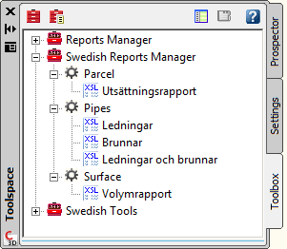

Report Name | Description | Sample File Name | Priority
Parcel > Utsättningsrapport | Visar utsättningsdata för Parcels (Tomt/Fastighet)  Translation of standard report Parcel > Inverse Report
Pipes > Ledningar | Rapport för ledningar  Translation of standard report Pipes > Structures
Pipes > Brunnar | Rapport för brunnar  Translation of standard report Pipes > Pipes
Pipes > Ledningar | Rapport för ledningar och brunnar  Translation of standard report Pipes > Pipes adn Structures
Surface > Volymrapport | Rapport som redovisar schakt- och fyll-volym för en TIN Volume Surface (Differensmodell)

Toolbox – Nya verktyg/New tools

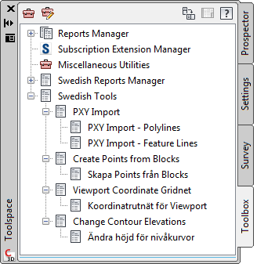
- PXY-Import – Polylines
  - Importerar oavsett om linjesträng är uppdelat med ” -1” vid radslut, eller via 1001.1 1001.2 1001.3 etc
  - Allt till egna Layers beroende av kod i .pxy-fil
  - Alla linjer blir 3D-Polylines
  - Alla punkter hamnar automatiskt i självgenererande Point Groups
  - Funktionen som importerar punkter och linjer från PXY-filer hanterar numera X och Y korrekt och fungerar med alla Nationella inställningar.

  - Routine to import a swedish point file format and create points and points groups with corresponding code and polylines according to line information. Lines and points are placed on a layer with same name as the code.
- PXY-Import – Feature Lines
  - Importerar oavsett om linjesträng är uppdelat med ” -1” vid radslut, eller via 1001.1 1001.2 1001.3 etc
  - Allt till egna Layers beroende av kod i .pxy-fil
  - Allt linjer blir Feature lines som enkelt kan hanteras i Elevation editor etc
  - Feature lines kan få egna Styles om man så önskar
  - Alla punkter hamnar automatiskt i självgenererande Point Groups
  - Funktionen som importerar punkter och linjer från PXY-filer hanterar numera X och Y korrekt och fungerar med alla Nationella inställningar.

  - Routine to import a swedish point file format and create points and points groups with corresponding code and Feature lines according to line information. Lines and points are placed on a layer with same name as the code.
- Create Points from Blocks:
  - Funktionen skapar Civil 3D Points för utvalda AutoCAD block.
  - Creates Civil 3D Points from selected AutoCAD block
- Viewport Coordinate Gridnet:
  - Funktionen skapar ett koordinatrutnät för en Viewport i en Layout.
  - Creates a coordinate gridnet for a layout viewport
- Change Contour Elevations
  - Funktion för att ändra/sätta höjd på nivåkurvor (Polylines)
  - Routine to change elevation on contours/polylines.

Drawing Settings > Object Layers
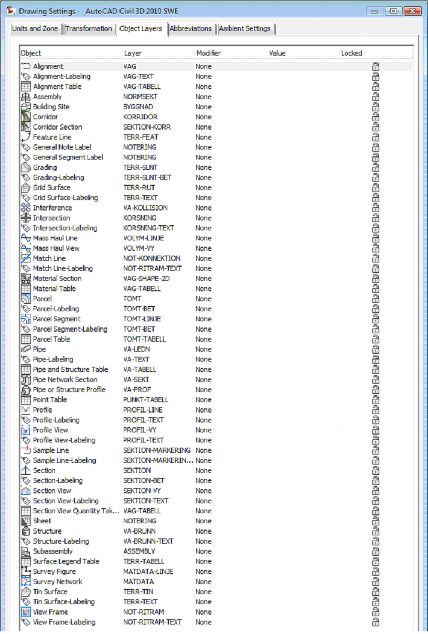

Object Layers
The following table lists all new object types added to the object layers tab in Tuckerman and their content for “out of the box” templates.
Object | Layer | Modifier | Value
Building Site | BYGGNAD
Intersection | KORSNING
Intersection-Labeling | KORSNING-TEXT
Grading-Labeling | TERR-SLNT-BET
Parcel-Labeling | TOMT-BET
Parcel Segment-Labeling | TOMT-BET

The following table lists existing object types on the object layers tab that should have their content for “out of the box” templates updated for Tuckerman.
Object | Layer | Modifier | Value

Ambient Settings
The following are the new drawing level ambient settings introduced in Tuckerman.
Node | Setting | Default
General | Driving Direction | Right Side of the Road

Object Styles
List all object styles you include in the country kit template(s) you are providing. You should provide a screen grab (in local language) (and optionally a drawing file) along with description and usage of the style in both English and your local language.
You must also indicate the name of the template file(s) that the style is saved in.

Multi-purpose Styles
<_DK Civil 3D 2010 Meter>
Feature Line Styles | Description | Screen grab / DWF / DWG | Default
Basis Feature Line | Bruges som standard ved opret feature line (tegne og fra objekt) | 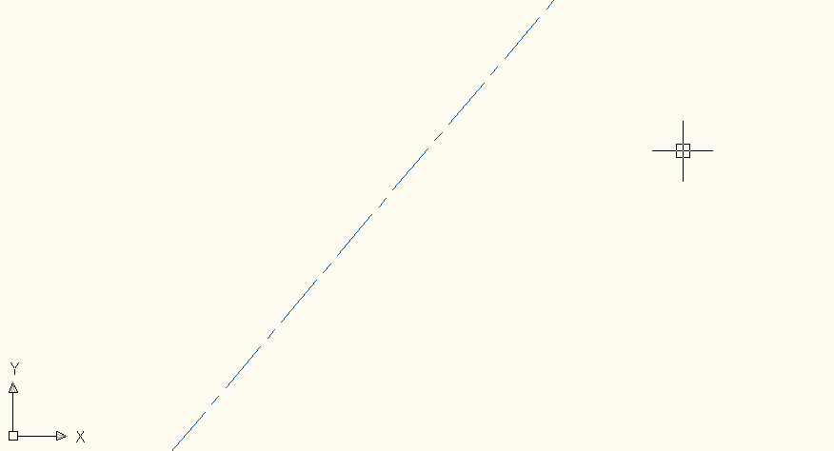
Øvrige | Standard Civil 3D feature lines, som er tilpasset for afbildning i længdeprofil og tværsnit

Code Set Styles | Description | Screen grab / DWF / DWG | Default
Alla koder | Standard korridor model
Alla koder QTO | Samma som ovan men med inställningar för mängdningsfunktionen QTO.  Same as above but with settings for QTO
Plan (Wireframe i 3D) | Visar endast längsgående linjer i korridoren, inga tvärgående. I 3D visas en trådmodell.  2D: Displays only alongside lines, no crossing.  3D: 3D a wireframe is displayed | 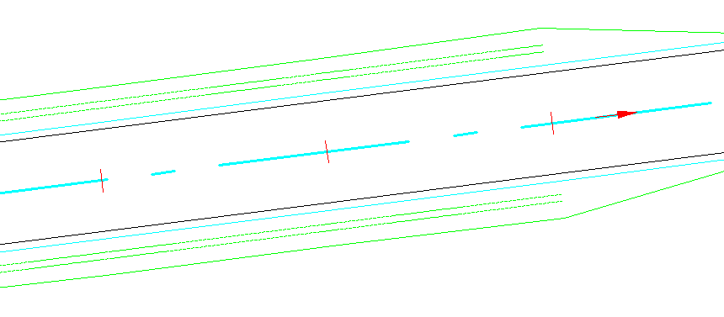
Plan (Render i 3D) | I plan visas endast längsgående linjer i korridoren, inga tvärgående. I 3D visas en renderad modell.  2D: Displays only alongside lines, no crossing.  3D: Rendered surface is displayed |  | Ja  Yes
Färgsolid i 2D -Render i 3D | I plan ifyllda solider i korridoren.  I 3D visas en renderad modell.  2D: Displays solids in the corridor.  3D: Rendered surface is displayed | 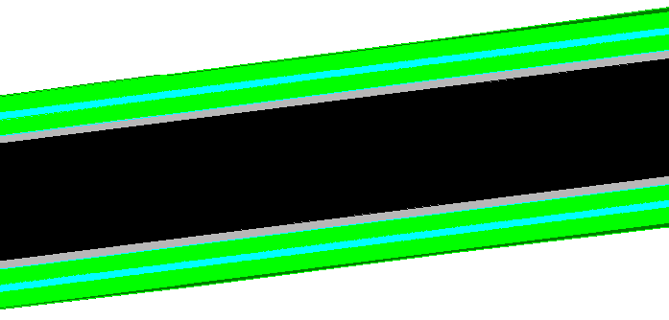
Raster i 2D -Render i 3D | I plan ifyllda solider i korridoren.  I 3D visas en renderad modell.  2D: Displays solids in the corridor.  3D: Rendered surface is displayed | 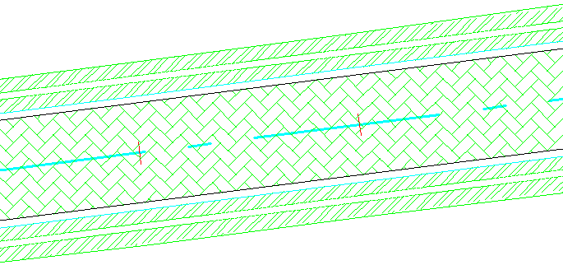
Tvärsektion | Används som grundinställning när man skapar sektionsritningar.  Used as default setting when creating section views. | Se Section View Styles  See Section View Styles
Tvärsektion -Utökad | Används för utökad info när man skapar sektionsritningar.  Used for additional info when creating section views. | Se Section View Styles  See Section View Styles

Marker Styles | Description | Screen grab / DWF / DWG | Default
 |  | 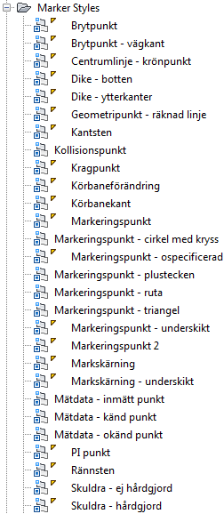

Link Styles | Description | Screen grab / DWF / DWG | Default
 |  | 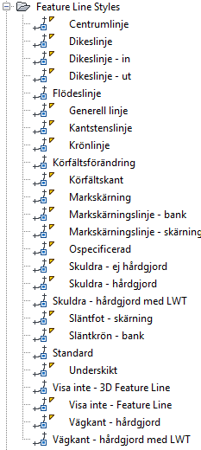

Shape Styles | Description | Screen grab / DWF / DWG | Default
 |  | 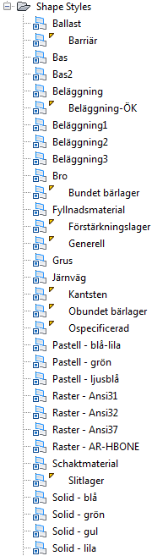

Slope Pattern Style | Description | Screen grab / DWF / DWG | Default
Släntmarkering |  | 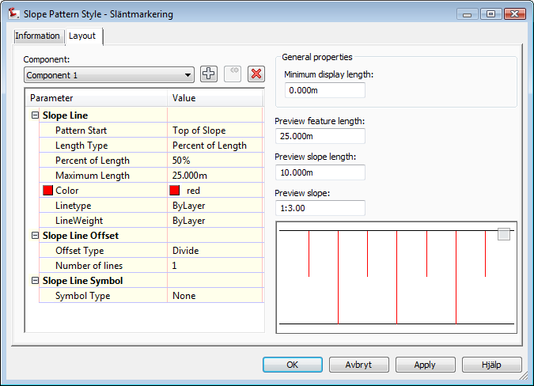 | Ja  Yes

Multipurpose Label Styles | Description | Screen grab / DWF / DWG | Default
Note
 |  | 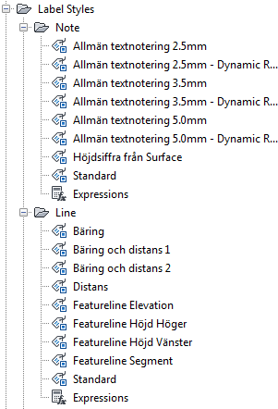
Line
 |  | 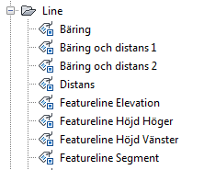
Curve
 |  | 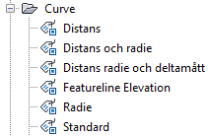
Marker
 |  | 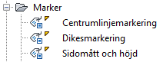
Link
 |  | 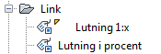
Shape
 |  | 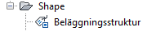

Points
<Template file name, start a new table for each template file>
User Defined Attribute Classifications | Description | Screen grab / DWF / DWG | Default

Point Styles | Description | Screen grab / DWF / DWG | Default
 |  | 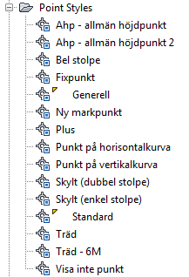

Point Label Styles | Description | Screen grab / DWF / DWG | Default
Punkt- Höjd i decimalpunkt | Höjdsiffra med decimalpunkten exakt i punkten  Elevation presented with decimal point in point centre
Punkt- Höjd Kod | Höjd och Kod  Elevation and Raw description
Punkt- Höjd Offset | Höjdsiffra placerad med offset  Elevation with offset
Punkt- Höjd VG | Höjd och vattengång  Elevation and Inlet level
Punkt- Höjd_höger | Höjdsiffra till höger om punkt  Elevation at right of point
Punkt- Höjd_under | Höjdsiffra under punkt  Elevation under point
Punkt- Kod | Endast Kod  Raw description only
Punkt- Kod Nummer | Kod och Nummer  Raw description and number
Punkt- Namn Höjd Kod | För punkter importerade via PXY (Namn X Y Z Kod)  Namn måste användas istället för Nr för vissa PXY-filer då löpnummret innehåller punkt t.ex. "1.01"  Name Elevation Raw description  Used for points imported from Swedish PXY file format where point number is alphanumeric and therefore stored in Name.
Punkt- Nummer | Endast nummer  Number only
Punkt- Nummer Höjd Kod | Nummer Höjd Kod  Number Elevation Raw description |  | Ja  Yes

Description Key Sets | Description | Screen grab / DWF / DWG | Default

Point Table Styles | Description | Screen grab / DWF / DWG | Default
Koordinattabell XY | Tabell med XY. Används då löpnummer ligger i kolumnen Number.  Table with No., code and XY. Used en point number is stored in Number. | 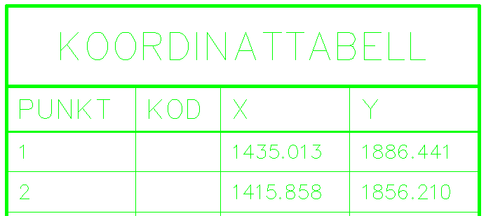 | Ja  Yes
Koordinattabell XY - Namn | Tabell med XY. Används då löpnummer ligger i kolumnen Name.  Table with No., code and XY. Used en point number is stored in Name. | Samma som ovan  Same as above
Koordinattabell XYZ | Tabell med XYZ. Används då löpnummer ligger i kolumnen Number.  Table with No., code and XYZ. Used en point number is stored in Number. | 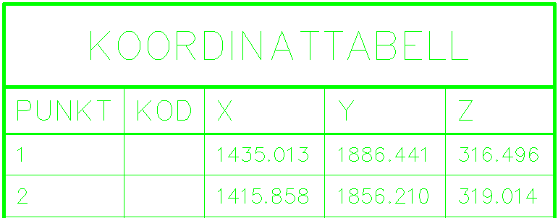
Koordinattabell XYZ - Namn | Tabell med XYZ. Används då löpnummer ligger i kolumnen Name.  Table with No., code and XYZ. Used en point number is stored in Name. | Samma som ovan  Same as above

Surfaces
<_AutoCAD Civil 3D 2010 DK.dwt>
Surface Styles | Description | Screen grab / DWF / DWG | Default
Avrinningsområden | Visar avrinningsområden för en modell  Displays watersheds | 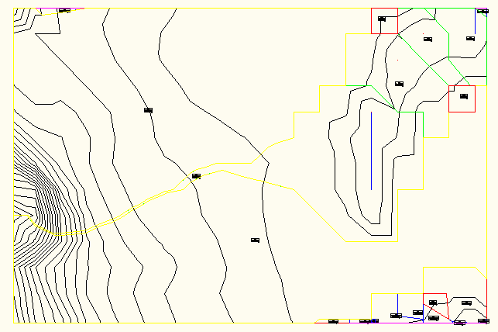
Färganalys och gräns | Visar 4 färger för 4 olika höjdintervaller, vilka kan justeras manuellt.  Elevation analysis in 4 different levels | 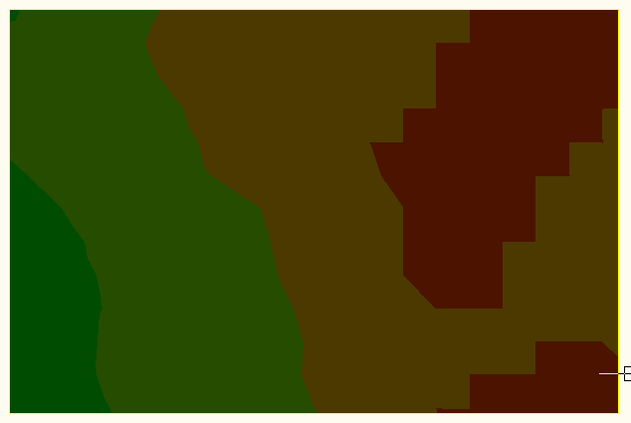
Rutnät | Visar rutnät med 10*10m  Gridnet in 10*10m | 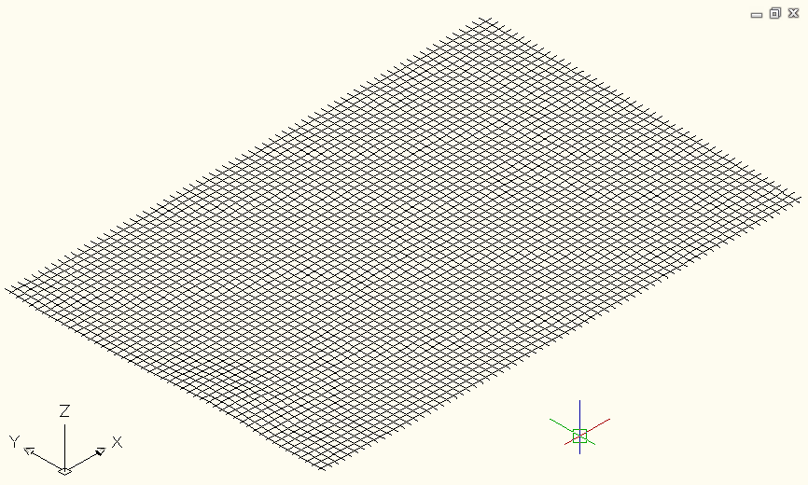
Rutnät- Höjdöverdriven | Visar rutnät med 10*10m, höjdöverdrivet 10ggr  Gridnet in 10*10m, Exaggerat Elevation by 10 | 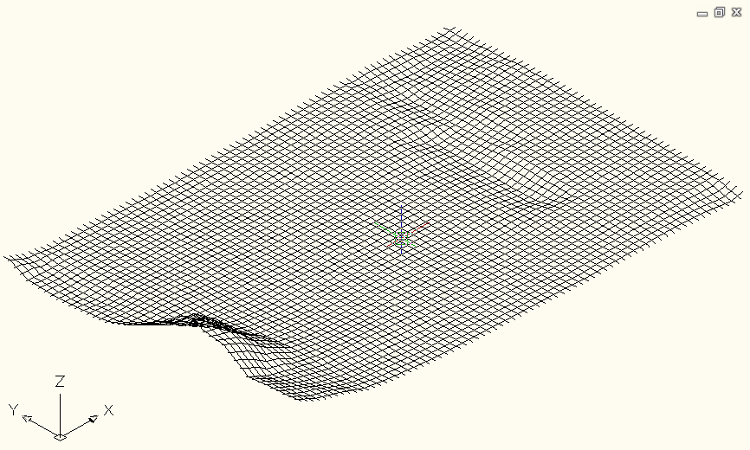
Nivåkurvor och gräns | Nivåkurvor med 1 m intervall och gräns  Contours at 1 m interval, and border | 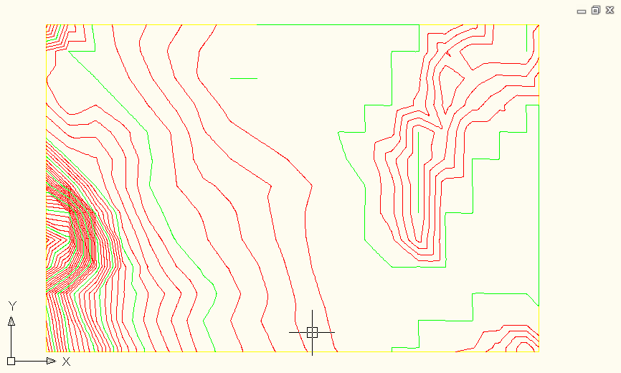 | Ja  Yes
Lutningspilar Nivåkurvor och gräns | Nivåkurvor med 1 m intervall, lutningspilar och gräns  Contours at 1 m interval, slope arrows and border | 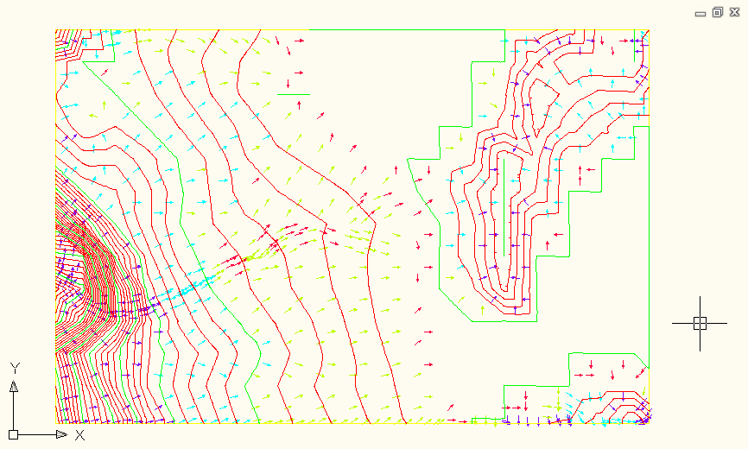
Nivåkurvor bakgrund | Nivåkurvor 1m med bakgrundsfärg  Contours at 1 m interval, in grey (background) | 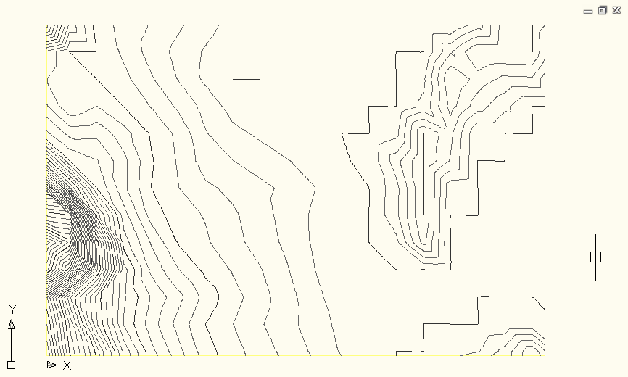
Trianglar Punkter och gräns | Visar punkter och trianglar.  Points and Triangels | 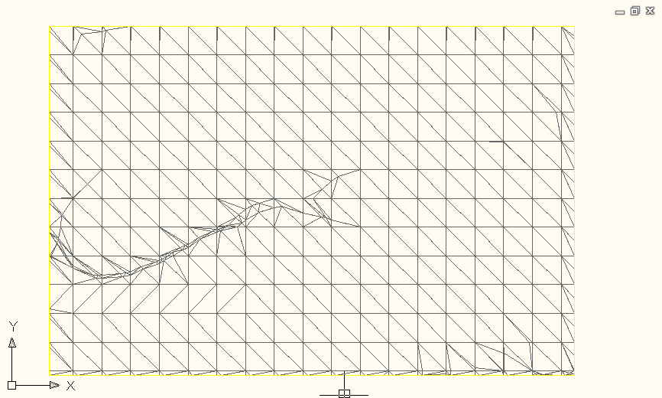
Endast gräns | Visar endast yttergräns  Border only | 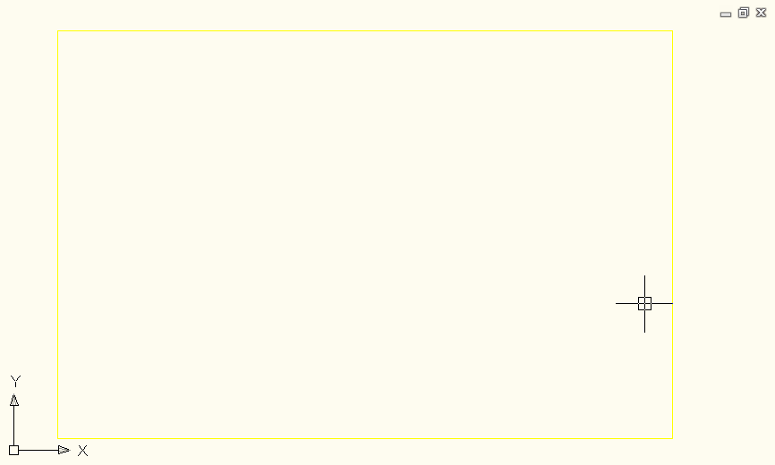
Visa inte - Yta | Allt avstängt  All off

Surface Label Styles Name/Type | Description | Screen grab / DWF / DWG | Default
Contour
Bakgrund | Används för “Nivåkurvor – Bakgrund”  Used for Surface style “Nivåkurvor – Bakgrund”
Nivåkurvor | Höjd ovanför nivåkurvan  Elevation above contour |  | Ja
Nivåkurvor - maskad | Höjd maskad i nivåkurvan  Elevation placed masked over contour
Slope
Lutningar 1: | Lutningar 1: med en decimal  Slope 1:X |  | Ja
Lutningar procent | Lutningar i procent med 2 decimaler  Grade in percent
Lutningar promille | Lutningar i promille med 2 decimaler  Grade in promille
Spot Elevation
Punkthöjd | Punkthöjd i terrängmodell med 2 decimaler.  Elevation beside Point marker |  | Ja
Punkt- Höjd i decimalpunkt | Höjdsiffra med decimalpunkten exakt i punkten. Använd ingen Marker.  Elevation presented with decimal point in point centre. Use no marker.
Watershed
Avrinningsområde | Avrinningsområden Id Typ Area

Surface Table Styles Name/Type | Description | Screen grab / DWF / DWG | Default
Direction
Minimum & maximum - riktning
Elevation
Minimum och maximum - höjder | Tabell med min och max höjder
Volymtabell | Tabell med min och max höjder samt arealer och volym
Volymtabell - Bantad | Tabell med min och max höjder samt arealer och volym
Slope
Minimum & maximum - lutning
Slope Arrow
Luningspil
Contour
Minimum & maximum - nivåkurvor
Watershed
Min og max højdekurver
User Defined Contour
Minimum & maximum - nivåkurvor

Parcels
<_AutoCAD Civil 3D 2010 DK.dwt>
User-Defined Attributes | Description | Screen grab / DWF / DWG | Default
<None>

Parcel Styles | Description | Screen grab / DWF / DWG | Default
Fastighetsgräns | Fastighetsgräns  Real estate property | 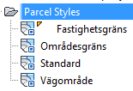
Områdesgräns | Områdesgräns  Area border
Vägområde | Vägområde  ROW

Parcel Label Styles | Description | Screen grab / DWF / DWG | Default
Area
Beteckning | Fastighetsbeteckning  Label for real estate property | 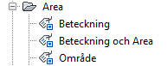
Beteckning och area | Fastighetsbeteckning och area  Label for real estate property and area
Område | Område  Area label
Line
 | Only translated original styles
Curve
 | Only translated original styles

Parcel Table Styles | Description | Screen grab / DWF / DWG | Default
Line
<None> | Only translated original styles
Curve
<None> | Only translated original styles
Segment
<None> | Only translated original styles
Area
Area Enbart | Fastighetsbeteckning och area  Real state label and area | 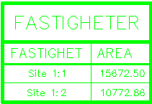
Fastigheter | Fastighetsbeteckning, area, omkrets och segment längder  Real state label, area, circumference, segment lenghts | 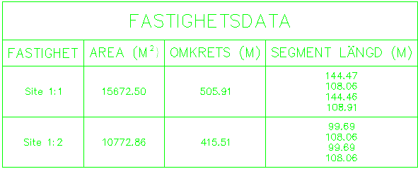

Grading
Grading Styles |  | Description | Screen grab / DWF / DWG | Default
Fyll | Fyllslänt (röd)  Fill grading style (red) |  | 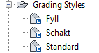
Schakt | Schaktslänt (grön)  Cut grading style (green)

Grading Criteria Sets |  | Description | Screen grab / DWF / DWG | Default
Avstånd @ Lutning % | Slänt med valfritt avstånd och lutning i %  Grading at distance and grade in %  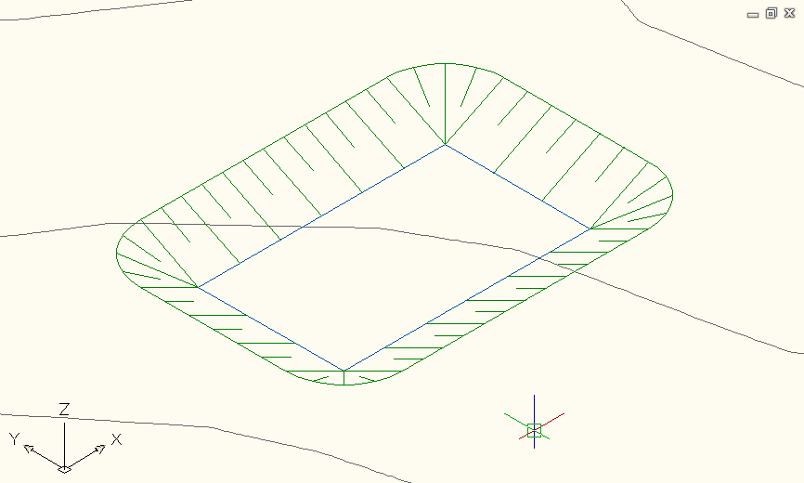 |  | 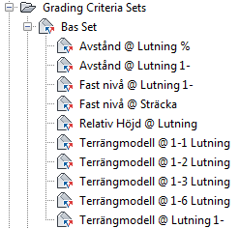
Avstånd @ Lutning 1- | Slänt med valfritt avstånd och lutning i 1:X  Grading at distance and slope 1:X  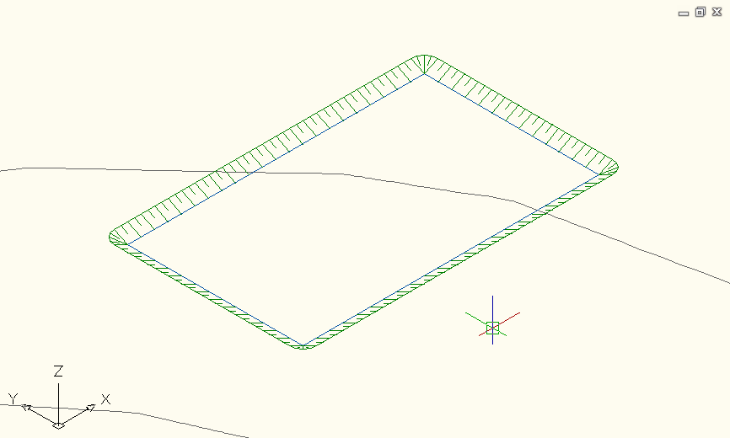
Fast nivå @ Lutning 1- | Slänt till valfritt nivå med lutning i 1:X  Grading to elevation with slope 1:X  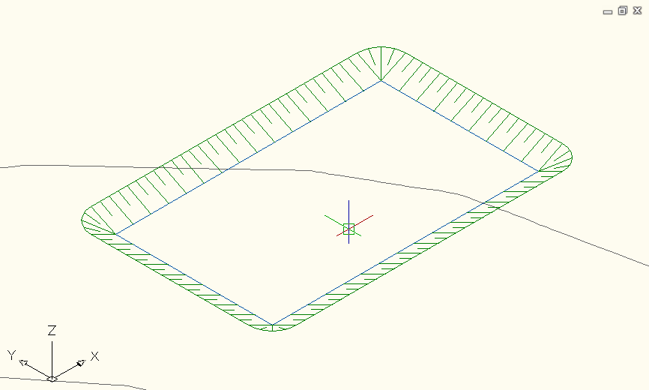
Fast nivå @ Sträcka | Slänt till valfri nivå med angiven horisontell sträcka  Grading to elevation with entered horizontal distance
Relativ Höjd @ Lutning | Slänt ned valfritt nivå med angiven horisontell sträcka  Grade down elevation with fixed horizontal distance
Terrängmodell @ 1-2 Lutning | Slänt mot terrängmodell med lutning 1:2  Grading to surface at slope 1:2  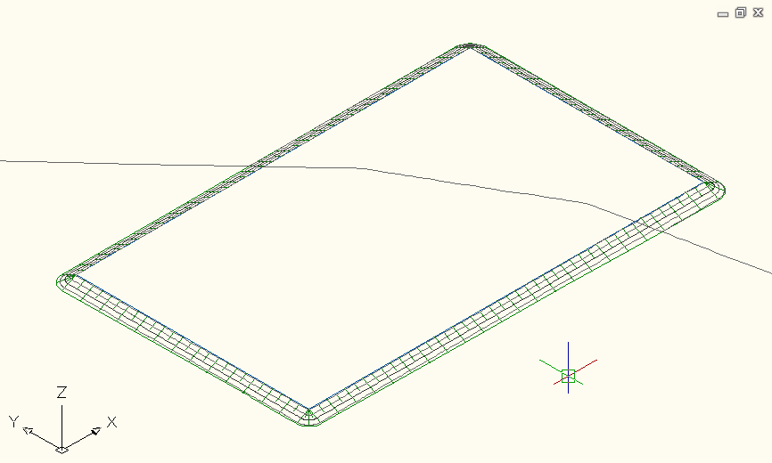
Terrängmodell @ 1-3 Lutning | Slänt mot terrängmodell med lutning 1:3  Grading to surface at slope 1:3  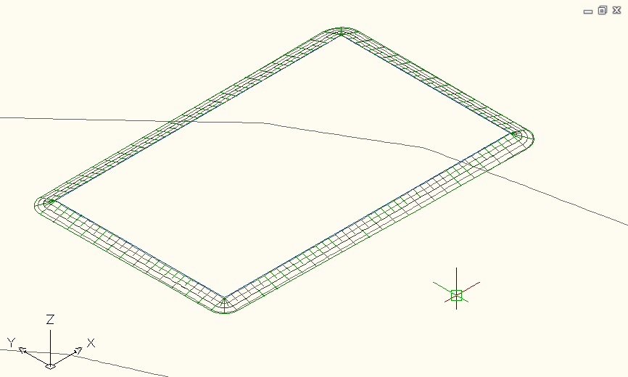
Terrängmodell @ 1-6 Lutning | Slänt mot terrängmodell med lutning 1:6  Grading to surface at slope 1:6  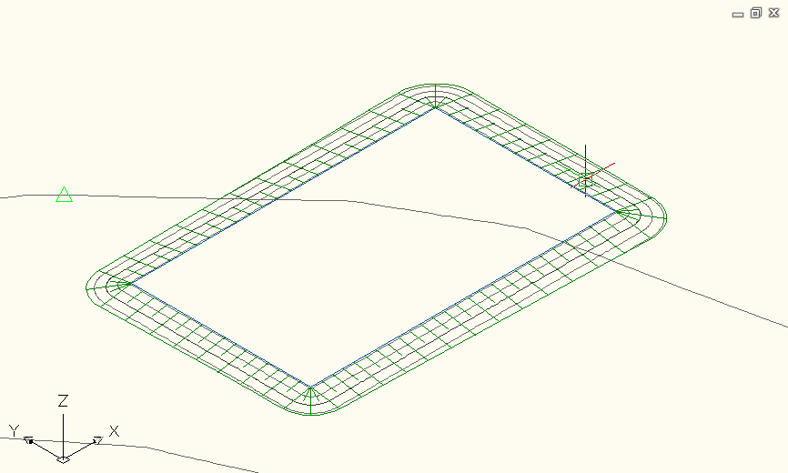
Terrängmodell @ Lutning 1- | Slänt mot terrängmodell med valfri lutning 1:X  Grading to surface at slope 1:X  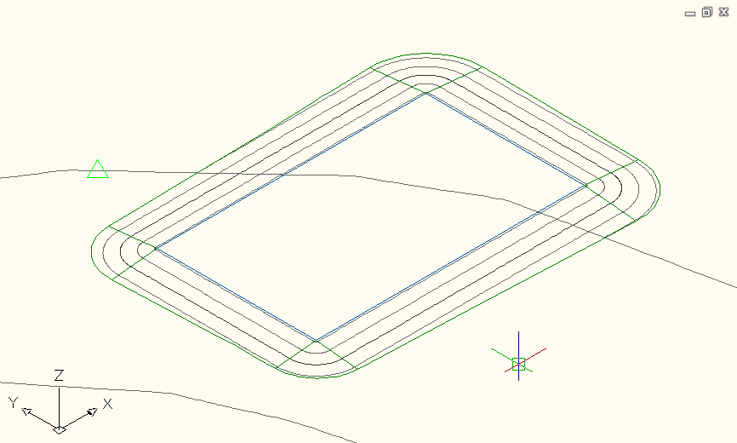

Alignments
<Template file name, start a new table for each template file>
Alignment Style | Description | Screen grab / DWF / DWG | Default
Enkel linje | Enkel grön linje  Simple green line | 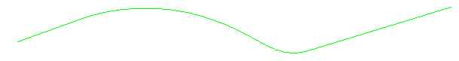
Linjeberäkning - konstruktion | Visar olika färger för raklinje, båge och klotoid. Används vid konstruktion.  Displays different color for line, arc and clothoid. Used at construction. | 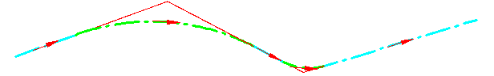 | Ja  Yes
Linjeberäkning - Offset | Enkel mörkröd (tunn) linje  Simple darkred line
Linjeberäkning - utskrift | Används vid utskrift  Used for plotting
Linjeberäkning - VA | Används för Linjeberäkning skapad från ledningar av ”Create alignment from network parts”. Ligger på lager som inte plottas.  Used for ”Create alignment from network parts”. On layer, set not to plot.
Linjeberäkning 1 - röd | Enkel röd alternativ linje  Simple red alternative line
Linjeberäkning 2 - gul | Enkel gul alternativ linje  Simple yellow alternative line
Linjeberäkning 3 - grön | Enkel grön alternativ linje  Simple green alternative line
Visa inte - linjeberäkning | Linjen visas inte  No display

Alignment Design Checks | Description | Screen grab / DWF / DWG | Default
Design Check Sets
Standard | A<R  A>R/3  L<R  L>0.1R | 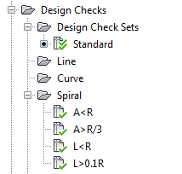
Line
Curve
Spiral
Tangent Intersection

Alignment Label Type/Name | Description | Screen grab / DWF / DWG | Default
Alignment Label Sets
Banverk | För spårprojektering  For rail alignments | 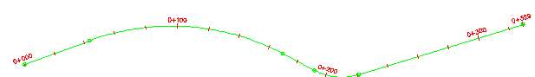
Vägverk – 100m | För vägprojektering. Längdmätning var 100m. TP-flaggor.  For road design. Chainage at every 100m. Labels at Geometry Point. | 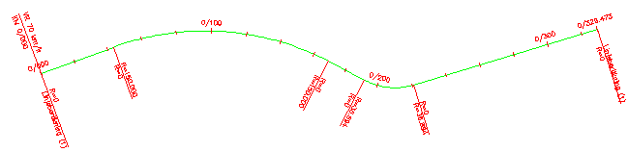 | Ja  Yes
Vägverk – 50m | För vägprojektering. Längdmätning var 50m. TP-flaggor.  For road design. Chainage at every 50m. Labels at Geometry Point.
Vägverk – 1000m | För vägprojektering. Längdmätning var 1000m. TP-flaggor.  For road design. Chainage at every 1000m. Labels at Geometry Point.
Vägverk - 100m med längdmätning i TP | Samma som ” Vägverk – 100m” men med längdmätning i varje TP.  Same as ” Vägverk – 100m” but with chainage label at geometry point | 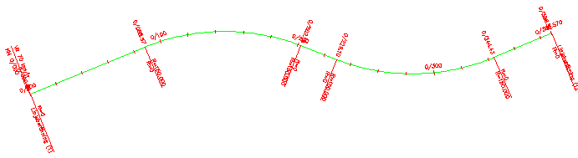
Vägverk - 100m med skevningskil | Samma som ” Vägverk – 100m” men med skevningskil vid varje skevningsändring.  Same as ” Vägverk – 100m” but with superelevation labels
Major Station | Label at Major Stations
Minor Station | Label at Minor Stations
Geometry Point | Label at Geometry Points
Profile Geometry Point | Labels at the profile geometry points on the alignment
Station Equation | Station equation Labels
Design Speed | Design Speed labels
Superelevation Critical Points | Labels at the critical Superelevation points on the alignment
Station Offset | Station Offset Labels
Line | Tangent labels
Elementbeskrivning | Används till tabellen “Elementtabell”  Used for table “Elementtabell”
Curve | Arc Labels
Elementbeskrivning | Används till tabellen “Elementtabell”  Used for table “Elementtabell”
Spiral | Spiral Labels
Elementbeskrivning | Används till tabellen “Elementtabell”  Used for table “Elementtabell”
Tangent Intersection | PI Labels

Alignment Table Type/Name | Description | Screen grab / DWF / DWG | Default
Line
Curve
Spiral
Segment | Line, curve or spiral element in a single table
Elemettabell | Tabell för elementbeskrivningar  Table for Element descriptions | 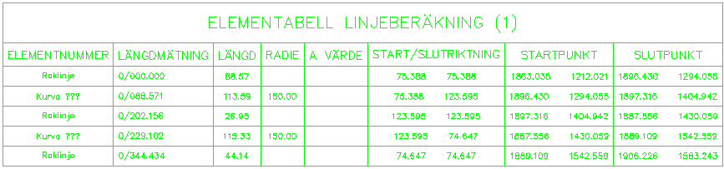

Profiles
<Template file name, start a new table for each template file>
Profile Style | Description | Screen grab / DWF / DWG | Default
Befintlig mark – höger  Befintlig mark  Befintlig mark - vänster | Grön streck-prickad linje  Green dash-dot linetype for EG-right  Ljusblå heldragen linje  Cyan continuous linetype for EG  Röd streckad linje  Red dashed linetype for EG-left | 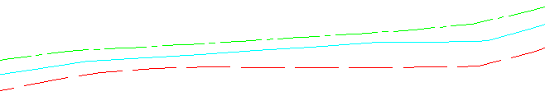
Berg  Förmodat berg | Berg  Rock surface (continuous Y-line)  Förmodat berg  Assumed Rock Surface (dashed Y-line) | 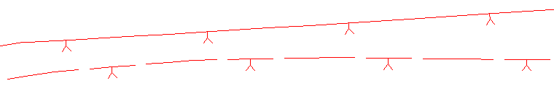
Konstruktion – VA
Projekterad linje a - blå | För projektering - Blå linje  Design Profile – Blue line
Projekterad linje b - magenta | För projektering - Magenta linje  Design Profile – Magenta line
Projekterad linje c - gul | För projektering - Gul linje  Design Profile – Yellow line
Projekterad ny marknivå | Används för ex Gradings och Surfaces höjdsatta för föreslagna nya nivåer  Proposed new ground level
Visa inte - profil | Profilen visas inte  No display
Vägprofil - konstruktion | För konstruktion av vägprofil, fet linje med olika färg för elementtyper  For road design, linewidth 0.3, different colors for element types | 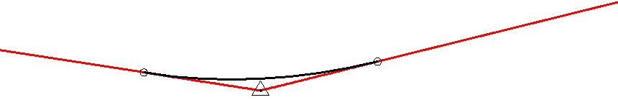
Vägprofil - utskrift | Tunn profillinje för utskrift  Thin profile line for printing | 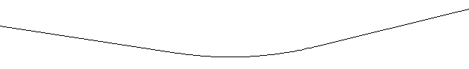

Profile Design Checks | Description | Screen grab / DWF / DWG | Default
Design Check Sets
Inga/None
Line
Curve

Profile Label Type/Name | Description | Screen grab / DWF / DWG | Default
Profile Label Sets
Komplett information | Gammal stil, används inte längre  Old style, not used anymore
TP-Lodrät information | Info för varje TP  Info for each TP | 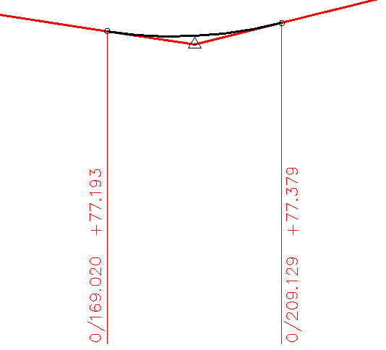
Vinkelspetsinformation | Info för vinkelspets  Info for PVI | 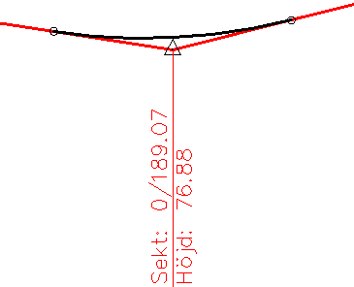
Visa inte – etiketter | Visa ingen information  No information displayed
Major Station
 |  | 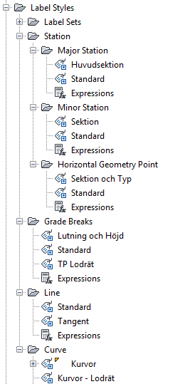
Minor Station
Horizontal Geometry Point
Grade Breaks
Line | Tangent Labels
Curve

Profile View Type/Name | Description | Screen grab / DWF / DWG | Default
1:1 höjdskala | 1:1 höjdskala  Metric style with vertical exaggeration set to 1 times
1:4 höjdskala | “”
1:8 höjdskala | “”
1:10 höjdskala | 1:10 höjdskala  Metric style with vertical exaggeration set to 10 times | 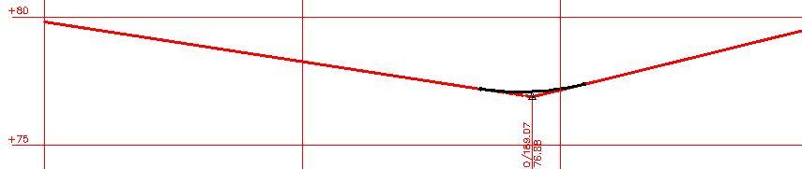
1:10 Höger i splittad vy | Används för splittade profiler “Split Profile Views” som “Last split view style” (i Create Profile View)  Used for “Split Profile Views” as “Last split view style” (in Create Profile View) | 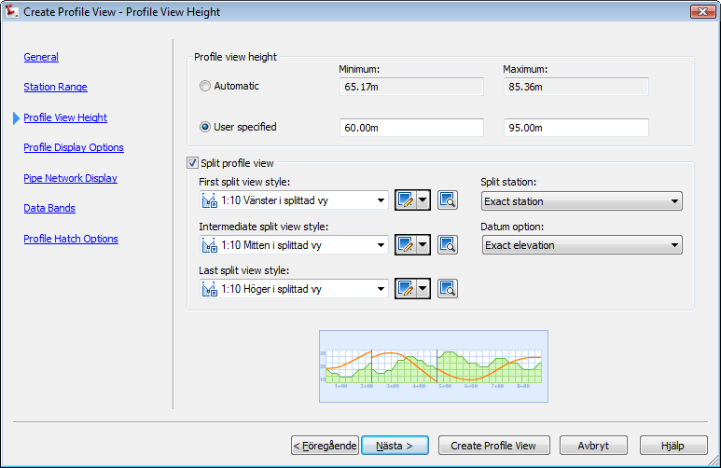
1:10 Mitten i splittad vy | Används för splittade profiler “Split Profile Views” som “Intermediate split view style” (in Create Profile View)  Used for “Split Profile Views” as “Intermediate split view style” (in Create Profile View)
1:10 Vänster i splittad vy | Används för splittade profiler “Split Profile Views” som “First split view style” (in Create Profile View)  Used for “Split Profile Views” as “First split view style” (in Create Profile View)
 | Avsedd att användas för staplade (stacked) Profile Views som ”Middle view style” och ”Bottom view style”  Used for stacked Profile Views as ”Middle view style” and ”Bottom view style” | 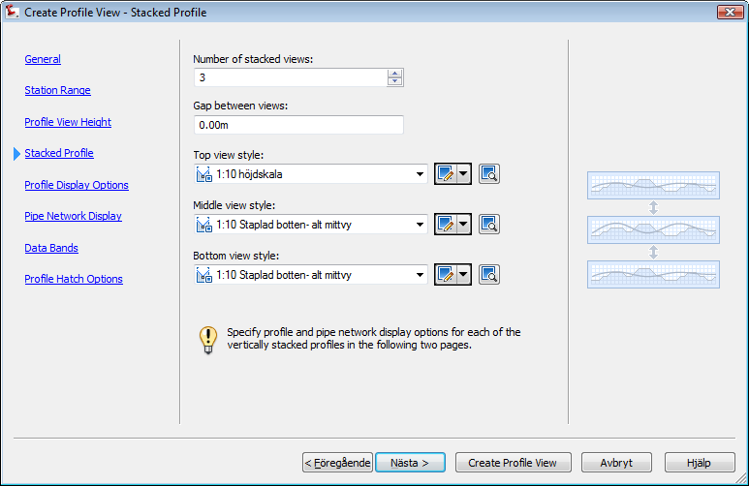

Profile View Label Type/Name | Description | Screen grab / DWF / DWG | Default
Station Elevation
 | Translated standard label | 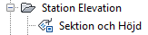
Depth
 | Translated standard label | 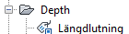

Profile Band Type/Name | Description | Screen grab / DWF / DWG | Default
Profile Band Set
VA-profil | Band för ledningsnät: Dagvatten, Spillvatten samt Vatten  Bands for Pipe networks: Storm, Sanatary and Water | 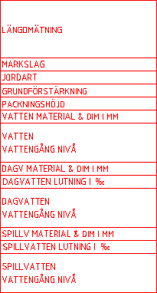
Visa inte - band | Inga informationsband  No bands
Vägverk | Band för Vägprofil | 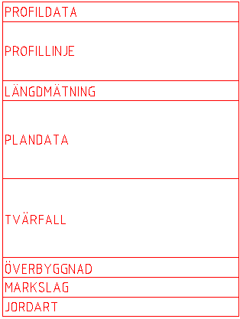
Vägverk - Utökad | Band för Vägprofil där profildata för raklinje, konkav kurva samt konvex kurva presenteras på varsin rad | 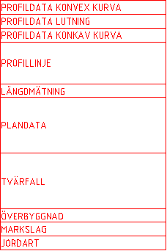
Vägverk och VA-profil | Kombination av Vägverk samt VA-Profil  Combination of styles Vägverk and VA-Profil
Profile Data
 |  | 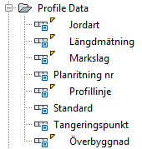
Vertical Geometry
 |  | 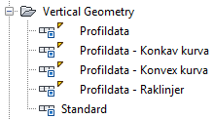
Horizontal Geometry
 |  | 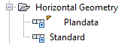
Superelevation Data
 |  | 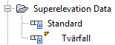
Sectional Data
 |  | 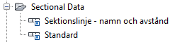
Pipe Network
 |  | 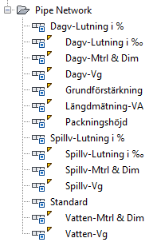

Sections
<Template file name, start a new table for each template file>
Sample Line Styles | Description | Screen grab / DWF / DWG | Default
Sektionsmarkering | Sektionslinjen ritas ut på ett lager som inte plottas  Sample line is drawn on layer, set not to plot. | 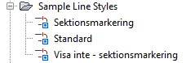
Visa inte - sektionsmarkering | Inga linjer visas  No lines visible

Sample Line Label Styles | Description | Screen grab / DWF / DWG | Default
Sektionsnamn | Längdmätningen anges per sektionslinje  Ligger på lager som inte plottas  Chainage is presented as SL-name on layer, set not to plot. | 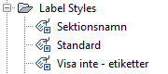 | Ja  Yes
Visa inte - etiketter | Inga etiketter  No labels

Section Styles | Description | Screen grab / DWF / DWG | Default
 | Se profilstilar för samma stilnamn  Se Profile Styles for corresponding names | 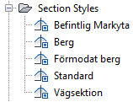

Section Label Styles | Description | Screen grab / DWF / DWG | Default
Label Sets
 |  | 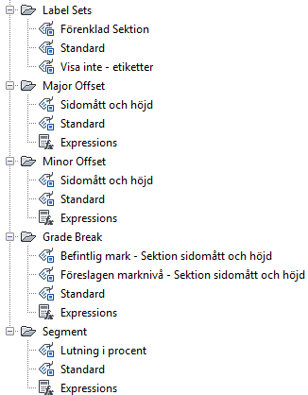
Major Offset
Minor Offset
Grade Break
Segment

Section View Styles | Description | Screen grab / DWF / DWG | Default
Tvärsektion - Enkel | Tvärsektion – Enkel  Section view style - simplified | 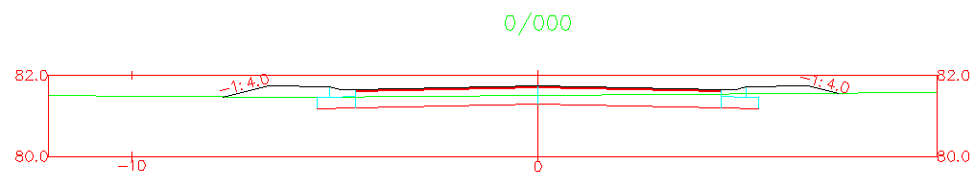 | Ja  Yes
Tvärsektion | Tvärsektion med större storlek  Section view style - basic | 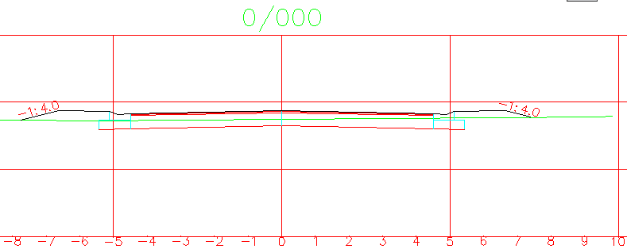

Group Plot Styles | Description | Screen grab / DWF / DWG | Default
 |  | 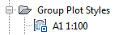

Sheet Styles | Description | Screen grab / DWF / DWG | Default
 | Ritning = Drawing | 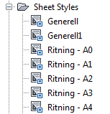

Label Styles | Description | Screen grab / DWF / DWG | Default
Offset Elevation
 | Sidomått och höjd  Offset and elevation | 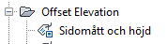
Grade
 | Lutning I % mellan punkter  Grade in % between points | 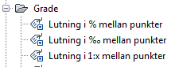

Section Band Styles | Description | Screen grab / DWF / DWG | Default
Band Sets
 |  | 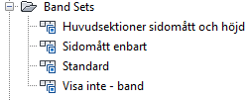
Section Data
 |  | 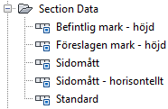

Section Table Styles | Description | Screen grab / DWF / DWG | Default
Total Volume
Schakt fyll och ack | Schakt och fyll, area och volym plus ackumulerad volym samt netto presenterad i tabell  Cut and fill, area and volume, also accumulated volumes and net presented in a table | 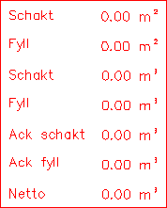
Schakt och fyll | Schakt och fyll, area och volym presenterad i bantad tabell  Cut and fill, area and volume presented in a compressed table | 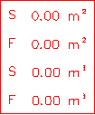
Material
Area och volym | Area, volym samt ack volym presenterat för enstaka material per längdmätning  Area, volume and acc volume presented for one material per chainage | 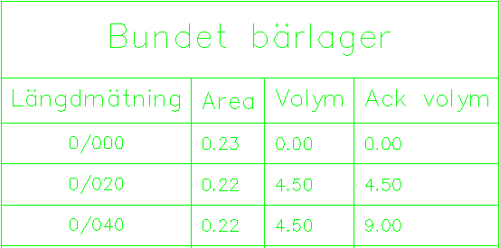

Pipe Networks
<Template file name, start a new table for each template file>
Parts Lists | Description | Screen grab / DWF / DWG | Default
Det finns fyra olika nätverkssystem, Parts lists:
- Dagvatten (Storm Sewer)
- Dränering (Drainage)
- Spillvatten (Sewer)
- Vatten (Water supply)

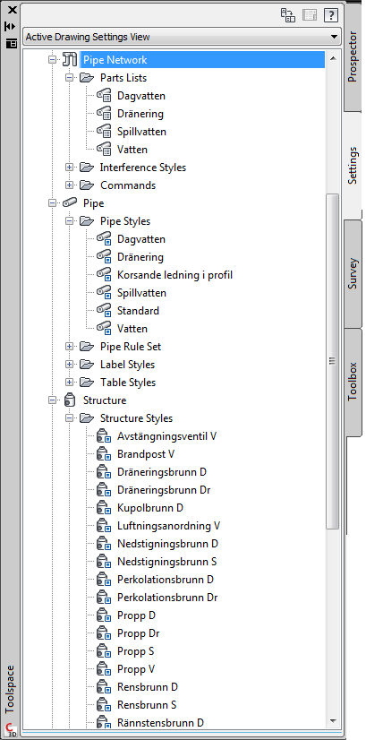

Dagvatten

Ledningar/Pipes
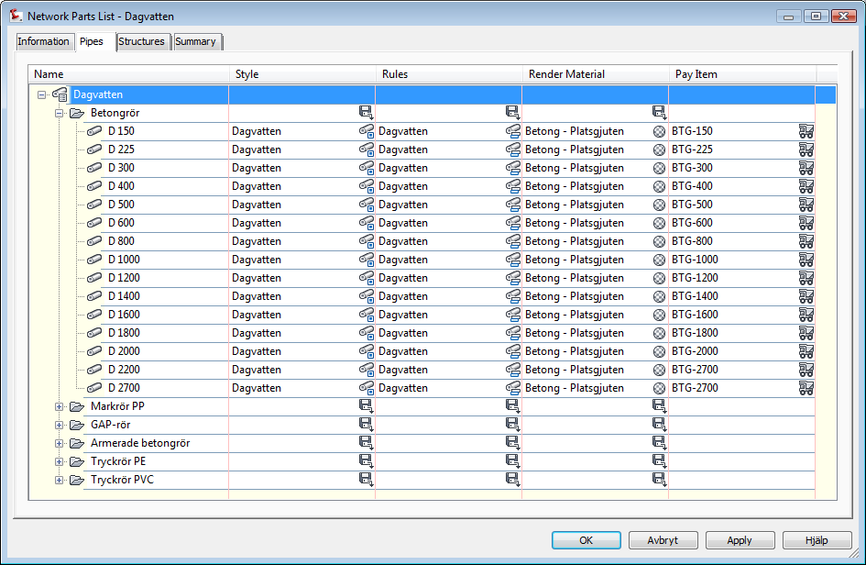

Brunnar/Structures
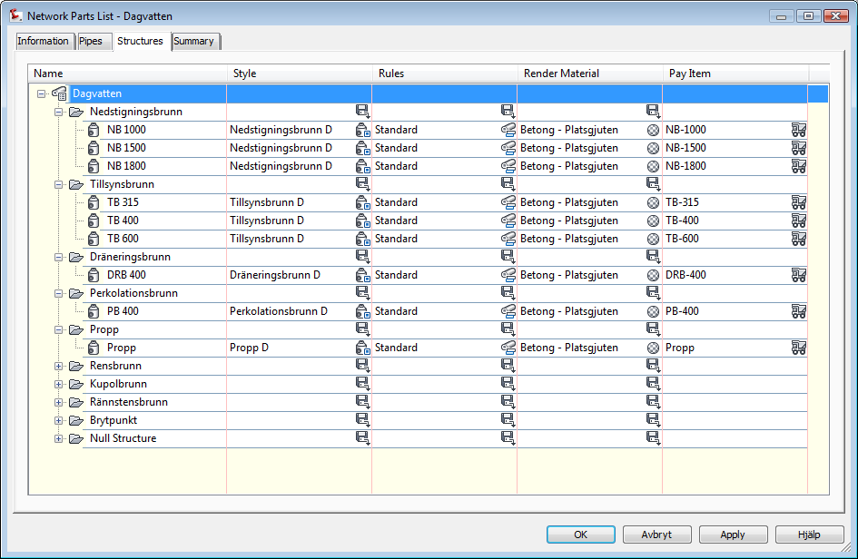

Dränering

Ledningar/Pipes
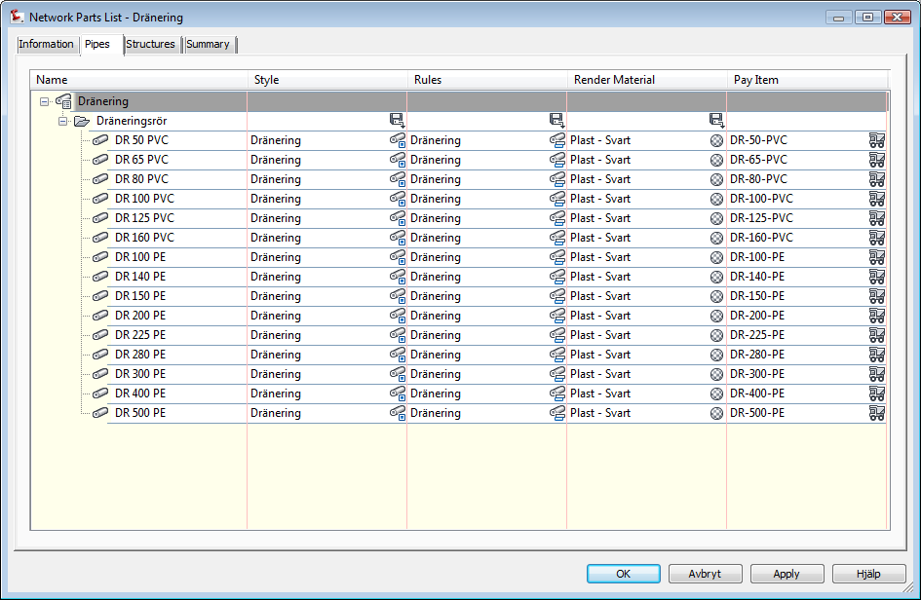

Brunnar/Structures
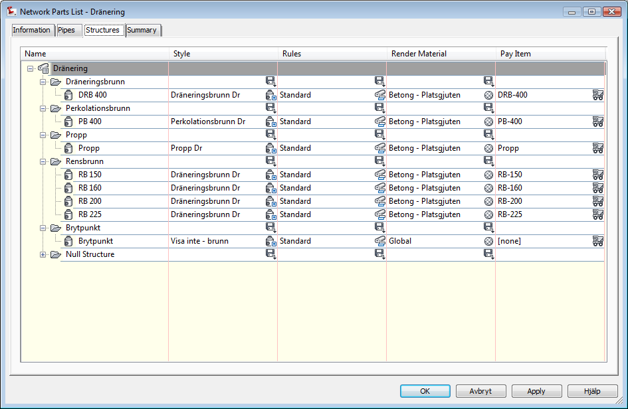

Spillvatten

Ledningar/Pipes
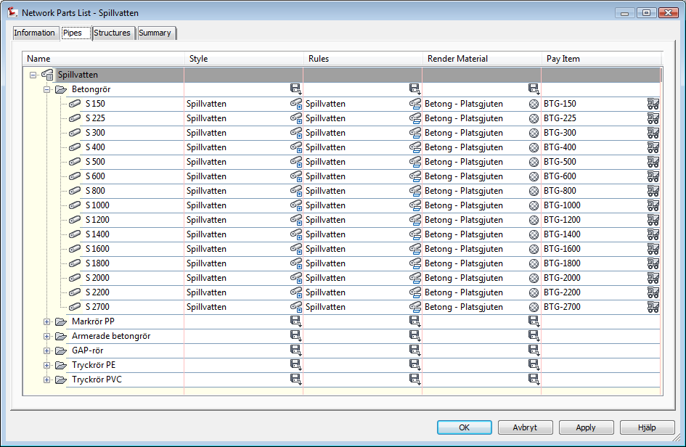

Brunnar/Structures
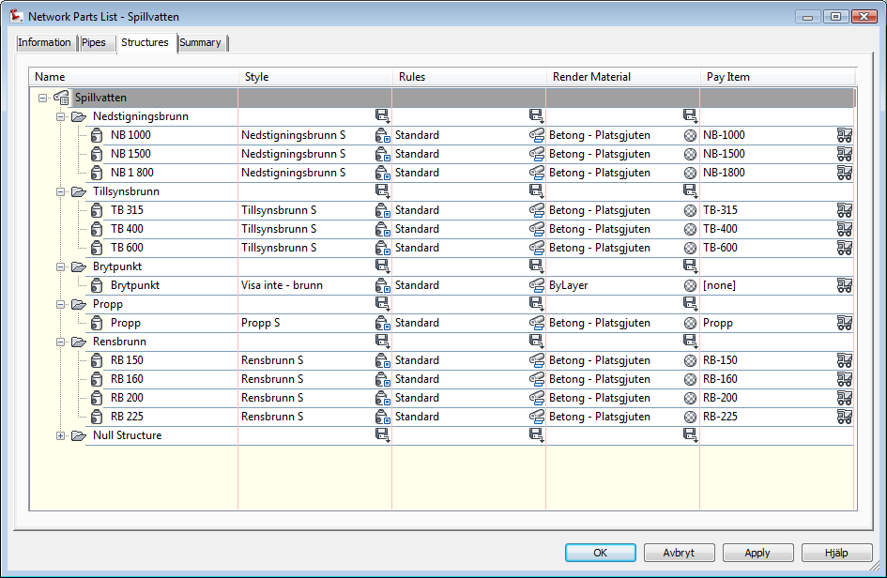

Vatten

Ledningar/Pipes
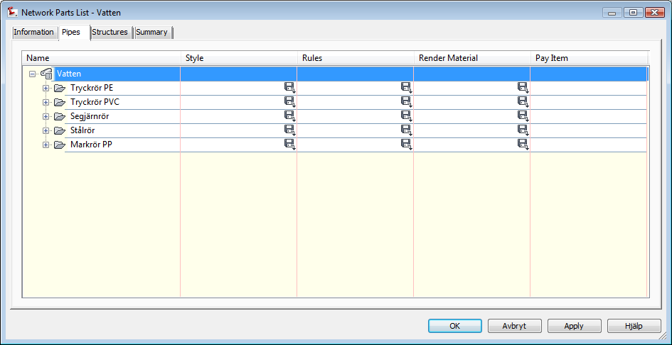

Brunnar/Structures
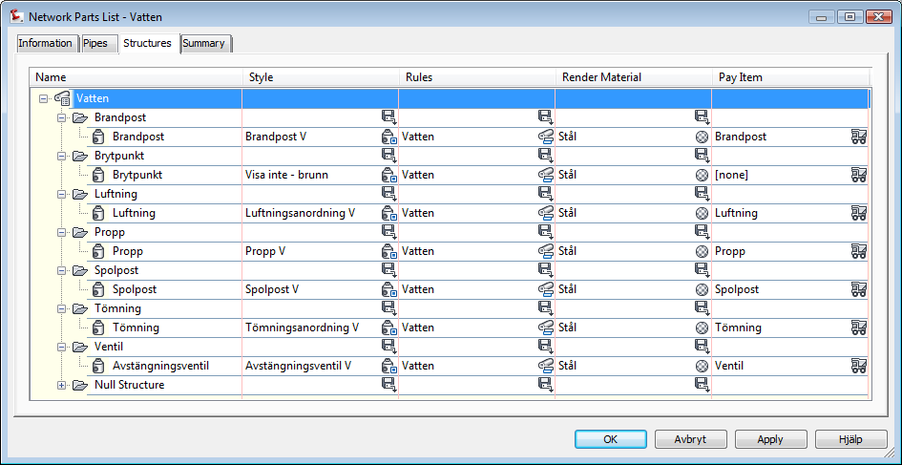

Interference Styles | Description | Screen grab / DWF / DWG | Default
Markering i plan och 3D-sfär | I plan visas en symbol men i 3D visas en sfär i kollisionspunkten  In Plan: A marker. In 3D a sphere. | 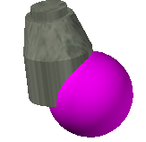
Markering i plan och 3D-vyn färgad | I plan visas en symbol men i 3D visas kollisionen som en färgad yta på objektet  In Plan: A marker. In 3D true interference solid | 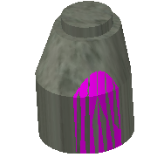

Pipe Styles | Description | Screen grab / DWF / DWG | Default
Spillvatten | Sewer | 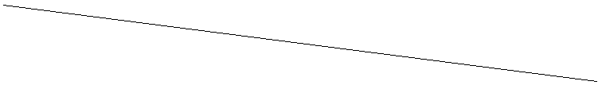
Dagvatten | Storm sewer | 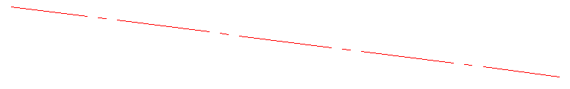
Vatten | Water supply | 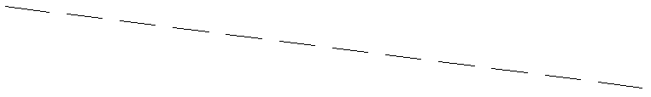
Dränering | Drainage | 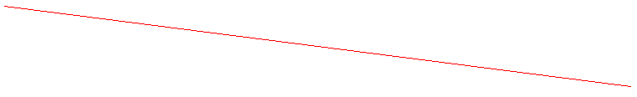
Korsande ledning i profil

Pipe Rule Set | Description | Screen grab / DWF / DWG | Default
Spillvatten | Sewer | 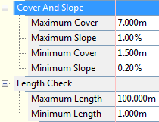
Dagvatten | Storm sewer | 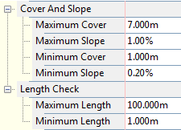
Vatten | Water supply | 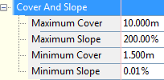
Dränering | Drainage | 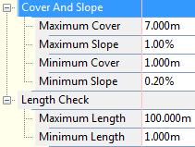

Pipe Label Styles | Description | Screen grab / DWF / DWG | Default
Plan Profile
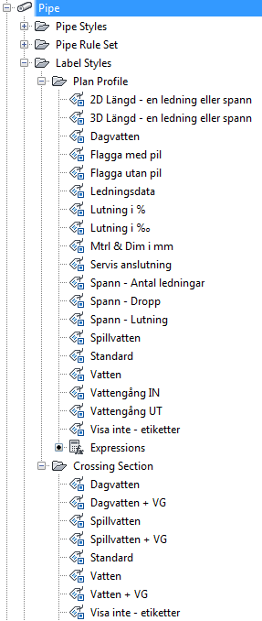

Crossing Section
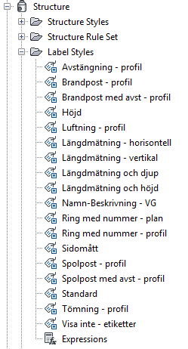

Pipe Table Styles | Description | Screen grab / DWF / DWG | Default
Ledningar | Data om ledningar  Info about pipes | 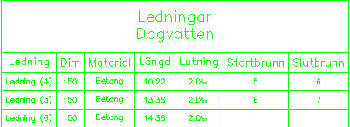
Med kapacitet i sekundliter | Med kapacitet i sekundliter om Mannings tal finns angivet på ledningen  If Mannin Coefficient is entered on the pipe, flow capacity is calculated | 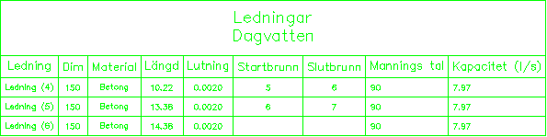

Structure Styles | Description | Screen grab / DWF / DWG | Default
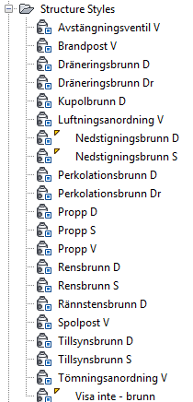

Structure Rule Sets | Description | Screen grab / DWF / DWG | Default
Sandfång | Sandfång endast  Only Sump depth | 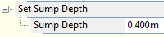
Standard | Standard regel för brunnar  Standard rule for structures | 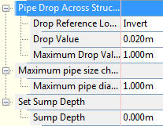 | Ja  Yes
Vatten | Regler för vatten-brunnar  Rules for water supply structures | 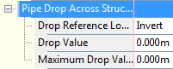

Structure Label Styles | Description | Screen grab / DWF / DWG | Default
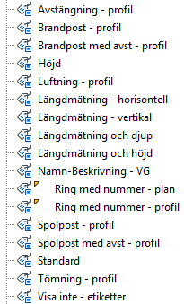

Structure Table Styles | Description | Screen grab / DWF / DWG | Default
Brunnar | Brunns- och ledningsinfo  Info about structures and pipes | 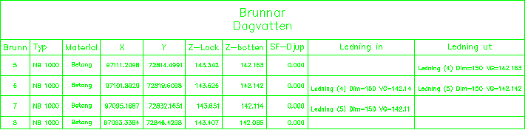 | Ja  Yes

Corridors
<Template file name, start a new table for each template file>
Corridor Styles | Description | Screen grab / DWF / DWG | Default
Korridor | Allt påslaget  All on
Visa inte - Korridor | Allt avslaget  All off

Assembly Styles | Description | Screen grab / DWF / DWG | Default
Normalsektion |  | 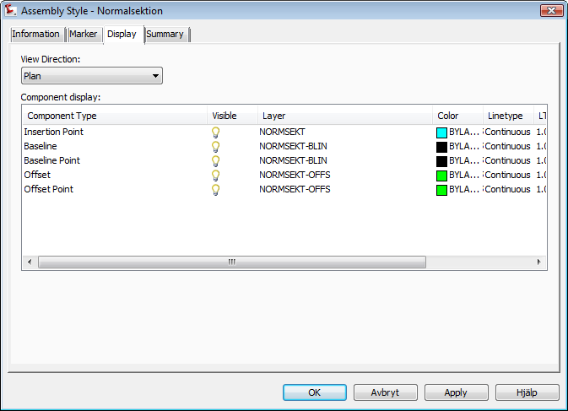 | Ja/Yes

Mass Haul Line Styles | Description | Screen grab / DWF / DWG | Default
 |  | 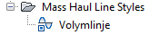

Mass Haul View Styles | Description | Screen grab / DWF / DWG | Default
Bantad vy | Bantad vy som kan placeras inuti en profilritning  Compressed view that can be placed in a Profile view | 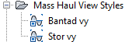 | Ja  Yes
Stor vy | Används för “ensamstående” vy  Used for “stand alone” view

Quantity Takeoff Criteria | Description | Screen grab / DWF / DWG | Default
VA-Mark + Berg + 3 skikt | Skapa yta för Schaktbotten, Kringfyllning befintlig mark samt berg.  För extern XML-rapport använd Sections > Generate volume report: Volymberäkning flera skikt.xsl  För tabell i ritningen använd Sections > Add Tables > Material Volume  Create surface for Trench and Special Backfill in Corridor. Needs surface for EG and Rock.  For external XML-rapport use Sections > Generate volume report: Volymberäkning flera skikt.xsl  For table in drawing use Sections > Add Tables > Material Volume | 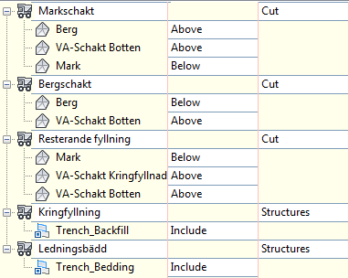
VA-Schakt | Skapa yta för Schaktbotten samt befintlig mark.  Sections > Generate volume report: Volymberäkning flera skikt.xsl  Sections > Add Tables > Material Volume  Create surface for Trench in Corridor. Needs surface for EG.  For external XML-rapport use Sections > Generate volume report: Volymberäkning flera skikt.xsl  For table in drawing use Sections > Add Tables > Material Volume | 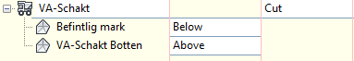
VA-Schakt + 2 skikt | Skapa yta för Schaktbotten samt befintlig mark.  Sections > Generate volume report: Volymberäkning flera skikt.xsl  Sections > Add Tables > Material Volume  Create surface for Trench in Corridor. Needs surface for EG.  For external XML-rapport use Sections > Generate volume report: Volymberäkning flera skikt.xsl  For table in drawing use Sections > Add Tables > Material Volume | 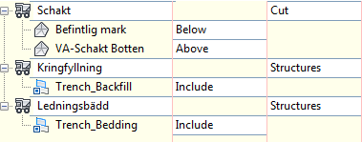
VA-Schakt + 3 skikt | Skapa yta för Schaktbotten, Kringfyllning samt befintlig mark.  Sections > Generate volume report: Volymberäkning flera skikt.xsl  Sections > Add Tables > Material Volume  Create surface for Trench and Special Backfill in Corridor. Needs surface for EG.  For external XML-rapport use Sections > Generate volume report: Volymberäkning flera skikt.xsl  For table in drawing use Sections > Add Tables > Material Volume | 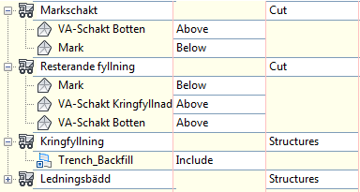
VÄG-Mark-Berg-schakt & Fyll + 4 skikt | Skapa yta för terrass i korridoren!  Ger volymrapport med mark- resp berg-schakt + fyll samt 4 skikt (i vägsektionen) specat sektionsvis, på separata rader.  Sections > Generate volume report: Volymberäkning flera skikt.xsl  Sections > Add Tables > Material Volume  Create surface for datum in corridor. Needs surface for EG and rock. Reports volumes for soil- and rock-cut, fill and 4 shapes from corridor. | 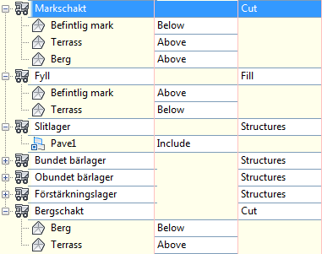
VÄG-Schakt & Fyll | Skapa yta för terrass!  Ger volymrapport med schakt resp fyll specat sektionsvis, på separata rader.  Sections > Generate volume report: Volymberäkning flera skikt.xsl  Sections > Add Tables > Material Volume | 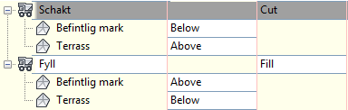
VÄG-Schakt & Fyll + 4 skikt | Skapa yta för terrass!  Ger volymrapport med schakt resp fyll samt 4 skikt specat sektionsvis, på separata rader.  Sections > Generate volume report: Volymberäkning flera skikt.xsl  Sections > Add Tables > Material Volume | 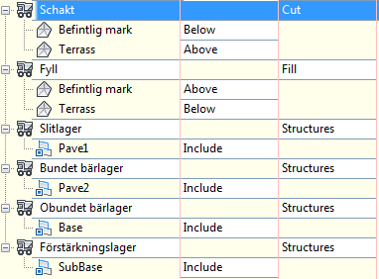
VÄG-Schakt Fyll Matjord + 4 skikt | Skapa yta för terrass och matjordsavtagning i korridoren!  Ger volymrapport med schakt resp fyll samt 4 skikt specat sektionsvis, på separata rader.  Sections > Generate volume report: Volymberäkning flera skikt.xsl  Sections > Add Tables > Material Volume  Same as above but create also a surface for Stripping top soil. | 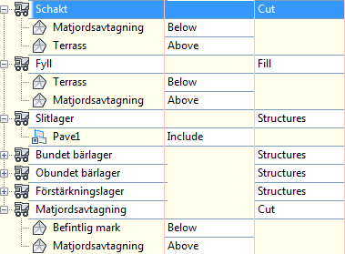
VÄG-Volymberäkning | Skapa yta för terrass i korridoren!  Ger volymrapport med schakt resp fyll specat sektionsvis, på samma rad.  Sections > Generate volume report: Volymberäkning.xsl  Sections > Add Tables > Total Volume  Denna används även för Volymdiagram – Mass haul view  Create surface for datum in corridor. Presents volumes for cut and fill per chainage on same row.  Use this for creating Mass haul view | 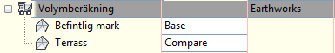

QTO Table Styles | Description | Screen grab / DWF / DWG | Default
Total Volume
Schakt och fyll | Area, volym samt ack volym för schakt & fyll presenterat per längdmätning  Area, volume and acc volume for cut and fill presented per chainage | 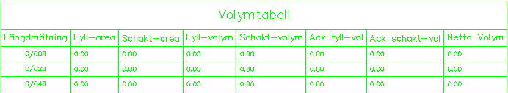
Material
Area och volym | Area, volym samt ack volym presenterat för enstaka material per längdmätning  Area, volume and acc volume presented for one material per chainage | 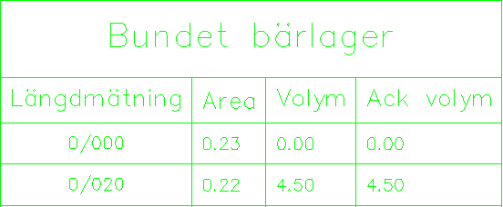

Plan and Profile Sheets
<Template file name, start a new table for each template file>
View Frame Styles | Description | Screen grab / DWF / DWG | Default
Standard

View Frame Label Styles | Description | Screen grab / DWF / DWG | Default
Standard

Match Line Styles | Description | Screen grab / DWF / DWG | Default
Full maskning av överlapp | Full maskning av överlapp  Full masking of overlap | 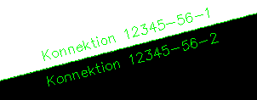
Ingen maskning | Ingen maskning  No masking
Punkt-maskning av överlapp | Punkt-maskning av överlapp  Dot-masking of overlap | 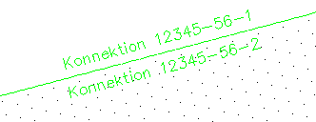

Match Line Label Styles | Description | Screen grab / DWF / DWG | Default
Match Line Left
Match Line Right

Survey
<Template file name, start a new table for each template file>
Network Styles | Description | Screen grab / DWF / DWG | Default
Standard | Translated standard style

Figure Styles | Description | Screen grab / DWF / DWG | Default
Byggnad | Building
Staket | Fence line
Trädlinje | Tree line
Väg centrumlinje | Road center line
Vägkant | Road edge

General - Multipurpose Styles – Shape Styles
This group contains the general component object styles and label styles. The following needs to be noted: (Generally all styles should be included with key description about them)
Add new Shape Style to all DWTs
Name: Multiple Boundary Material
Display Component | Visible | Layer | Color | Linetype | LTScale | Lineweight | Plot Style
All View Directions:
Shape Border Line | On | C-ROAD-SHAP | Blue | ByLayer | 1.0000 | ByLayer | NA
Shape Area Fill | On | C-ROAD-SHAP-PATT | Blue | ByLayer | 1.0000 | ByLayer | NA

Hatch Display Component Type | Pattern | Angle | Scale
All View Directions:
Shape Area Fill | ANSI31 | 0 | 1.7500

Object Defaults

Object | Description | Default Style
General Note Label Style | 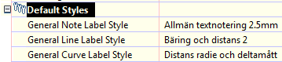
General Line Label Style
General Curve Label Style
Point Style | 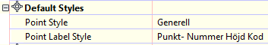
Point Label Style
Point Table Style | Koordinattabell XY
Surface Style | 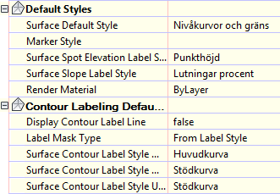
Surface Marker Style
Surface Spot Elevation Label Style
Surface Slope Label
Contour Label Major
Contour Label Minor
Contour label User-defined
Parcel Style | 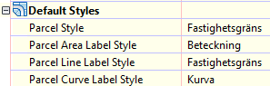
Parcel Area Label
Parcel Line label
Parcel Curve Label
Feature Line Style | 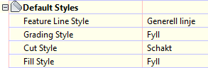
Grading
Cut Slope Grading
Fill Slope Grading

Tool palette(s)

Subassemblies and assemblies
None

Material styles
None

Drawing symbols and (MV)Blocks
None

Pipe and Structure Catalogs
Förändringar i Pipe Catalog
50mm ledningsdimension har lagts till för PP- och PE-rör.
Alla filer har flyttats till Sweden Pipe Catalog respektive Sweden Structure Catalog så nu måste man först välja den svenska katalogen i kommandot Set Pipe Network Catalog.

Changes in Pipe and Structure Catalogs
50 mm dimension has been added to family PP-rör and PE-rör.
Files have been moved to Sweden Pipe Catalog and Sweden Structure Catalog. User has to select it in command: Set Pipe Network Catalog.
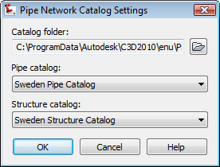

Highway design check files
För den nya funktionaliteten Criteria Based Design för både Alignments och Profiles finns nu en vidareutvecklad XML-fil. Den tidigare versionen innehöll funktionalitet endast för skevning. För civil 3D 2009 finns nu inställningar för horisontella radier, övergångskurvor och skevning samt för vertikala kurvor.

Inställningen för Criteria Based Design appliceras på en Alignment när man skapar den eller i Alignment Properties.

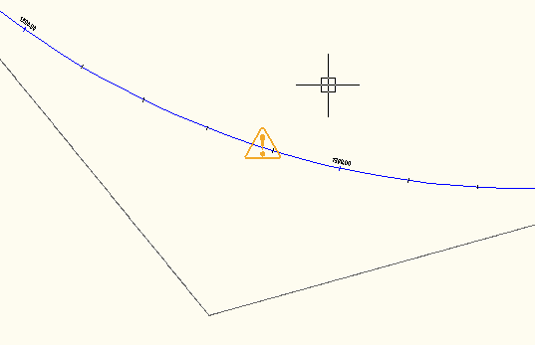

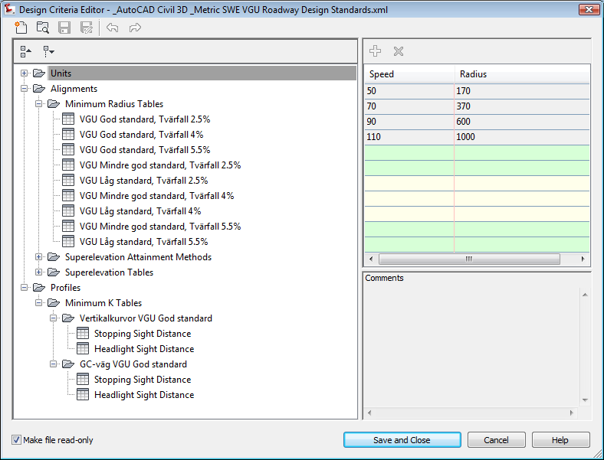

Quantity Take Off

Overview of QTO
The QTO feature of Civil 3D “Tuckerman” is designed to create links between pay items from a DOT master pay items list and elements in the Civil 3D model. After the links are created, the QTO tools can extract the information and create reports or export the information to be used in estimation applications.

For the CK, there are four things that will be needed to make QTO work: a master pay items file, a pay items index file, a units mapping file and a series or custom report templates.

Creation of QTO

Master Pay Items List
The Master Pay Items List can have three formats, but the most common will be a CSV file (comma separated file) that contains three fields of information: Pay Item Number, Pay Item Description and Units. The program will use the Windows regional setting for the “List Separator” to split the file on. By default in English (US) this is a “,”.
In Swedish “;” is used as list separator
QTO-info is assigned to all pipes and structures in all parts lists. For corridors QTO is assigned to Code set style “Alla koder – QTO”. There is a QTO-file and an index file created for Swedish QTO, called “Ledningar och brunnar samt Väg.csv” and “Ledningar och brunnar samt Väg.xml”

På svenska används “;” som listseparator.
QTO-info är lagt på alla ledningar och brunnar i alla partslists samt för Korridoren i Code set style ”Alla koder – QTO”. Det finns en svensk QTO-fil samt index-fil som heter “Ledningar och brunnar samt Väg.csv” and “Ledningar och brunnar samt Väg.xml”

Pay Items Index
The Pay Items Index file is used to categorize the Master Pay Items file from a flat list to a tree structure.

Units Mapping File
The Units Mapping file will map the strings for the units from the local to the system units.

Unit | Description
EA | Styck
M1 | Meter
M2 | Square meter

Reports
Reports for the QTO feature are made using HTML style sheets (.XSL) files to format the QTO output. The output will be formatted by Civil 3D using the ambient settings for the QTO command. The report will list all the QTO items found in the model for the region specified.

QTO Command Settings
The command settings for the QTO are used to control the output of the xml file that will be published when the user makes a quantity takeoff. The primary settings are:

Setting | Description
Linear Unit | Meter
Area Unit | Square Meter
Volume Units | Cubic Meter
Station

Installation of QTO
Future
See section 5.5 of content spec for information on style sheets provided to format quantity reports – provide details here of additional reports required.

Superelevation standards
Skevning ingår i den svenska filen för Design Standard.
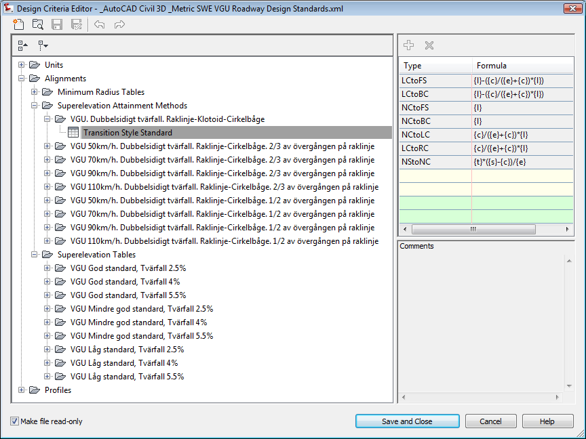

Intersection feature – Styles, Names and Assembly sets

Name | DWT Value | Comments | Screengrab/DWG/DWF
Intersection Style | Korsning
Intersection Label Style | Korsning
Offset Alignment Style | Linjeberäkning - Offset
Curb Return Alignment Style | Linjeberäkning - Offset
Offset Profile Style | Vägprofil - konstruktion
Curb Return Profile Style | Vägprofil - konstruktion
Offset Alignment Label Set | Visa inte - etiketter
Curb Return Alignment Label Set | Visa inte - etiketter
Offset Profile Label Set
Curb Return Profile Label Set
Intersection Name Format | Korsning (<[Next Counter(CP)]>)
Intersection Quadrant Name Format | Kvadrant <[Quadrant Location]>
Offset Alignment Name Format | <[Parent Alignment Name(CP)]>-<[Side]>-<[Offset Value]>
Curb Return Alignment Name Format | <[Intersection Name(CP)]> - <[Intersection Quadrant Name(CP)]>
Offset Profile Name Format | <[Parent Alignment Name(CP)]> - <[Side]> - <[Cross Slope Value]>
Curb Return Profile Name Format | <[Alignment Name(CP)]> - Profil
Corridor Region Name Format | Region - <[Assembly Name(CP)]> - (<[Next Counter(CP)]>)
See section 5.4 of content spec for instructions on developing an assembly set for the intersection feature.

Installation
The following table is used to catalog all the files that are part of the CK along with a brief description, the current location and the folder where they will be installed, and if the file is added to the user cache for second and subsequent restricted rights user installation. This information will be used when the install is created for the CK.

File Name | Description | Path | Installation Folder |  | User Cache
Huvudväg - Slänt höger.dwg  Huvudväg - Slänt vänster.dwg  Huvudväg genom korsning.dwg  Huvudväg halv sektion - Slänt höger.dwg  Huvudväg halv sektion - Slänt vänster.dwg  Huvudväg komplett sektion.dwg  Korsningskurvor.dwg  Sidoväg halv sektion - Slänt höger.dwg  Sidoväg halv sektion - Slänt vänster.dwg  Sidoväg komplett sektion.dwg  __SWE Assembly Set.xml | Assemblies for intersections |  | Assemblies
_AutoCAD Civil 3D _Metric SWE VGU Roadway Design Standards.xml | Design standard files |  | Corridor Design Standards\Metric
Ingen kategorisering.xml  Ledningar-brunnar+Väg.csv  Ledningar-brunnar+Väg.xml | QTO-files |  | Pay Item Data\SWE
AecbIDrop.htm  AecbIDrop.xml  AeccSharedPropertyLists.xml  Autodesk Logo.jpg  Circular Pipes swe  default.jpg  SWE Pipes.apc  SWE Pipes.htm | Pipes main files |  | Pipes Catalog\SWE Pipes
AeccCircularArmeradeBetongror_Metric.bmp  AeccCircularArmeradeBetongror_Metric.dwg  AeccCircularArmeradeBetongror_Metric.xml  AeccCircularBetongror_Metric.bmp  AeccCircularBetongror_Metric.dwg  AeccCircularBetongror_Metric.xml  AeccCircularBetongror_Metric2.bmp  AeccCircularBetongror_Metric2.dwg  AeccCircularBetongror_Metric2.xml  AeccCircularDranror_Metric.bmp  AeccCircularDranror_Metric.dwg  AeccCircularDranror_Metric.xml  AeccCircularGAPror_Metric.bmp  AeccCircularGAPror_Metric.dwg  AeccCircularGAPror_Metric.xml  AeccCircularMarkrorPP_Metric.bmp  AeccCircularMarkrorPP_Metric.dwg  AeccCircularMarkrorPP_Metric.xml  AeccCircularMarkrorPP_Metric2.bmp  AeccCircularMarkrorPP_Metric2.dwg  AeccCircularMarkrorPP_Metric2.xml  AeccCircularSegjarnror_Metric.bmp  AeccCircularSegjarnror_Metric.dwg  AeccCircularSegjarnror_Metric.xml  AeccCircularStalror_Metric.bmp  AeccCircularStalror_Metric.dwg  AeccCircularStalror_Metric.xml  AeccCircularTryckrorPE_Metric.bmp  AeccCircularTryckrorPE_Metric.dwg  AeccCircularTryckrorPE_Metric.xml  AeccCircularTryckrorPE_Metric2.bmp  AeccCircularTryckrorPE_Metric2.dwg  AeccCircularTryckrorPE_Metric2.xml  AeccCircularTryckrorPVC_Metric.bmp  AeccCircularTryckrorPVC_Metric.dwg  AeccCircularTryckrorPVC_Metric.xml | Pipe family files |  | Pipes Catalog\SWE Pipes\Circular Pipes swe
AecbIDrop.htm  AecbIDrop.xml  AeccSharedPropertyLists.xml  Autodesk Logo.jpg  default.jpg  Structures swe  SWE Structures.apc  SWE Structures.htm | Structure main files |  | Pipes Catalog\SWE Structures
AeccStructBrandpost_Metric.bmp  AeccStructBrandpost_Metric.dwg  AeccStructBrandpost_Metric.xml  AeccStructBrytpunkt_Metric.bmp  AeccStructBrytpunkt_Metric.dwg  AeccStructBrytpunkt_Metric.xml  AeccStructDräneringsbrunn_Metric.bmp  AeccStructDräneringsbrunn_Metric.dwg  AeccStructDräneringsbrunn_Metric.xml  AeccStructKupolbrunn_Metric.bmp  AeccStructKupolbrunn_Metric.dwg  AeccStructKupolbrunn_Metric.xml  AeccStructLuftningsanordning-test_Metric.bmp  AeccStructLuftningsanordning-test_Metric.dwg  AeccStructLuftningsanordning-test_Metric.xml  AeccStructLuftning_Metric.bmp  AeccStructLuftning_Metric.dwg  AeccStructLuftning_Metric.xml  AeccStructNedstigningsbrunn_Metric.bmp  AeccStructNedstigningsbrunn_Metric.dwg  AeccStructNedstigningsbrunn_Metric.xml  AeccStructPerkolationsbrunn_Metric.bmp  AeccStructPerkolationsbrunn_Metric.dwg  AeccStructPerkolationsbrunn_Metric.xml  AeccStructPropp_Metric.bmp  AeccStructPropp_Metric.dwg  AeccStructPropp_Metric.xml  AeccStructRensbrunn_Metric.bmp  AeccStructRensbrunn_Metric.dwg  AeccStructRensbrunn_Metric.xml  AeccStructRännstensbrunn_Metric.bmp  AeccStructRännstensbrunn_Metric.dwg  AeccStructRännstensbrunn_Metric.xml  AeccStructSpolpost_Metric.bmp  AeccStructSpolpost_Metric.dwg  AeccStructSpolpost_Metric.xml  AeccStructTillsynsbrunn_Metric.bmp  AeccStructTillsynsbrunn_Metric.dwg  AeccStructTillsynsbrunn_Metric.xml  AeccStructTömning_Metric.bmp  AeccStructTömning_Metric.dwg  AeccStructTömning_Metric.xml  AeccStructVentil_Metric.bmp  AeccStructVentil_Metric.dwg  AeccStructVentil_Metric.xml | Structure family files |  | Pipes Catalog\SWE Structures\Structures swe
StationFormatting_SE.xsl | Reporting header |  | Quantities Report Style Sheets\scripts
Volymberäkning flera skikt.xsl  Volymberäkning.xsl | Swedish Quantity take of reports |  | Quantities Report Style Sheets\xsl
GetParams.xsl  GetSettings.xsl  RepGenConfig.xml  RepGenSettings.xml | Report settings files |  | Reports\Support
SWE-header.xsl  SWE-Parcel_Inverse.xsl  SWE-Pipes and Structures.xsl  SWE-Pipes Only.xsl  SWE-Structures Only.xsl  SWE-SurfaceVolumeReport.xsl | Swedish reports |  | Reports\Support\xsl
Afkoord.dvb  C3dbl.dvb  Chelev.dvb  Surface elevation analysis.dvb  Swe Import Points to Feature lines.dvb  Swe Import Points to Polylines.dvb  Swe Import Points.dvb | Swedish tools |  | Reports\vba - SWE
afkoord.lsp  BH90K.SHX  c3dbl.lsp  chelev.lsp  mark.shx  Surface elevation analysis.LSP  vv.shx | Swedish support files, lsp and shx |  | Support
SWE Detailed Area (CSV).xsl  SWE Detailed Area (HTML).xsl  SWE Detailed Area (TXT).xsl  SWE Detailed Count (CSV).xsl  SWE Detailed Count (HTML).xsl  SWE Detailed Count (TXT).xsl  SWE Detailed Linear (CSV).xsl  SWE Detailed Linear (HTML).xsl  SWE Detailed Linear (TXT).xsl  SWE Summary (CSV).xsl  SWE Summary (HTML).xsl  SWE Summary (TXT).xsl | QTO-reports |  | Takeoff Report Style Sheets
_AutoCAD Civil 3D 2010 SWE.dwt | Template |  | Template
_SWE Civil 3D Plan+Profil.dwt  _SWE Civil 3D Plan.dwt  _SWE Civil 3D Profil.dwt | Plan Production Templates |  | Template\Plan Production
SWE-ToolBoxCfg.xml | Toolbox config file |  | Toolbox

